**The Crimean War & The Charge of the Light Brigade:**

**History & Film** 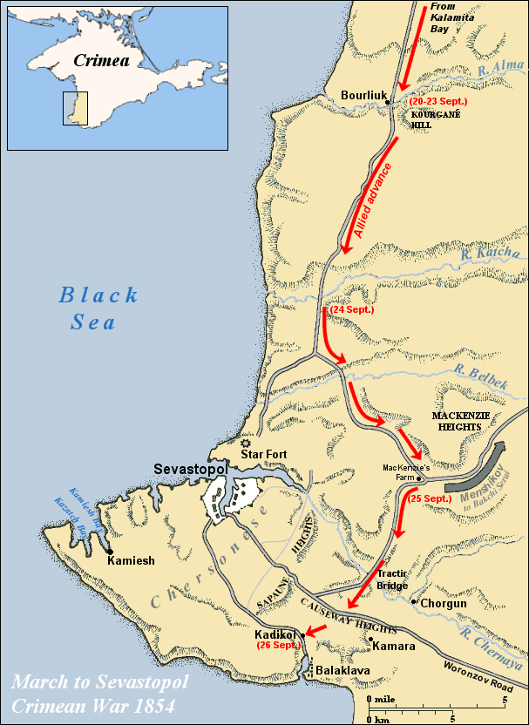

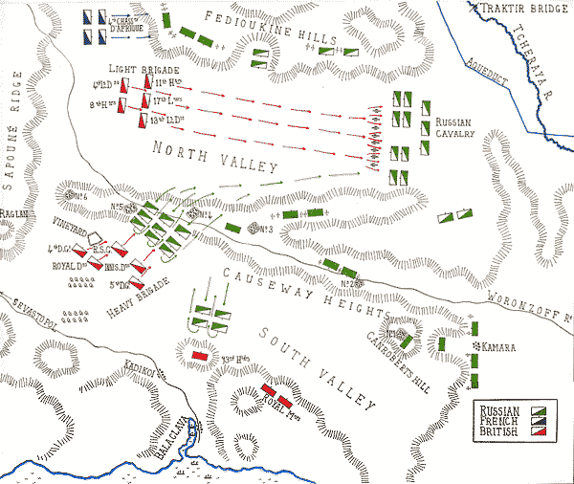

**Source:** [**http://www.britishbattles.com/crimean-war/balaclava.htm**](http://www.britishbattles.com/crimean-war/balaclava.htm)

**Big Picture**:

1. The War: “Russian” or “Eastern” War (1853-1856)
2. The Battle: Balaklava (October 25, 1854)

Charge of the Light Brigade

1. The Reporter: [W. H. Russell](http://www.lsu.edu/lsupress/bookPages/9780807134450.html) (November 14)
2. The Poet: [Lord Tennyson](http://www.bbc.co.uk/arts/poetry/outloud/tennyson.shtml) (December 9)
3. The Films: *Charge of the Light Brigade* ([1936](http://www.youtube.com/watch?v=pXzCOlPHFmc) & [1968](http://www.youtube.com/watch?v=cBiUWQ5YLQ4&feature=related))
4. Interpretation: History & Film

**The Crimean War (1853-56)**

**BACKGROUND: W. H. Russell & the Crimean War, by Eamon Dyas (*Times Online*, October 19, 2004)**

|  |  |
| --- | --- |
| |  | | --- | | The war in the Crimea provided British history with two of its most potent iconographic images, the **Charge of the Light Brigade** and **the Lady with the Lamp**. Various factors contributed - it was the first war in which the **telegraph** was to figure, and the first to be systematically **photographed** - but their immortality was chiefly ensured by [**William Howard Russell's**](http://www.lsu.edu/lsupress/bookPages/9780807134450.html) reporting for *The Times*.  3g09183r.jpg  Russell, then a young reporter, had been sent to the Crimea as special correspondent in February 1854, by *The Times's* editor, John Thadeus Delane. Delane believed that he would be back by Easter, but events were to keep him there for 18 months.  By 1855, under the incentive of military requirements, a telegraph was established between Balaclava and Varna. Russell was aware of the advantages the telegraph offered but, because of military monopoly, was very rarely able to use it. Consequently the average time it took to get his messages from the front to *The Times* in London was three weeks.  Russell also witnessed the first use of the camera in war. His diary of March 19, 1855, records the arrival of [**Roger Fenton**](http://www.loc.gov/pictures/collection/ftncnw/) who had been commissioned to compile a **photographic record of the conflict** by Thomas Agnew & Sons of Manchester. Fenton brought with him two assistants, five cameras, 700 glass plates and a mobile darkroom, and spent nearly four months in the Crimea. However, the photographic technology of the time would not allow him to take action pictures and he had to content himself with images of landscapes, camp scenes, fortifications, and portraits of leading personalities. In May 1855 Russell had his own photograph taken by Fenton.  **The Charge of the Light Brigade**  The battle took place on the morning of October 25, 1854, at Balaclava. The first news to reach the British public came in *The Times* on November 4, in the form of a Foreign Office telegram from Constantinople (it had been passed to the paper by the Duke of Newcastle, then Secretary for War). The event would have remained just one military disaster among many, were it not for the vivid descriptive power of Russell's letter, dispatched on October 26. It took almost 20 days to reach London and was published in on November 14.  It was this description of the battle that inspired [**Alfred Lord Tennyson**](http://www.bbc.co.uk/arts/poetry/outloud/tennyson.shtml) to compose his Charge of the Light Brigade, published in a collection called Maud and other poems in 1855.  Source: <http://www.timesonline.co.uk/article/0,,17629-1317949,00.html> | |

**SOURCE: Report: William Howard Russell, published November 14, 1854 (*The Times*, London)**

[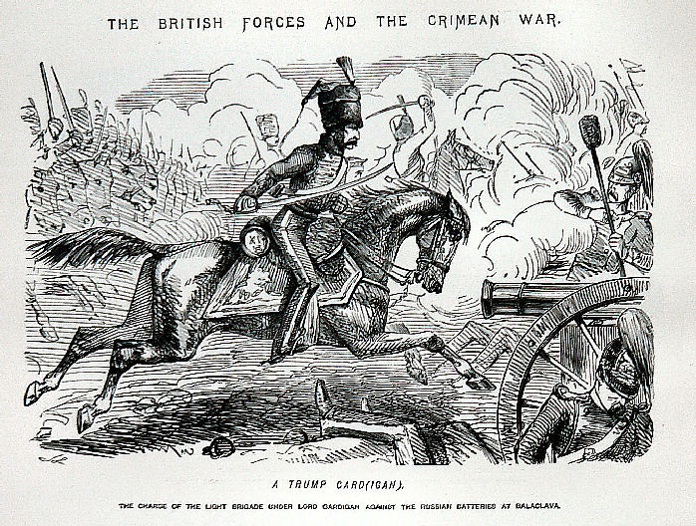](http://www.john-leech-archive.org.uk/keyword/crimean-war.htm)At ten minutes past eleven, our Light Cavalry Brigade advanced . . . As they rushed towards the front, the Russians opened on them from guns in the redoubt on the right, with volleys of musketry and rifles. They swept proudly past, glittering in the morning sun in all the pride and splendour of war. We could scarcely believe the evidence of our senses! Surely that handful of men are not going to charge an army in position? Alas! it was but too true - their desperate valour knew no bounds, as far indeed was it removed from its so-called better part - discretion. They advanced in two lines, quickening their pace as they closed towards the enemy. A more fearful spectacle was never witnessed than by those who, without the power to aid, beheld their heroic countrymen rushing to the arms of death. At the distance of 1200 yards the whole line of the enemy belched forth, from thirty iron mouths, a flood of smoke and flame, through which hissed the deadly balls. Their flight was marked by instant gaps in our ranks, by dead men and horses, by steeds flying wounded or riderless across the plain. The first line is broken, it is joined by the second, they never halt or check their speed an instant; with diminished ranks, thinned by those thirty guns, which the Russians had laid with the most deadly accuracy, with a halo of flashing steel above their heads, and with a cheer that was many a noble fellow's death-cry, they flew into the smoke of the batteries, but ere they were lost from view the plain was strewed with their bodies and with the carcasses of horses.

They were exposed to an oblique fire from the batteries on the hills on both sides, as well as a direct fire of musketry. Through the clouds of smoke we could see their sabres flashing as they rode up to the guns and dashed between them, cutting down the gunners as they stood. We saw them riding through the guns, as I have said; to our delight we saw them returning, after breaking through a column of Russian infantry and scattering them like chaff, when the flank fire of the battery on the hill swept them down, scattered and broken as they were. Wounded men and dismounted troopers flying towards us told the sad tale - demi-gods could not have done what we had failed to do . . . At thirty-five minutes past eleven not a British soldier, except the dead and dying, was left in front of those bloody Muscovite guns.

**Source:** [**http://www.timesonline.co.uk/article/0,,17629-1317953,00.html**](http://www.timesonline.co.uk/article/0,,17629-1317953,00.html)

1. **SOURCE: Letters: Excerpts by Captain W. P. Richards to his mother, Camp Sebastopol**

**October 7, 1854**

I have no news to tell you, we are still losing a great many men and officers, but the mortality is daily decreasing and the **cholera** nearly gone, we that is, the English army, have **lost nearly 9,000 men**, killed, wounded, dead and sick on board ships, since we landed in the Crimea. I have myself enjoyed the best of health, in fact they say I am like iron. I heard by the last mail from old Sam Batcheller, who tells me of four more vacancies. I am now 21st for promotion, and I also hear that five Generals are going to retire and six more General Officers, also that there is to be a Battalion about November, if this is true, I shall get my promotion this year, if not about April. If I am well I intend when the Army goes into winter quarters to apply for five months leave of absence to England, as I do not see the fun of wintering here which is far from healthy, and I should like to be home for a short time….

**November 7, 1854**

[Lord Raglan](http://victorianweb.org/history/crimea/raglan.html) gave an order that the [Cavalry should charge](http://victorianweb.org/history/crimea/paget/light.html) and retake the guns (by the way no one knew where they were then), the consequence was, the cavalry charged slap into the centre of the Russian Army and nearly the whole were killed, wounded or taken prisoners. They performed [prodigies of valour](http://victorianweb.org/authors/tennyson/charge.html), but were cut up by artillery and musketry. The remainder cut their way back, after this we left the Russians on the hills (where they subsequently entrenched themselves), and returned to our camp. The next day the 26th they were so plucky at their success of the day before, that they resolved to attack the right of our army, and drive the whole of us into the sea.

They (that is the common Russian soldiers), were told we were so frightened that directly they showed themselves, we should run away. They then made them drunk, this they always do, and sent them at us, but they did not send any guns with them. Well we turned out (1st and 2nd Divisions), who were on the right and 18 guns of ours were amongst them, and sent them to the right about in half an hour, with the loss of about 1,500 killed, wounded and prisoners, well, Lord Raglan was much pleased, and thought like an old ass as he is (mind this is now the opinion of the whole army) that after this dressing they would not attack the position again, although it is our weak point. The Engineers, however, advised his strengthening it by heavy guns and some earth works, but he being in his second childhood said "Nonsense, they will not dare to come again".

**January 29th 1855**

We are going on much the same as usual, the weather has been the last week much milder, the snow has nearly disappeared, but the thaw has made the Camp like a very wet and deep ploughed field, at any rate this is better than the intense cold we have had lately. We are now reduced to 9,500 effective bayonets, inclusive of 3,000 at Balaklava under [Sir Colin Campbell](http://victorianweb.org/history/crimea/campbell.html). It really makes one laugh to see the nonsense they put in the papers, about our now having 30,000 men etc., with every comfort, etc., etc.

I received a letter from Aunt (tell her I will answer it by next mail), by last Mail, in which she says the people are enraged at the falsehoods the *Times* tells about things out here. I can assure you that it is true every word of it, and that they do not state one half of [the miseries](http://victorianweb.org/history/crimea/gowing/hospital.html#hardship) going on here. There is a general feeling of dislike and hatred growing up rapidly in the Army against [Lord Raglan](http://victorianweb.org/history/crimea/raglan.html), from his want of foresight, and total neglect of the officers, men and Horses. No doubt people will try to excuse him by saying he has not this, or that and has great difficulties to contend with. We allow all this, but still we who are here, see and know of fifty things he might have done with the greatest ease, if [he had chosen](http://victorianweb.org/history/crimea/condition.html#blame), in Hutting, feeding, defences, visiting the sick, etc., etc., but not a thing has he done, is hardly ever seen, and if anyone proposes a measure to him he only pooh,pooh! and says impossible.

Source: <http://victorianweb.org/history/crimea/richards/richardsov.html>

1. **SOURCE: Poem: “The Charge of the Light Brigade,” by Alfred, Lord Tennyson (first published in *The Examiner*, December 9, 1854)**

[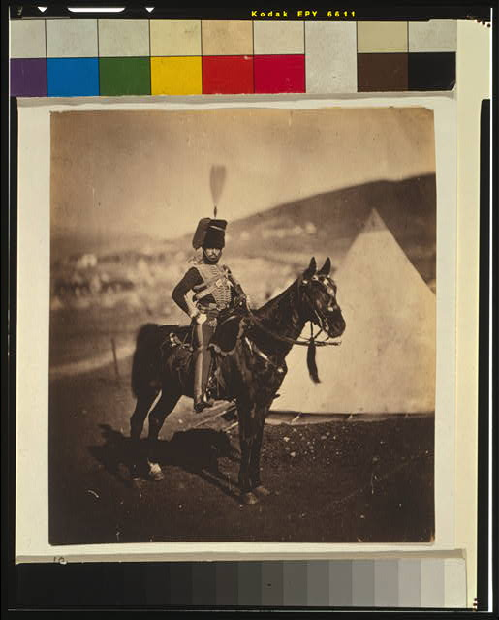](http://www.loc.gov/rr/print/coll/251_fen.html)

Half a league half a league,   
Half a league onward,   
All in the valley of Death   
Rode the six hundred:   
'Forward, the Light Brigade!   
Charge for the guns' he said:   
Into the valley of Death   
Rode the six hundred.   
  
'Forward, the Light Brigade!'   
Was there a man dismay'd ?   
Not tho' the soldier knew   
Some one had blunder'd:   
Theirs not to make reply,   
Theirs not to reason why,   
Theirs but to do & die,   
Into the valley of Death   
Rode the six hundred.   
  
Cannon to right of them,   
Cannon to left of them,   
Cannon in front of them   
Volley'd & thunder'd;   
Storm'd at with shot and shell,   
Boldly they rode and well,   
Into the jaws of Death,   
Into the mouth of Hell   
Rode the six hundred.   
  
Flash'd all their sabres bare,   
Flash'd as they turn'd in air   
Sabring the gunners there,   
Charging an army while   
All the world wonder'd:   
Plunged in the battery-smoke   
Right thro' the line they broke;   
Cossack & Russian   
Reel'd from the sabre-stroke,  
Shatter'd & sunder'd.   
Then they rode back, but not   
Not the six hundred.   
  
Cannon to right of them,   
Cannon to left of them,   
Cannon behind them   
Volley'd and thunder'd;   
Storm'd at with shot and shell,   
While horse & hero fell,   
They that had fought so well   
Came thro' the jaws of Death,   
Back from the mouth of Hell,   
All that was left of them,   
Left of six hundred.   
  
When can their glory fade?   
O the wild charge they made!   
All the world wonder'd.   
Honour the charge they made!   
Honour the Light Brigade,   
Noble six hundred!