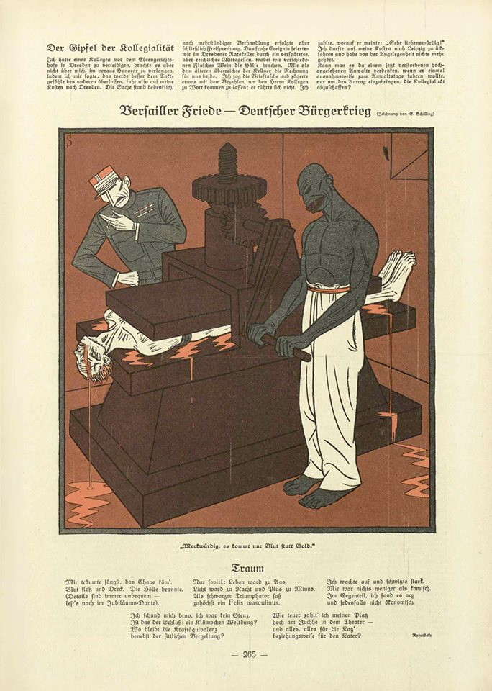
Adolf Hitler, Versailles Peace Treaty, & the Death of Democracy
- An English general said with justice: “The German army was stabbed in the back.” No guilt applies to the good core of the army. Its achievements are just as admirable as those of the officer corps. Where the guilt lies has clearly been demonstrated. If it needed more proof, then it would be found in the quoted statement of the English general and in the boundless astonishment of our enemies at their victory. [General Paul von Hindenburg, testimony before Parliamentary Investigatory Committee, 18 November 1919]
- To the half-heartedness and weakness of the parties in Parliament was added the half-heartedness of Governments... Everything stood under the sign of half-heartedness and lukewarmness, even the fight for existence in the World War and still more the conclusion of peace… THE ONLY POSSIBLE CONDITIONS UNDER WHICH A GERMAN STATE CAN DEVELOP AT ALL MUST THEREFORE BE: THE UNIFICATION OF ALL GERMANS IN EUROPE, education towards a national consciousness, and readiness to place the whole national strength without exception in the service of the nation. . . . For liberation something more is necessary than an economic policy, something more than industry: IF A PEOPLE IS TO BECOME FREE IT NEEDS PRIDE AND WILL-POWER, DEFIANCE, HATE, HATE, AND ONCE AGAIN HATE.... [extract from speech by Adolf Hitler in Munich, 10 April 1923]
- Victims of the promiscuous passions of the blacks are found half dead in meadows and ditches, their clothes in tatters, their delicate young bodies torn by the brutality of the attacks. Many have bite wounds which show clearly how wildly the black beast has fallen on his victim. I could quote innumerable examples with names and dates; and it must not be forgotten that almost all these men are infected with venereal diseases. [excerpt from speech by American journalist, Ray Beveridge, travelling to Germany after French occupation of the Rhineland, 1923]
- The German has no democratic tradition. Never have had… The Nazis emerged in circumstances during the 1920s, after the world war had been lost, when the German people were oppressed and humiliated and staggering from one economic crisis and from one political crisis to another. So this actually was very propitious. Someone must be to blame for it. And the entire anti-Semitism of the Nazis is actually encapsulated in the words: The Jew is guilty, for everything, always. [testimony of Arnon Tamir, about growing up Jewish in 1920s-1930s Germany]
- We see in the present system of majorities and organized irresponsibility the main cause of our steadily increasing miseries. So why do we want to be in the Reichstag? We enter the Reichstag to arm ourselves with democracy’s weapons. If democracy is foolish enough to give us free railway passes and salaries, that is its problem. It does not concern us. Any way of bringing about the revolution is fine by us…We are coming neither as friends or neutrals. We come as enemies! As the wolf attacks the sheep, so come we. You are not among your friends any longer! You will not enjoy having us among you! [Nazi propaganda minister, Joseph Goebbels, “Why Do We Want to Join the Reichstag?” Der Angriff, 30 April 1928]
- I was swept along not only by his passionate speech, but also by his sincere commitment to the German people as a whole, whose greatest misfortune was being divided into so many parties and classes. Finally a practical proposal for the renewal of the people! Destroy the parties! Do away with classes! True people’s community…. The same night it became clearer to me where I belonged: to the new movement. It alone gave hope of saving the German fatherland. [18-year old clerk, born 1910, who joined the NSDAP in 1929 recalls attending a Nazi speaker]
- Jews were associated with Communism, definitely. There was a vicious joke making the rounds… that it was just a well that there was one goy—a slightly derogatory term for a non-Jew—among the Communists in Russia, because at least he could sign the death warrants on a Saturday. That is a bit vicious, but there was a strong connection between Communism and the Jews, definitely. [testimony of Jutta Rüdiger, a 21-year old student who heard Hitler speak in 1932]
- Six million unemployed [at the start of 1933] means, with three people in one family, six times three equals eighteen million without food. And when a man was unemployed at that time, then there was only one thing left: either he became a Communist or he became an SA man. And so business thought that it was better for these people to become SA men, because there was discipline and order; and at the beginning—you really have to say this today—at the beginning you couldn’t tell whether National Socialism was something good with a few bad side-effects or something evil with a few good side-effects, you couldn’t tell. [testimony of Johannes Zahn, in 1932 a 32-year old German banker]
- We National Socialists believe that Adolf Hitler is an emissary for a new Germany. We believe that he has been sent by God to liberate the German people from the blood-sucker almighty Jewry. [Publisher of anti-Semitic paper Der Stürmer, Julius Streicher, from a speech in 1932]
- I give Germany six months more before she either goes communist or has a war with Poland. The great danger I feel is that the Dictator party will make war as soon as they have got the German army up to strength in order to counter the forces of Communism. It is a hell of a shame as the Germans are such splendid people. Amongst the younger people there is a sort of eager desperation, as they realize they are going to be the cannon fodder. [a 22-year old student from New Zealand, Geoffrey Cox was in Berlin for the July 1932 election, letter home to his mother]

All Roads Lead to War . . . Again:
Hitler & the Death of Germany Democracy

THE RISE OF ADOLF HITLER
25 MAY 1913 arrives in Munich, Germany
18 JAN 1914 arrested by Austrian agents for evading draft; (5 FEB 1914) fails army’s medical exam & is released
16 AUG 1914 inducted into 2nd Bavarian Infantry Regiment; (1 SEPT) transfers to 1st Company, List Regiment
3 NOV 1914 becomes Private First Class (Gefreiter)
9 NOV 1914 selected as regimental dispatch runner (meldegänger)
2 DEC 1914 German Army awards Hitler the Iron Cross, 2nd Class
OCT 1918 recuperates at Pasewalk military hospital for mustard gas attack; (19 NOV 1918) leaves
5 JAN 1919 German Workers’ Party (DAP) formed by Anton Drexler & Karl Harrer
3 APRIL 1919 2nd Demobilization Company elects Hitler as its official representative

12 APRIL 1919 chooses to stay in German Army
JUNE 1919 Captain Karl Mayr (Head, Education and Propaganda Department) chooses Hitler as “Education Officer” for Military District Command 4 to promote “anti-Bolshevik” ideas among the ranks
JULY 1919 becomes verbindungsmann (“low-level political agent”) for Reichswehr to spy on radical groups
9 JULY 1919 Treaty of Versailles ratified = Germany lost the war; “the shame of Germany’s surrender overwhelmed him”
10 JULY 1919 starts 3rd lecture in propaganda courses at Palais Porcia (in Munich)
AUG 1919 talks publically for the 1st time & gets “affirmation and recognition from a larger circle of people”; summer of 1919 is a period of “politicization & radicalization” for his ideology
12 SEPT 1919 ordered to attend his 1st meeting of German Workers’ Party (DAP) with 40 present; is given & reads Drexler’s pamphlet
16 SEPT 1919 writes 1st public anti-Semitic statements (letter about the “Jewish question” to Adolf Gemlich)
16 OCT 1919 gives 1st formal speech at DAP; 3 months later 10 x’s as many attendees
13 NOV 1919 publicly critiques Versailles Treaty at DAP meeting
24 FEB 1920 DAP becomes National Socialist German Workers’ Party (NSDAP)
1 APRIL 1920 Reichswehr discharges Hitler
3 AUG 1920 gives 3rd public speech at DAP which is heavily anti-Semitic; Jewish
conspiracies now “a fixed part of Hitler’s world view”

29 JULY 1921 NSDAP votes Hitler as leader; receives 553/554 votes; days later the Sturmabteilung (SA, aka “Brownshirts”) formed
8-9 NOV 1923 Beer Hall Putsch takes place (lasts 17 hours)
DEC 1923 Weimar hyperinflation reaches its peak
1923 Hitler hones his “Jewish narrative” to more simplistic, clearly-stated ideas
1 APRIL 1924 sentenced to five years in Landsberg Prison; serves only 9 months
27 FEB 1925 1st public speech after prison release
18 JULY 1925 Mein Kampf published; (1939) full English translation published
MAY 1925 NSDAP earns 6.5% in Reichstag elections
MAR ‘26- MAR ‘27 Bavarian government bans Hitler from public speaking
MAY 1928 NSDAP earns only 2.6% in Reichstag elections
28-29 OCT ‘29 “Black Monday & Tuesday” stock market crashes Wall Street
1930-1933 Hitler downplays anti-Semitism in his speeches; stresses anti-Bolshevism, rejection of Versailles Treaty, & need for German “regeneration”
SEPT 1930 NSDAP rises to 18.3% in Reichstag elections
JULY 1932 NSDAP and KPD earn 52% votes (Nazis peak support 37.4%)
NOV 1932 NSDAP and KPD earn 49.8% votes (Nazis decline to 33.1%)
30 JAN 1933 President Paul von Hindenburg appoints Hitler chancellor
23 MAR 1933 Reichstag passes “Enabling Act” giving Hitler dictatorial powers

