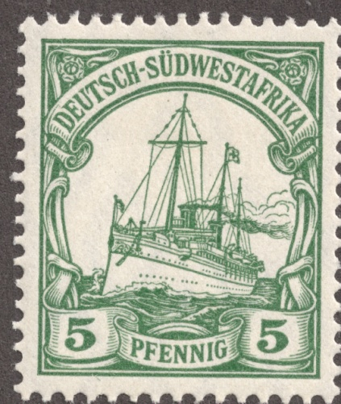
TIMELINE: Before the genocide in German South West Africa [GSWA]
(1884-1885) Congress of Berlin: formalized the major European powers “Scramble for Africa” including an up-and-coming powerhouse, Germany, under Otto von Bismarck
(Aug. 7, 1884) German flag first raised in GSWA
(May 1886) Ernst Heinrich Göring appointed Commissioner of GSWA
(April 17, 1886) dual legal system created with different laws for whites & natives
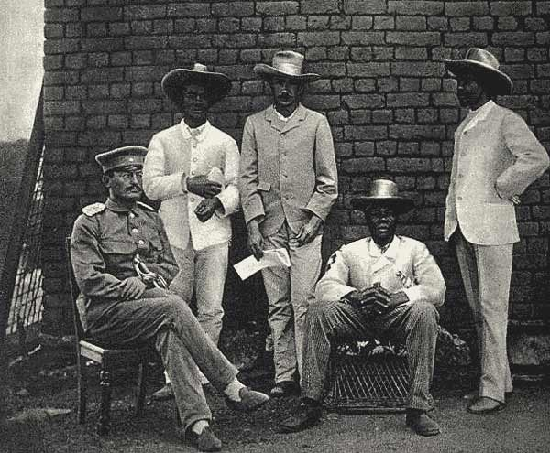
(1888) Samuel Maharero expels German officials; first German Schutztruppen (Imperial Security Troops) arrive to protect base at Otjimbingwe
(1890) Herero agree to German protection under rule of Samuel Maharero
(1892) Nama & Herero make peace to deal with German colonial occupation
(1893) Theodor Leutwein appointed Commissioner of GSWA
(1894) all native tribes forced into unequal German treaties
(1895) treaty allowing German to confiscate 5% of all cattle crossing frontiers of Herero territory; Maherero given 50% of profit from cattle sold
(1896) Khaua-Mbandjeru Rebellion: tribe dispersed by Leutwein & Schutztruppen, leaders shot, 12,000 cattle taken away. Khaua disarmed & interned in forced labor camps and tribal territory confiscated.
(1897) cattle-plague, rinderpest, destroys 50-95% of African livestock
(1901) Schutztruppen crush rebellion of Grootfontein. Prisoners brought to Windhoek to work; tribal lands, livestock, & horses confiscated.
(1903) Schutztruppen sent south to fight Bondelwarts rebellion leaving central Hereroland empty of German military presence and most of the 4,674 German colonists/
(January 12, 1904) Herero War begins, successful until June (Germans are surprised & humiliated)
(August 11, 1904) Battle of the Waterberg, led by General Lothar von Trotha, 1,584 Germans with machine guns & cannons. Surviving Herero driven into Omaheke Desert, German seal off escape routes & access to watering holes.

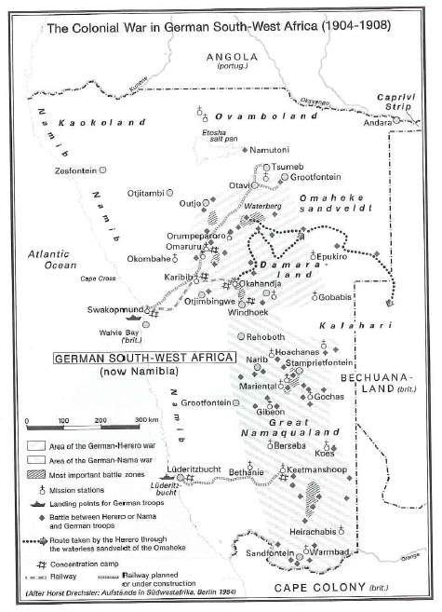
Primary Sources: Genocide in German South West Africa (1904-1908): Read each excerpt carefully. Match it with the correct author, date, & description. Write on a SEPARATE sheet of paper [10 points].
- If we rebel, we will be annihilated in battle since our people are practically unarmed and without ammunition, but the cruelty and injustice of the Germans have driven us to despair and our leaders and our people both feel that death has lost its terrors because of the conditions under which we now live.
- I was present when the Herero were defeated in a battle in the vicinity of Waterberg. After the battle all men, women, and children who fell into German hands, wounded or otherwise, were mercilessly put to death. Then the Germans set off in pursuit of the rest, and all those found by the wayside and in the Sandveld [Omaheke desert] were shot down and bayoneted to death. The mass of the Herero men were unarmed and thus unable to offer resistance. They were just trying to get away with their cattle.
- All Herero must leave the country. If they do not do so, I will force them with cannons to do so. Within the German borders, every Herero, with or without weapons . . . will be shot. I shall no longer shelter women and children. They must either return to their people or they will be shot at.
- This bold enterprise shows up in the most brilliant light the ruthless energy of the German command in pursuing their beaten enemy. No pains, no sacrifices were spared in eliminating the last remnants of enemy resistance. Like a wounded beast the enemy was tracked down from one water-hole to the next, until finally he became the victim of his own environment. The arid Omaheke [Kalahari desert] was to complete what the German army had begun: the extermination of the Herero nation.
- [The] difference between . . . those populations that fail and those that advance lies in spreading themselves . . . the areas of the failed groups lie torn apart, lawless, and poor. Advanced populations, in contrast, find the best places . . . [and ] grow.
- I do not concur with those fanatics who want to see the Herero destroyed altogether...I would consider such a move a grave mistake from an economic point of view. We need the Herero as cattle breeders...and especially as labourers.
- The experiences forged at this time live on. The result of the perhaps small, but in its execution delicate and in its aftermath often bloody [episode], was the formation of a set of projected colonial goals that have not been lost. The employment of these goals in German colonial politics, and in the empire of Adolf Hitler, has been made certain through Reichsleiter Ritter von Epp.
- Cold - for the nights are often bitterly cold there - hunger, thirst, exposure, disease and madness claimed scores of victims every day, and cartloads of their bodies were every day carted over to the back beach, buried in a few inches of sand at low tide, and as the tide came in the bodies went out, food for the sharks.
- A century ago, the oppressors—blinded by colonialist fervor—became agents of violence, discrimination, racism and annihilation in Germany’s name. The atrocities committed at that time would today be termed genocide—and nowadays a General von Trotha would be prosecuted and convicted. We Germans accept our historical and moral responsibility and the guilt incurred by Germans at that time. And so, in the words of the Lord’s Prayer that we share, I ask you to forgive us our trespasses.
- The land, our course, must be transferred from the hands of the natives to those of the whites, [this] is the object of colonization in the territory. The land shall be settled by whites. So the natives must give way and either become servants of the whites or withdraw…
- One ought to give them the amount of protection that they need, as a race inferior to us, so that their existence will last. They ought to be given no more and it should only be for so long as they are useful to us. Otherwise free competition, which means in my opinion, their extinction! This point of view sounds almost brutally egotistical – but whosoever thinks all the way through the previously described ‘psychological points’ cannot be of any other opinion.
- The Nama who chooses not to surrender and lets himself be seen in German territory will be shot, until all are exterminated. Those who, at the start of the rebellion, committed murder against whites or have commanded that whites be murdered have, by law, forfeited their lives. As for the few not defeated, it will fare with them as it fared with the Herero, who in their blindness also believed that they could make war successfully on the powerful German Emperor and the great German people. I ask you, where are the Herero today?

Match the correct primary source quotations above with the accompanying descriptions and writers/speakers below.
- Jan Kloete, a guide for the German military forces, later describes the atrocities he witnessed against the Herero in the aftermath of the Battle of Waterberg, August 11-12, 1904.
- Governor Theodor Leutwein disagrees with von Trotha’s elimination of the Herero, arguing that they are needed for economic reasons, particularly as laborers.
- German geographer, Friedrich Ratzel makes reference to his theory of “living space” for ‘best’ populations to grow. [From article by Ratzel, “Der Lebensraum” (1901)].
- Excerpt from a story from an official publication for the German general staff, Der Kampf [The Struggle] makes explicit reference to the von Trotha’s policy of extermination, even bragging about German actions [Tilman Dedering, A Certain Rigorous Treatment of all Parts of the Nation: The Annihilation of the Herero in German South West Africa, 1904].
- Chief Samuel Maherero expresses his frustrations with German behavior and the dangers of rebellion immediately before the Herero uprising in early 1904.
- German geneticist Eugen Fischer argues that allowing Africans to ‘freely compete’ will ultimately lead to their extinction as an inferior race. [from Fischer’s book, The Rehoboth Bastards and the Problem of Miscegenation among Humans (Jena 1913)].
- The colonial newspaper Deutsch Südwestafrikanische Zeitung makes clear that the native people of Namibia must give up their land for the European settlers [January 22, 1901].
- Excerpt from Lothar Von Trotha’s infamous “Annihilation Order” or Vernichtungsbefehl threatening the Herero nation with extermination of all men, women, & children [October 2, 1904].
- Nazi party member Franz Ritter von Epp links his colonial experiences with the Herero in Africa directly to Hitler’s policies [Franz Ritter von Epp’s autobiography, A Life for Germany (Munich, 1939)].
- Aspiring British diamond prospector, Fred Cornell, describes the horrible conditions for the Nama people at the Shark Island concentration camp, just off the coast from Lüderitz.
- Lieutenant-General Lothar von Trotha refers directly to the extermination of the Herero in threatening the Nama people with the same fate [April 22, 1905].
- German Minister for Development & Economic Cooperation, Heidemarie Weiczorek-Zeul apologizing in Omahakari, Namibia for atrocities committed a hundred years earlier by German imperial troops. [August 14, 2004].

