Eduard Pernkopf’s Anatomical Atlas

Topographische Anatomie des Menschen (1937-1960) Eduard Pernkopf (1888-1955)
- volume I (1937) two books
- volume II (1941) two books
- volume III (1952) one book
- volume IV (1960) two books
team of Viennese artists
- Erich Lepier (1898-1974)
- Karl Endtresser (1903-1978)
- Franz Batke (1903-1983)
- Ludwig Schrott (1906-1970)
English editions (1963-64, 1980, 1989)
Senate Report (1998): Vienna Anatomical Institute (1938-1945)
- 3,964 unclaimed bodies: hospitals & geriatric institutions
- 7,000 bodies: fetuses, still-born babies, children
- 1,377 execution victims: 50% for political reasons [526 “high treason”]
- 41 plates: definitely executed prisoners
- 350 paintings: unclear origins
- 791 illustrations: 50% pre-1938 or post-1945

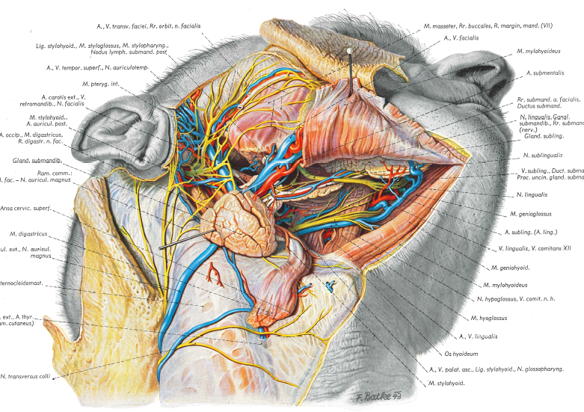
Selected Resources
Pernkopf’s Atlas:
- Angetter D. 2000. Anatomical Science at University of Vienna 1938-45. The Lancet 355: 1454-1457.
- Baker K. 2019. Eduard Pernkopf: The Nazi book of anatomy still used by surgeons. BBC News.
- Bazelon E. 2013. The Nazi Anatomists: How the corpses of Hitler's victims are still haunting modern science—and American abortion politics. Slate (6 November 2016).
- Begley S. 2019. The surgeon had a dilemma only a Nazi medical text could resolve. Was it ethical to use it? STAT News (30 May 2019).
- Carstens P. 2012. Revisiting the infamous Pernkopf Anatomy Atlas: Historical lessons for medical law and ethics. Fundamina 18: 23-49.
- Einhorn A. 2019. The world’s best anatomy was designed by a Nazi: Is it ethical to use it? Jerusalem Post (20 August 2019).
- Hildebrandt S. 2006. How the Pernkopf Controversy Facilitated a Historical and Ethical Analysis of the Anatomical Sciences in Austria and Germany: A Recommendation for the Continued Use of the Pernkopf Atlas. Clinical Anatomy 19: 91-100.
- Hubbard C. 2001. Eduard Pernkopf’s Atlas of Topographical and Applied Human Anatomy: The Continuing Ethical Controversy. The Anatomical Record (New Anat.) 265: 207-211.
- Israel HA, Seidelman WE. 1996. Nazi origins of an anatomy text: The Pernkopf atlas. JAMA 276: 1633.
- Paterniti M. 2002. The Most Dangerous Beauty. GQ (28 September 2002).
- Pringle H. 2010. Confronting Anatomy’s Nazi Past. Science 16: 274-275.
- Riggs R. 1998. What should we do about Eduard Pernkopf’s Atlas. Academic Medicine 73: 380-86.
- Wade N. 1996. Doctor’s question the use of Nazi’s medical atlas. New York Times (26 November)
- Weissmann G. 1985. Springtime for Pernkopf. Hospital Practice 20:142-168.
- Williams D. 1988. The History of Eduard Pernkopf’s Topographische Anatomie des Menschen. The Journal of Biocommunication 15:2-12.
- Yee A et al. 2019. Ethical considerations in the use of Pernkopf’s Atlas of Anatomy: A surgical case study. Surgery 165: 860-867.

