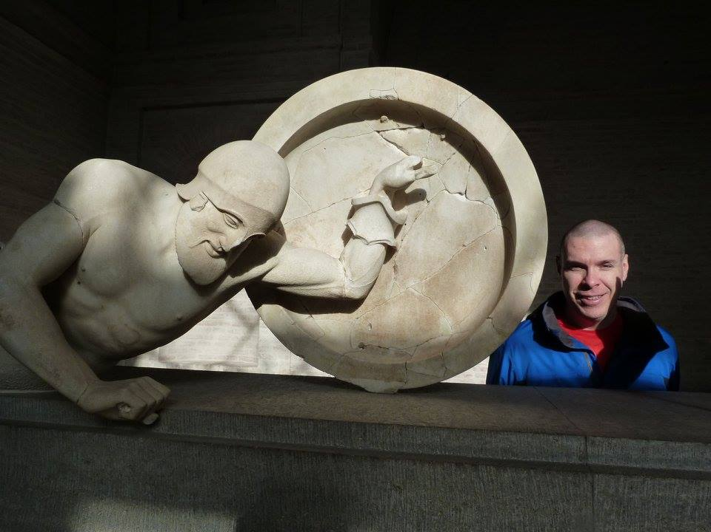
Ancient Mediterranean World
HIS-121-CRF01, 3 credits, 48 contact hours
Fall 2019, MWF 9:05-10 am
BH305
Dr. Robinson Yost

“To be ignorant of what occurred before you were born is to remain always a child. For what is the worth of human life, unless it is woven into the life of our ancestors by the records of history?”

Marcus Tullius Cicero
Dying Hoplite (ca. 500 B.C.) Glyptothek, Munich, Germany

Course Description: Surveys the cultural, religious, political and social heritage of the ancient Near Eastern people [e.g., Egyptians, Mesopotamians, Israelites, Greeks, Romans] as the foundations of Western Civilization.

Pre-requisites: There are no official pre-requisites for this course. However, it is highly recommended that you have experience doing structured writing assignments to perform well in the class. What you lack in writing skills you may have to work on via private tutoring (2071 Cedar Hall) or in the Writing Center (3067 Cedar Hall). You can always ask me questions as well. Be sure to get help early if needed.

Introduction:
This course traces the major aspects of prehistory and ancient history in the Near East, including the earliest civilizations in Mesopotamia and Egypt, the Greeks, and the Romans. We will examine broad themes, specific people, influential ideas, pivotal events, military developments, and general societal trends. In addition, we will emphasize the importance of history as a series of debates about what happened and why it happened.

First and foremost, history requires interpreting many different sources (primary & secondary) to reconstruct an explanation of the past. The study of history requires READING and lots of it. Regular READING CANNOT be avoided in a history course.

Student Learning Objectives:
- Demonstrate broad knowledge of key historical events, people, ideas, and other factors that have shaped diverse civilizations in the Ancient Mediterranean World
- Interpret various primary sources within the historical context of the Ancient Mediterranean World
- Analyze and evaluate secondary sources written about the Ancient Mediterranean World and identify approaches to history interpretation through critical reading
- Construct historical arguments based on sources relevant to the Ancient Mediterranean World
- Show understanding of the lasting impact of the Ancient Mediterranean World on later periods including the present

Contact Information:
- Office: Cedar Hall, Social Sciences, Office 1029
- Phone: 398-5899 ext. 5210
- E-mail: ryost@kirkwood.edu
- Office Hours: Monday-Friday, 11:10 am-12:10 pm or by appt. NOTE: I will not be checking e-mail regularly on weekends or evenings. Also, information about grades cannot be given out over the phone or e-mail.

Grades & Exams (Subject to Change):
● First exam 100 points September 27th
● Second exam 100 points November 1st
● Third exam [FINAL] 150 points Dec. 13th, 9:05-10:55 am
● Reading/video quizzes 250-300 points several weekly
● In-class writings/other 250-300 points daily or weekly
THREE EXAMS = 30-35% (total grade); EVERYTHING ELSE = 65-70% (total grade).

All exams & reading quizzes are OPEN NOTES, you may NOT use your textbooks or photocopies of the textbooks. Please take notes in your own words and remember that copying everything into a notebook is not good note-taking. Exams will be returned within TWO WEEKS of when the exam was taken. [Fun Fact: Your instructor’s favorite country to visit is Iceland where he has ridden horses descended from those brought there by the Vikings.] Contact me if you do not get your exam back. It is the student’s responsibility to keep all assignments and track their own grades. Please visit me in my office with any questions about exams, quizzes, notes, grades, or ways to improve performance (I will not “re-grade” assignments or exams). You can always ask questions in writing as well any time during the semester.

Emergency Information: See Facilities: Emergency/Crisis Information http://www.kirkwood.edu/site/index.php?p=7987

Required Course Materials [books available at Kirkwood Bookstore]:
- Hunt, Lynn., et. al., The Making of the West: Peoples and Cultures (Fourth Edition, Volume I: To 1740), 2012
- Lualdi, Katherine J., Sources of The Making of the West (Fourth Edition, Volume I: To 1740), 2012
- Handouts, internet readings, & videos (it is a requirement of this course to obtain assignments online)
- TALON: regular access to TALON is a REQUIREMENT of this course for watching videos, obtaining numerous readings, & keeping up with course assignments. If your home computer does not work (and the Help Desk cannot help you fix the problem), then you will need to use computers on campus to complete assignments.
- Exam books (TWO or THREE are required for exams for entire semester; these are purchased by student at the bookstore)
Exam book Policy: If a student fails to bring an exam book on exam day, then he or she may either
- buy one for an inflated price from the instructor or
- write on notebook paper & take 10 points off the score
- Extra copies of the textbook & sourcebook are available for photocopying on 2-hour reserve at the Kirkwood library main campus. [Fun Fact: Born in upstate New York, your instructor grew up in east Texas and went to Centenary College in Shreveport, Louisiana before eventually ending up Iowa.] There is also an accompanying website for the textbook with chapter overviews, practice exercises, etc. NOTE: These study guides are for supplementary use. They are for study purposes only; exercises will not be graded.

Grading Scale:
A = 93-100% B = 83-86% C = 73-76% D = 63-66%
A- = 90-92% B- = 80-82% C- = 70-72% D- = 60-62%
B+ = 87-89% C+ = 77-79% D+ = 67-69% F = 59% or below
NOTE: No curving in this course, bonus points will give plenty of opportunities to earn points.

Drop Date/Refund Dates: Last date for 100% refund, September 1st, last day for 50% refund, Sept. 9th
Last date to drop is December 2nd. Details of the refund schedule can be found under Academic & Enrollment Policies at: http://www.kirkwood.edu/site/index.php?p=35066
Attendance/Make-up Exam/Late Assignment Policy: Each student is expected to attend every scheduled class meeting. In the event that classes are missed due to illness, injury, or other legitimate reasons, it is the responsibility of the student to obtain class notes from a classmate (NOT the instructor); schedule makeup exams with instructor directly.
- LATE ASSIGNMENTS (OUTSIDE CLASS ONLY) will receive HALF CREDIT, unless there are valid and verifiable reasons for being late. Contact the instructor immediately if you are unsure about what constitutes a valid excuse. It’s always better to hand something in late (within a reasonable amount of time) than not hand in anything at all.
- IN-CLASS ASSIGNMENTS, including quizzes, cannot be made up owing to large amounts of bonus points available (the only exceptions to this policy are school-sponsored activities, military service, & jury duty). Simply showing up every day and handing in everything does not guarantee high grades; QUALITY counts not just quantity. Unless arrangements have been made with the instructor in advance, homework submitted via e-mail will be given a zero and deleted.
- MAKE-UP EXAMS must be scheduled and taken within ONE WEEK of the original exam date. To schedule a make-up a student must have a legitimate and verifiable reason (e.g., doctor's note) for missing the exam. Hence, "I was tired" or "I didn't feel well" are NOT valid reasons for taking a make-up exam. Scheduling makeup exams with the instructor is the responsibility of the individual student. Makeup exams will be taken in the Testing Center (Cedar Hall 2055).

Academic Accommodations: Students with specific academic and/or classroom needs may request individualized accommodations. Students wishing to request accommodations should complete an ‘Accommodation Request Form’ which is available at the Learning Services office, 2063 Cedar Hall, or online at www.kirkwood.edu/accommodations. Students will be asked to provide documentation supporting their request. An accommodation plan must be completed each semester and e-mailed to instructors before accommodations go into effect. Students are responsible for communicating with their instructor to discuss specific arrangements. Please communicate with your instructor in person.

Counseling & Career Services: Free, confidential counseling services are available for Kirkwood Community College students seeking career direction, academic support and individual counseling. While college years are a time of personal growth, this time can be accompanied by accelerated change and significant challenges that often bring considerable stress. Counselors promote student emotional and intellectual well – being. Call 319-398-5540 or visit www.kirkwood.edu/counseling to learn more.
Kirkwood Plagiarism Policy:
Kirkwood Community College is a community of shared values, foremost of which is a strong commitment to academic integrity, honorable conduct, and respect for others. [Fun Fact: Several years ago in Poland, your instructor went for a ride in the back of a police van as a suspected pickpocket.] Through the honest completion of academic work, students sustain the integrity of the college and promote a culture of civility, fairness, trust, and respect among its members. Those who violate these standards must be held responsible.

Kirkwood students are responsible for authenticating all work in a course. This includes but is not limited to quizzes, exams, presentations, papers, journals, and projects. For this reason, it is recommended that students engage in a verifiable working process on assignments and conduct themselves during class in a manner that does not lead to the suspicion of academic dishonesty. Examples of Academic Dishonesty include but are not limited to: Plagiarism and Fabrication, Misrepresentation, Cheating and Facilitation, and Impeding Fair and Equal Access to the Education and Research Process.

It is the student’s responsibility to be aware of the behaviors that constitute academic dishonesty. A detailed description of this policy and the sanctions associated with it can be found here: http://www.kirkwood.edu/site/index.php?p=32303

Electronic Devices Policy: In the interests of preserving a productive learning environment, as free of as many disruptions as possible, all electronic devices (phones, tablets, laptops, etc.) shall either be turned off or placed in a non-audible mode while in the classroom. Course-Specific Policy: A student using such devices for social media, texting, or ANY other electronic activity (even just checking messages) will see 10 points deducted from his/her total points earned (this will apply EVERY time the occurrence takes place). This point penalty may, or may not, be announced by the instructor at the time of the infraction. Be polite, be respectful: put them away & turn them off.

Productive Classroom Learning Environment: We believe that the best learning takes place in an environment where faculty and students exhibit trust and mutual respect. In a productive learning environment, faculty and students work cooperatively, recognize and respect differences, model the values of character and citizenship, and become lifelong learners. [Fun Fact: After studying physics & mathematics as an undergraduate, your instructor attended graduate school at Iowa State University where he studied the history of science.] All students, faculty, staff, service providers and visitors who are involved with any aspect of the college’s mission are members of Kirkwood’s learning community.

Classroom Expectations [Learning Environment & Student Conduct]: In this course, it is unacceptable to do homework during class or bring children. See the Kirkwood Student Handbook if you are uncertain about appropriate behaviors. Course-Specific Behavior Policy: The following address distracting, disrespectful, or otherwise inappropriate behaviors disrupting a productive learning environment among mature adults
- Disruptive actions include, but are not limited to, sleeping, repeated tardiness, passing notes, talking, reading textbooks during class, doing homework in class, open demonstrations of disrespect, headphone/ear bud usage; repeated classroom departures (during a single class or over the course of the semester).
- When behavior is disruptive, the student may be asked to stop or leave the class; any and all worked missed during that session CANNOT be made up. [Fun fact: Your instructor’s most recent hobby called kumihimo is a Japanese form of making braids. The word means “gathered threads.”]
- When such behavior persists, 10 points will be deducted from his/her total points earned (this applies in each instance of noncompliance). For example, reading the textbook or phone use of any kind in class. Be polite to your classmates; be respectful of everyone in the room.
.
In-Class Writings & Tentative Schedule: Anything we do in class assumes that you have already read the assigned material & taken notes. There will be many in-class writing assignments [SEE BELOW] that make up a significant part of your grade & CANNOT BE MADE UP if you miss class (or are late).

Over the course of the semester you will do numerous short in-class timed writings, usually based on reading assignments.
These writings will usually be evaluated in the following manner:
√ (check mark): shows preparation & solid understanding of material [FULL CREDIT= 5 points]
√- (check minus): shows lack of preparation & lack of understanding [HALF CREDIT= 2.5 points]
0 (zero): shows little or no sign of preparation & no understanding [NO CREDIT = 0 points]
Midterm Grades: A midterm grade will be calculated and posted on EagleNet. The midterm grade is a grade-in-progress, and will not affect your official GPA, nor will it impact financial aid. [Fun Fact: One of your instructor’s hobbies is juggling which he learned as a kid almost forty years ago.] The midterm grade has three purposes: first, to communicate your academic performance; second, to provide opportunities for you to discuss your progress with your instructor; and third, to allow Kirkwood to design college-wide intervention programs that will improve student success.

Resources for Students: As stated in the Student handbook: In compliance with Public Law 105-244, Kirkwood Community College makes a wide variety of general institutional information available to students. For additional information, go to: http://www.kirkwood.edu/site/index.php?p=32303

Kirkwood also offers many easily accessed services to assist students, but it is up to the individual to take advantage of these resources. There is lots of help available for those willing to take initiative (see below).
- Facilities: Emergency/Crisis Information Campus Security 389-1774
- One Stop Office (Financial Aid, Registration, etc.)— 319-398-7600 or 1-877-386-9101
- Advising & Transfer Center – 108 Iowa Hall, 398-5540
- Counseling Center – 108 Iowa Hall, 398-5540
- International Programs – 1-800-332-2055
- Learning Services – 2063 Cedar Hall, 398-5425
- Dean of Students—108 Iowa Hall, 393-5540
- Testing Center - 2055 Cedar Hall, 1-800-332-2055
- Writing Center – 3067 Cedar Hall
- Computer Labs—131 Nielsen Hall & 122 Linn Hall

History/Cultures: This course meets the criteria for the History/Cultures distribution group in the Liberal Arts Program. The following outcomes apply to all courses in this distribution group.
- Students will compare and contrast one’s own cultural perspective with that of another culture
- Students to be able to discuss key/unique features of a particular cultural & historical perspective
- Apply critical thinking to broad historical, cultural, and/or geographical contexts
- Employ methodologies used by historians & cultural practitioners to study the disciplines of history & culture

Student Policies (Academic & Enrollment Policies): It each student’s responsibility to be aware of the behaviors that constitute academic dishonesty. A detailed description of this policy and the sanctions associated with it can be found online. As stated in the Student handbook: In compliance with Public Law 105-244, Kirkwood Community College makes a wide variety of general institutional information available to students.

FERPA Regulations: Due to federal privacy regulations, students CANNOT RECEIVE GRADING or ATTENDANCE information via e-mail or the phone. [Fun Fact: Your instructor has visited the Galapagos Islands where he saw some of the same wildlife as Charles Darwin during his famous voyage of the Beagle in the 1830s.] Otherwise, all such information has to be handled by speaking directly with the instructor. (If a student wishes to waive FERPA privileges, it will be his/her responsibility to present the instructor with a copy of signed/official paperwork ahead of time.)

If you have filled out FERPA forms that allow your grade information to be discussed without direct contact, please provide a copy to your instructor. For verification purposes, students must physically be present when they complete the paperwork. (If you are interested in filling out FERPA forms, visit or speak with someone in Enrollment Services OR Learning Services.

College-Sponsored Activities: Students involved in activities where they are required to represent the college, i.e. college-sponsored activities, must give written notice to the faculty member at least one week in advance of the absence unless last minute schedule changes make this notice impossible. If regular season athletic schedules have been developed, student participants must present written notice of anticipated absences within the first week of the semester. Failure to provide timely written notice may result in the loss of this opportunity.

Faculty shall accord students the opportunity to independently make up course work or work of equal value, for the day(s) the event was scheduled and to take a scheduled exam at an alternate time. The faculty member shall determine alternate exam times and due dates for missed coursework. These assigned dates may be prior to the dates of the absence.

Organizers (coaches, faculty and staff) of college sponsored activities shall 1) assist students in planning class schedules to minimize the number of absences; 2) inform students of their responsibilities as described above; and 3) provide written communications to faculty announcing and verifying the need for student class absence. [Fun Fact: Your instructor’s dog was named Laika after the Soviet space dog—the first animal to orbit the earth in November 1957.] Written notices should be provided at the beginning of the semester if the schedule is known, or as soon as possible after the need for a student absence is determined.

* College sponsored activities (excluding practices) include such events as athletic competitions, student academic competitions and conferences, musical and drama performances, and class field trips. Questions on whether an activity is a college-sponsored event for purposes of this policy should be directed to the Vice-President of Instruction. If anticipated absences for a semester appear to be extraordinarily numerous or difficult to accommodate, a faculty member may appeal the need for the full accommodation to the VP of Instruction.
Tentative Schedule

The following schedule is NOT set in stone. Therefore, if you miss classes you need to find out what was missed from a classmate. Do not expect the instructor to contact you. Do not assume that we are exactly following the schedule; it is intended as a general guideline to course topics and reading assignments. Remember this is a face-to-face class, so I expect to see your face in class.

Introduction: What is history? What do historians do?

I. Prehistory & The Earliest Civilizations
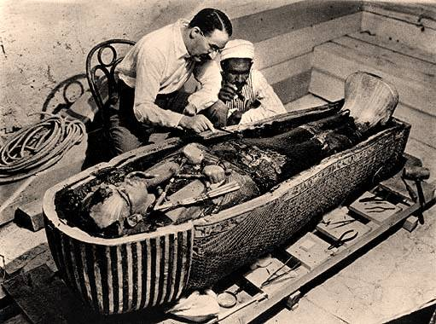
Prologue: Before Civilization (c. 200,000 – c. 10,000 B.C.)
Ch. 1 Foundations of Western Civilization (c. 4,000- 1000 B.C.)
Mesopotamia, Home of the First Civilization (c. 4000-1000 B.C.)
Civilization in Ancient Egypt (c. 3100 –1000 B. C.)
Civilization in Bronze Age Greece & Anatolia (c. 2200-1000 B.C.)
Ch. 1 Sourcebook
Ch. 2 New Paths for Western Civilization (c. 1000 –500 B.C.)
Dark Age to Empire
Remaking Greek Civilization
Creation of the Greek Polis
New Directions for the Greek City-State
Ch. 2 Sourcebook

II. Hellenic (Classical) Greece & Hellenistic Greece

Ch. 3 The Greek Golden Age (c. 500-400 B.C.)
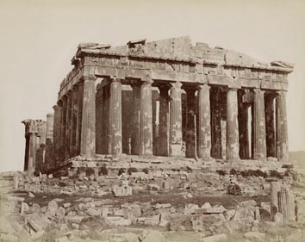
Clash between Persia & Greece (499-479 B.C.)
Athenian Confidence in the Golden Age
Tradition & Innovation in Athens’ Golden Age
The End of the Golden Age
Ch. 3 Sourcebook

Ch. 4 From the Classical to the Hellenistic World (c. 400-30 B.C.)
The Decline of Classical Greece (c. 400-350 B.C.)
The Rise of Macedonia (359 –323 B.C.)
The Hellenistic Kingdoms (323-30 B.C.)
Hellenistic Culture
Ch. 4 Sourcebook

III. Roman Republic & Roman Empire

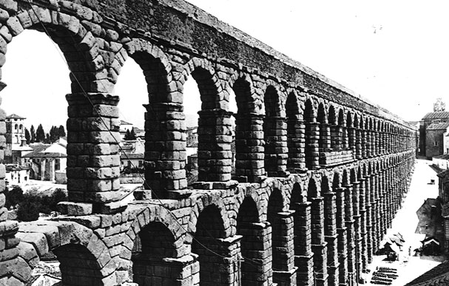
Ch. 5 The Rise of Rome (c. 753-44 B.C.)
Social & Religious Traditions
From Monarchy to Republic (c. 753-287 B.C.)
Roman Imperialism & Its Consequences (5th to 2nd centuries B.C.)
Upheaval in the Late Republic (c. 133-44 B.C.)
Ch. 5 Sourcebook

Ch. 6 The Roman Empire (c.44 B.C. – A.D. 284)
Creating “Roman Peace”
Maintaining “Roman Peace”
The Emergence of Christianity
"Top Dozen Most Common Irresponsible Student Attitudes & Behaviors"

- Just because you didn’t pay attention, listen, or follow directions (given verbally & in writing), how is that your teacher’s fault? Information given in class & the syllabus is important, whether you paid attention to it or not. “I didn’t realize” isn’t a valid excuse.
- Rude & demanding behavior is not only rude & demanding (whether in class or via e-mail), but it will not to get you what you want. Respect is a two-way street, you don’t get to demand respect while being disrespectful.
- Don't tell your instructor as class begins that you “Couldn't get it to work” or “Couldn’t find it.” It’s too late, you waited too long. It doesn’t matter how many “allies” you bring over to your side either, they are irresponsible like you. You should have asked for help before class.
- Apparently you are “really busy.” But so is everyone else. Good students are just as busy as you are, but don’t use that as an excuse. Success is about the choices you make, but so is failure.
- Because you (or someone else) paid for school, does NOT make you a customer. You are a student & that comes with responsibilities beyond paying. Being a student is like a job, failing means you’re about to be fired unless you get your act together.
- We get it, you really like looking at your phone every thirty seconds! Maybe you really believe that you “need” to do this, but you don’t. This won’t help you learn, and it doesn’t make you any smarter either. It’s just rude & disrespectful to everyone else.
- Showing up late a couple times is not a big deal. However, when you are frequently five or more minutes late, then it’s time to reevaluate why you signed up for this class. Figure out your schedule early in the semester, and show up on time.
- Okay, you were absent that one time because you got sick, but that doesn't cover the other five times you weren't in class (instructors know when you are not in class, we keep records and notice when people are missing).
- I understand you think it’s “unfair” that you’re not getting what you want. But is it “fair” to everyone else if you get special breaks or extra credit? How is making exceptions for one student “fair” to everyone else?
- Saying things like "I have As in all my other classes" doesn't impress, especially if you've done nothing to earn your grade in this class. In any case, what goes on in other courses is NOT relevant to this class. Corollary: “This isn’t my major” is a non sequitur.
- Showing up after midterms to claim you're “ready to work really hard" fails to demonstrate genuine seriousness, especially when also you ask "Is there any extra credit?"
- Of course all classes should be fun, easy, & entertaining because “this isn’t your major.” But meaningful learning requires hard work, frustration, even failure. If everything were fun, easy, & entertaining, then no one would learn anything.
- Course policies don’t apply to you because in high school (or other classes) you were always good at manipulating teachers (e.g., crying, bullying, complaining) to get your way. You’re special, so the rules don’t really apply to you, only other students. If you don’t get special treatment, it means the instructor is being “unfair.”
Just consider the above a common-sense list of what not to do as a mature, responsible college student. The list was compiled with the input of multiple teachers with decades of teaching experience at Kirkwood. Don’t be on the list!

Student Contract (Fall 2019)

Please read the following carefully. Sign & date at the bottom.

I understand the importance of CLASS ATTENDANCE to my grade. I recognize that in-class writing assignments (as described in the syllabus) and reading quizzes CANNOT be completed outside of class regardless of excuse (legitimate or illegitimate). I know the ONLY EXCEPTIONS to this are: college-sponsored activities, jury duty, & military service. I know the reason for this is the opportunities for LOTS OF BONUS POINTS throughout the semester [if I think this is unfair, I should meet immediately with the instructor to opt out of the bonus points in favor of make ups].

I understand the necessity of keeping up with READING ASSIGNMENTS (as mentioned in the syllabus) for my success in this course. I know that cramming the night before an exam is not a good idea; neither is reading assigned homework during class time. I recognize that regular reading & note-taking are expected.

I understand that when I am ABSENT (as discussed in the syllabus), I need to go to TALON announcements and get notes from a student not the instructor. I know that I should exchange e-mail addresses or phone numbers with several reliable classmates to get assignments if I have to miss class. It is my responsibility to keep up with missed work.

I understand what PLAGIARISM is (as discussed in the syllabus) and I know that plagiarized work will receive a zero. I realize that copying sentences from another source (including the textbook) is a form of plagiarism. I should write everything in my own words in this class.

I understand that there are point penalties for DISRUPTIVE behavior as described in the syllabus and that I am expected to complete all assignments as found on TALON. If I have questions, I will ask them as soon as possible.

I understand the GRADING SCALE and MAKEUP EXAM policies (as discussed in the syllabus). I will ask questions about anything I do not understand.

I know when the LAST DAY TO DROP the course is (as discussed in the syllabus) and I know dropping is my responsibility not the instructor’s.

I understand when I NEED HELP OR HAVE QUESTIONS, I should seek it out immediately from the instructor or other available resources (as discussed in the syllabus). I realize that the instructor does not have the power to read my mind, move objects without touching them, or communicate with the dead.

Signing this contract means that I have READ the syllabus and the contract itself. I realize that the instructor is the first person I should approach with any problems, questions, or concerns.

Your Name (Please Print): __________________________ Date: ______________________
Your Signature: ___________________________________
Course: __________________________________________

NOTE: Each student is responsible for being familiar with the information appearing in the syllabus and contract. Failure to read these will not be considered an excuse for noncompliance. Do not sign something without reading it!
Take-Home Survey (to be handed in next class period) [Answer all questions without using Google or any online sources]

- Briefly describe your experience with studying history in high school. Was it a positive or negative learning experience? Explain.

- How much reading did you do in your high school history classes? Estimate by number of pages per week.

- How much time spent on the following: TV, computers, video games, Facebook, Twitter, cell phone? Estimate by hours per day total.

- What type of exams or tests did you have in your high school history course? How did you study or prepare for them? Explain.

- How much writing did you do in your high school history classes? Did you have a research paper? Did you have essays? What sort of assignments? Explain.

- History is about more than just names, dates, & places (or facts), but everyone needs to know some facts. Without basic content knowledge, you cannot claim to know any deeper historical knowledge. With this in mind, please answer the following:
  - When was World War II? Give years.

  - What is the significance of the date August 6, 1945? June 28, 1914? September 11, 2001?

  - Who fought against whom in the United States Civil War?

  - How many Americans died in the Vietnam War?

  - Why was the Cold War significant? Explain.

