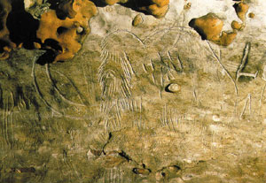
Cave paintings: entrancing the Otherworld
What possessed our ancestors to paint inside the deepest reaches of caves? According to new research, the answer is to be found in the shamanic visions, possibly identifying the first creation of sacred space, for contact with the divine.
Philip Coppens

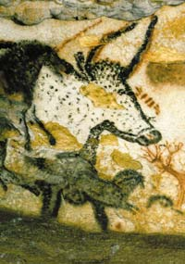
Many authors claim that it is a “fact” that “civilisation” began ca. 6000 years in Sumer. The concept of the origins of Mankind to 4004 BC, based on biblical dating and symbolised by Bishop Usher, have been replaced with the notion that civilisation occurred pretty much at the same time.
The never articulated question is what Mankind did in the preceding 30,000 years of its existence. Nothing? This is pretty much what some people think… Fortunately, those people are wrong. Richard Rudgley’s 1999 book The Lost Civilisations of the Stone Age: A Journey Back to Our Cultural Origins is a point in hand. Rudgley presented an overview of scattered items of information, but the most underreported yet best known aspect of that period is that 15,000 years ago, our ancestors created the most stunning paintings, in the deepest caves.
Lascaux in France and Altamira in Spain are but two examples of an ever growing list of caves where explorers have chanced across stunning depictions of life tens of thousands of years ago. It seems that each suitable cave was used by our ancestors for this artwork.
An important question to ask is why these depictions are discovered in the deepest nooks of caves. What made our ancestors make these drawings in these inaccessible places, where there was little chance of these paintings serving any social function. The question as to why our ancestors painted these drawings is furthermore riddled with preconceptions. In 1865, Sir Edward Tylor argued that there was a correspondence between magic and prehistoric art. Other experts, such as Abbé Henri Breuil, interpreted these as “hunting magic”, where the depictions were made for their “magical power” over the animal that would be killed. As a consequence, the animal would be killed more easily. However, such thinking is highly illogical. For this logic to work, it would mean that for every animal hunted, a painting would be created. This seems highly improbable. Indeed, such an interpretation was in the end too naïve: a later overview would reveal that only 15 percent of depictions were of animals that played any role whatsoever in the hunt.
Religious art
When these paintings were created, the mammoth was still extant. Many archaeologists proclaimed these paintings were hunting scenes, but this conclusion is now no longer supported.
To repeat the question: what is it that persuaded our ancestors to penetrate the innermost darkness of a cave and paint? Amongst those who have tried to answer this question is David Lewis-Williams, a South African scientist who felt that the status quo on the subject matter was inadequate. For some reasons, our ancestors were attracted to those darkest regions of the Underworld, which was carefully explored and became a workshop to express the earliest expressions of “art”. Still, it was not art; it was religious art: the art had a purpose. The caves became the cathedrals of the Stone Age, with the paintings depicting the core of their religious beliefs.
This theory as such was nothing new. In the first decades of the 20th century, several researchers had catalogued the prehistoric caves, specifically in France and Spain. Each researcher tried to build a theory that might explain what he had discovered, but it seemed that each subsequent discovery invalidated the previous theory. One such theory was that the series of paintings found in the caves were part of a pattern, whereby certain depictions were only found in certain parts of the cave system (e.g. near the entrance or in the deepest reaches). However, this theory was proven inadequate, resulting in the common “understanding” that it was very difficult, if not impossible, to make sense of what our ancestors had been doing… In short, it was felt that the art work, however “brilliant” for our “primitive ancestors” had been nothing more than random paintings in caves – without any further logic.
Lewis-Williams thought differently. He felt that a pattern did exist. He also felt that the paintings were a clear distinguishing factor between our ancestors – modern man – and its “nephews”, such as Neanderthal man. According to Lewis-Williams, Neanderthal man, despite his close proximity, did not possess an “imagination” in the sense that we do: we are the only being on this planet that is able to create “art”: draw images of the mind – for a purpose, whatever purpose that is. He also identified that what was depicted were images of the mind: visions, i.e. what the mind observed when it was in another “reality” – possibly another aspect of our existence that distinguishes us from other creatures. It is clear that our ancestors – or at least some of them – must have experienced altered states of consciousness. It is equally clear that this must have greatly intrigued them – as it continues until the present day, even though our modern society has pushed it into the criminal underworld, which is almost as dark as the inside of the caves. But in prehistoric times, Lewis-Williams argues, those visions would be the foundation for the creation of our religion, beginning with the belief in an “Otherworld” beyond our normal, physical senses. In this respect, the caves were indeed the first cathedral, of mankind’s proto religion.
Visions & spirit guides
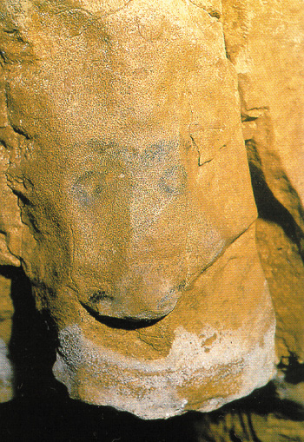
The shaman creating the paintings would use the natural contours of the rock and “exteriorise” what his visions had allowed him to see. In this example, the rock transformed into an animal’s head, simply by drawing two eyes.
Lewis-Williams is a firm believer that the artwork of the caves are depictions of what our ancestors witnessed in their visions: enigmatic lines, strange patterns, followed by animals. They form a logical sequence of what anyone today still sees in their own hallucinogenic experiences. Such patterns are known from anthropological studies of shamanic cultures, who equally often used hallucinogenic substances to enter the Otherworld.
He further argues that many paintings seem to “rise” out of the rock. The paintings “transform” the natural shape of the rock, in the same way that our observation would be transformed under the influence of hallucinogenic substances. The act of painting was therefore bringing the visions of the Otherworld into this reality: creating the Otherworld here, in the deepest reaches of the Underworld.
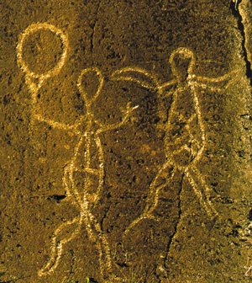
Most of the animals depicted in the scenes were healthy. Many anthropologists have identified that the shaman, in his voyage to the Otherworld is either transformed in or aided by an animal, often totemic in nature. This animal acts as his “spirit guide”, or his “power animal”. Animals were often chosen for a particular quality, such as the ability of flight for birds. By Egyptian times, the gods would become identified with totemic animals, such as Thoth’s ibis, or Sekhmet’s lion. Each of the depicted animals has specific qualities, which would identify them for such an identification.
Gateway to another dimension
The walls of the caves were a portal into another dimension. The Otherworld was located behind, or inside, the rocks. Our cave painting ancestors felt this, and our shamanic cultures, whether past or present, feel the same. The figures painted on these walls had escaped that reality – bridged the divide, like the shamans. These were the mediators between our reality and our needs and the Otherworld, the home of the gods who had been identified as responsible for the creation of this world. The cave was therefore the first temple, where sacred space was created to allow contact with the divine. It was in its innermost recesses, in the belly of Mother Earth, that the Otherworld was closest – and where the darkness of the cave created a silence and solitude everyday reality did not offer.
Apart from animal depictions, humans were also drawn. This being has a drum, an instrument that is uniquely identified with the shaman.
Confronted with these cave paintings, we are staring at the birth of the physical representation of a belief in “another world”, which would evolve into a dedicated cult – and in the end organised religion. It would lead to the building of the Egyptian pyramids, artificial tombs trying to reflect natural caves, the Book of the Dead being the written account of the shamanic visions experienced in the Otherworld. On the Greek island of Crete, the prehistoric caves would be places where the Greek gods were born and were buried, maintaining their focus of worship from prehistoric into Minoan times.
In the end, Lewis-Williams’ observations are in line with the work of Rudgley. He also argues that civilisation did not begin overnight, but developed gradually along with the evolution of Mankind. The arrival of Egypt or Sumer was not sudden. If anything, what has set Egypt and Sumer apart is the legacy they have left for us to study. Slowly but surely, the veil of their ancestors is being lifted and opened up for study, which peels back our history to its earliest days…
This article originally appeared in Frontier Magazine, No. 9.6, (November/December 2003).
