Chapter 7 [Part ONE]: The Peak Years of Killing:
1942 & 1943 [167-196]

Explain the following statement [Pick ONE]:
1) “[Without] war and German victories there would have been no genocide of the European Jews.”
2) “Military decisions & developments in 1942 and 1943 had repercussions far beyond the military sphere.”

“Big Picture” Questions:
- What factors caused human suffering to increase each year that the war dragged on, especially after 1943?
- What did German conquest mean for those conquered?
- What specific steps were taken to annihilate the Jews and others? How did the killing centers operate?
- Who resisted the Nazis, what methods did they use, and what impact did resistance have? [Part Two]

GERMAN MILITARY POWER AT ITS HEIGHT [168-178]
General Plan East, Germanization, & the Nazi “New Order”
• Theodor Schieder food & babies for “Aryan master race”
• expulsion of Slavs use of euphemisms
• “racially valuable” children to be “Germanized”
Slave Labor & German Reactions
• purpose of slave laborers & what they produced
• attitudes toward brutality & rejection of Christianity
• Himmler (October 1943) “human animals” [QUOTE]
• bribery of officials & wealthy German generals
The Battle of Stalingrad (fall 1942 –winter 1943) [173-178]
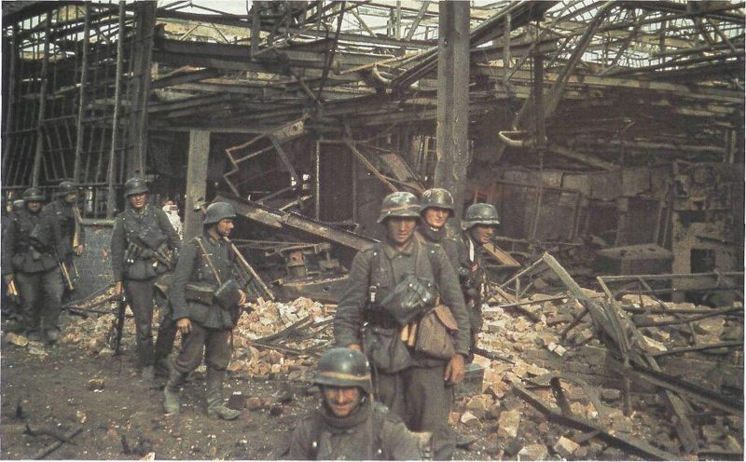
• What did Hitler hope to gain? What happened & why?
• Important turning point (symbolic & military)?
• criticism & “defeatism”?
• “Street of Roses” (early 1943)?
• Romanian & Hungarian Jews?
• “Harvest Festival” in Lublin (fall 1943)?
• Why did the Nazis waste manpower & resources killing Jewish civilians with a war to be won?
North Africa & Italy [178-182]
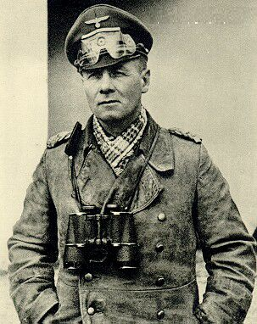
• Italians request help (1940) German Africa Corps (1941)
• “Desert Fox” versus “Monty” El Alamein (Nov. ‘42)
• “Operation Torch” (Nov. ’42) Morocco & Algeria
• Germans can’t supply troops Axis falls in Africa (May ’43)
• “Big picture” impact of North African campaign?
• Allied forces in Sicily (July ’43) Fascist regime collapses
• Effects in & outside Italy on civilian populations?

THE HOLOCAUST AT ITS PEAK [182-196]
The Killing Centers [182-191]
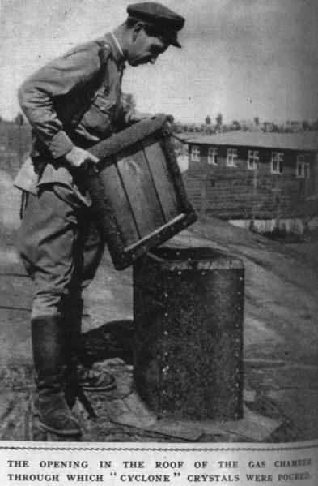
• Chelmno, Belzec, Sobibor, Treblinka, Majdanek, Auschwitz-Birkenau
• Terms: gas vans, Sonderkommando, “selections”, “shower room”, Operation Reinhard (Heydrich)
• Names: Kurt Gerstein, Wirth, Stangl, Eichmann, Hoess, Mengele
• How, when, & where did these death camps operate? Similarities & differences? Who died & how many?
• treatment of non-Jewish camp prisoners (Gypsies, Soviet POWs)
GENDER & GENOCIDE [191-196]
Zyklon B

