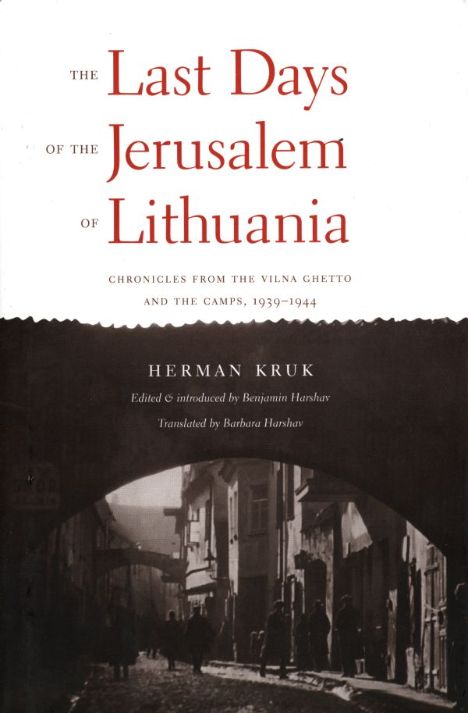
Source Introduction & Analysis: The Last Days of the Jerusalem of Lithuania (2002) by Herman Kruk
DIRECTIONS
1) Read the Introduction below
2) Choose ONE excerpt from the diary
3) Write the paper following the instructions below
Be certain to write in complete sentences & include details & specifics from the source excerpts. The paper should be 2.5-4 pages in length (double spaced), do not write less than the minimum.
QUESTIONS
Choose ONE of the excerpts from Kruk’s diary to complete this assignment. Based on reading Kruk’s diary, answer the following:
1. Identify which excerpt you chose.
2. In your own words, summarize the main ideas/stories/memories from the excerpt.
3. Explain how the excerpt connects to the bigger historical picture or context. Show that you understand with details from readings and/or videos assigned in this course.
The main point of this assignment is to demonstrate that you’ve read an excerpt from Kruk’s diary and understand how it fits into the broader context of the Holocaust in Lithuania.
Source Introduction & Analysis: The Last Days of the Jerusalem of Lithuania (2002) by Herman Kruk
The author (biography before the Vilna ghetto):
Hershl (Herman) Kruk was born on May 19, 1897 in the Polish city of Plotsk. The same year the WWI began, Kruk’s father died. During the war, his hometown changed hands several times being occupied by the German and Russian forces. During the German occupation, Jews had opportunities they had not had under Russian rule. Kruk, for example, worked as a photographer to support his family and later served as a supervisor in a factory preserving fruits & vegetables to be sent to Germany. German occupation during WWI meant freedom from persecution and oppression for the Jewish population: Jewish clubs, unions, and libraries appeared overnight.
During the war Kruk immersed himself in self-education and politics. He read Yiddish literature and, as a Communist, participated in the German Revolution of November 1918 led by Rosa Luxemburg. In a newly-independent Poland following the war, he was drafted into the Polish army. During this time, Kruk became increasingly aware of Communism’s weaknesses and critical of the Soviet uses of terror.
Although Kruk had no formal education, during the interwar years, he continued to read, write, and promote education among the workers. He organized “traveling libraries,” directed a cultural department for trade unions in Warsaw, and ran a Yiddish library (editing its monthly journal and publishing many articles).
When war broke out on September 1, 1939, Kruk crossed into the Soviet-occupied zone of Poland. Kruk and his brother met with a group of Yiddish writers and they arrived in Vilna on October 10 just before the city was turned over to independent Lithuania (as part of the agreement between Hitler and Stalin). He attempted to bring his wife, but she was arrested by the Soviets and exiled to the Russian camps. During the summer of 1940, Kruk aided other Jewish writers & political activists who were in danger of being arrested by the Soviets (who had recently annexed all the Baltic countries) to get U.S. visas and escape. Kruk himself stayed; when he finally bought a ticket to Vladivostok in the Russian Far East, it was too late. The Soviet authorities blocked his travel. On June 24, 1941, only two days after the beginning of Operation Barbarossa, the Wehrmacht marched into Vilna.
The diaries: Vilna ghetto & Estonian camps
The ghetto diary of Herman Kruk was discovered by partisans as they returned from the forests in July 1944 to the ruins of the Vilna ghetto. It was found buried in a cellar, but was incomplete owing to people scavenging for valuables. The diary made it New York in 1947, but was not published until 1961 (in its original Yiddish). At that time there was little interest in the Holocaust and a separate body of scholarly material/research on the subject had yet to emerge. Kruk’s diary was not translated into English for another four decades.
After being transferred from the Vilna ghetto to a camp in Estonia, Kruk continued to write about his experiences. He often scribbled on scraps of paper following 14-16 hours of hard labor. On September 17, 1944, Kruk buried his last reminisces in the Lagedi camp in front of six witnesses. As the Red Army approached the next day, Kruk and most of his fellow survivors were shot by the German guards and their bodies burned. One of the witnesses, Nisan Anolik, however, not only hid & survived, but returned to Lagedi to recover Kruk’s writings. After war’s end, Anolik brought Kruk’s camp diaries to Vilna for inclusion in the new “Jewish Museum.” In 1947, Soviet authorities shut down the museum and all of its contents were taken for “recycling” to a paper factory by the NKVD. Fortunately, a Lithuanian saved many of these Jewish books & manuscripts from destruction by the Soviet secret police. They would turn up again half a century later, after the collapse of the Soviet Union.
The most recent edition of Kruk’s diaries, translated into English, pieces together the surviving bits from his Vilna ghetto writings and those from Estonian concentration camps. It also includes pre-ghetto diaries dating back to fall 1939. Kruk’s diary is extremely rare in that it was written in a ghetto & in concentration camps during the events themselves with very little knowledge of the broader context. In fact, Kruk has no hindsight about the “Final Solution” as he did was unaware of the Nazi’s attempt to exterminate all European Jews, even though he was ultimately a victim. Finally, as should be clear, it is near miraculous that any of his writings survived the war at all.
DIARY EXCERPTS [Choose ONE]:

- September 6-16, 1939 [1-17]
- June 23 – July 24, 1941 [46-67]
- Aug. 27 – Sept. 5, 1941 [76-96]
- September 6-18, 1941 [96-117]

- March 1-18, 1942 [222-241]
- Sept. 5-30, 1942 [350-371]
- July 7 – Sept. 17, 1944 [692-705]

