Totalitarianism & Genocide:
Nazism & Stalinism
[FINAL PAPER (optional), 100 points]

The historian’s responsibility is not to prove which of the two men was the more evil or deranged, but to try to understand the differing historical processes and states of mind that led both of these dictatorships
to murder on such a colossal scale.

The Dictators: Hitler’s Germany & Stalin’s Russia (2004)
By Richard Overy
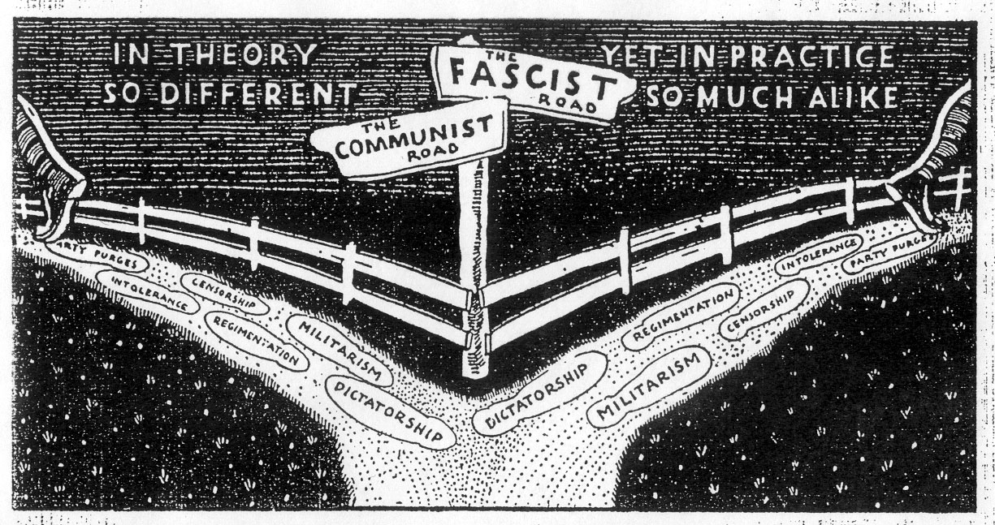
Paper Length: typed, doubled-spaced, 5-7 pages
Due date: You must hand in your paper by class-time. This can be via e-mail attachment or in person, but late papers will NOT be accepted. [May 13th, 12:20-2:10 pm (Tuesday)]
Assignment: Using the quote & illustration above as starting points, address the following:
- What are the major ideological differences between Nazism & Communism in theory? What are their major similarities in practice?
- Describe Hitler & Stalin’s differing approaches to dictatorship; why are both regimes described as totalitarian? Explain.
- Why did both Nazism & Communism lead to genocide? Compare & contrast the motivations & contexts behind their genocidal actions.

