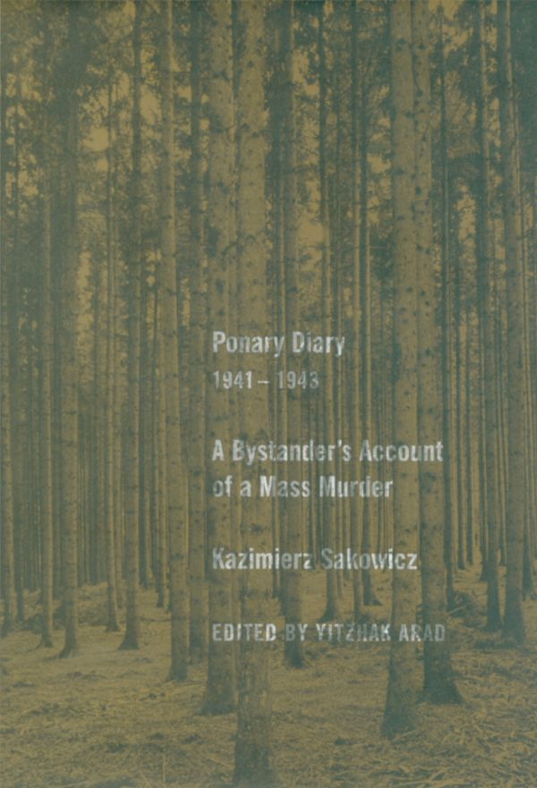
Ponary Diary, 1941-1943: A Bystander’s Account of a Mass Murder (2005)
by Kazimierz Sakowicz
Born in Polish Wilno (Lithuanian Vilnius, Jewish Vilna) in 1894, Kazimierz Sakowicz studied law in Moscow before returning home to work for various newspapers. As a Polish journalist, he later operated a print shop in Wilno which published several journals. When Soviet troops occupied the area in 1939, Sakowicz closed his business; he & his wife moved to Ponary, a suburb of Wilno, to live in a cottage in the woods. Sakowicz rode his bicycle into town performing a variety of odd jobs.
During formal control of Lithuania (1940-1941), the Soviets began constructing an airbase near Ponary. The Sakowicz’s home was located next to a fuel storage facility with large pits & connecting ditches excavated for large fuel tanks. On June 22, 1941, the German invasion of the USSR put a stop to the Soviet airbase. Nonetheless, the Nazis would soon utilize the large empty pits & ditches. Executions by shooting began at Ponary on July 11, 1941 and did not end until July 1944.
Hiding in his attic, Sakowicz witnessed executions taking place at one of the large pits. He also gathered information from neighbors, railroad employees, farmers, and the Lithuanian killers themselves who he referred to as “Ponary riflemen.” Sakowicz also counted the victims brought to the site, wrote down the numbers on trucks & automobiles carrying victims, and even described the victims’ clothing. Although the diary’s last entry is November 6, 1943, evidence suggests that Sakowicz kept writing until early July 1944 hiding these pages. On July 5, 1944, Kazimierz Sakowicz’s body was found in the Ponary woods next to his bicycle.
The Ponary diary is unique in that it is written by a bystander. At great risk to his own life, Sakowicz described the murders of between 50,000 and 60,000 Jewish men, women, & children by Nazis and their Lithuanian collaborators. He wrote quickly in shaky handwriting on loose sheets of paper before sealing the pages in lemonade bottles and burying them in the ground. The diary covers events from July 1941 until November 1943. It was long kept from scholars, perhaps because it implicated Lithuanians as killers, and was first translated into English in 2005.
BACKGROUND CONTEXT
Events in Wilno, Sept. 1939 –July 1941 [1-11]. Everyone needs reads these pages regardless of which diary excerpt you choose below. Numbers in brackets are page numbers.
EXCERPTS FROM DIARY [Choose ONE]
- July 11- August 26, 1941 [11-22]
- September 2-17, 1941 [22-30]
- October 21-November 25, 1941 [30-40]
- December 5, 1941-August 26, 1942 [40-51]
- September 1942-February 1943 [52-60]
- February 18-April 4, 1943 [61-70]
- April 5, 1943 [70-81]

