Excerpts from
Emperor Haile Selassie’s appeal
to League of Nations, Geneva, Switzerland (June 1936)

I, Haile Selassie I, Emperor of Ethiopia, am here today to claim that justice which is due to my people, and the assistance promised to it eight months ago, when fifty nations asserted that aggression had been committed in violation of international treaties....
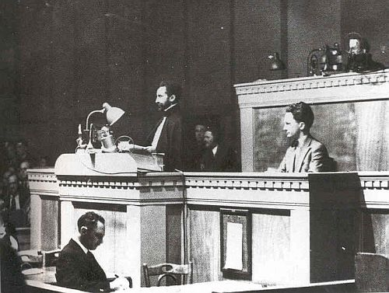
It is my duty to inform the Governments assembled in Geneva, responsible as they are for the lives of millions of men, women and children, of the deadly peril which threatens them, by describing to them the fate which has been suffered by Ethiopia. It is not only upon warriors that the Italian Government has made war. It has above all attacked populations far removed from hostilities, in order to terrorize and exterminate them.

At the beginning, towards the end of 1935, Italian aircraft hurled upon my armies bombs of tear-gas. Their effects were but slight. The soldiers learned to scatter, waiting until the wind had rapidly dispersed the poisonous gases. The Italian aircraft then resorted to mustard gas. Barrels of liquid were hurled upon armed groups. But this means also was not effective; the liquid affected only a few soldiers, and barrels upon the ground were themselves a warning to troops and to the population of the danger...

Special sprayers were installed on board aircraft so that they could vaporize, over vast areas of territory, a fine, death-dealing rain. Groups of nine, fifteen, eighteen aircraft followed one another so that the fog issuing from them formed a continuous sheet. It was thus that, as from the end of January, 1936, soldiers, women, children, cattle, rivers, lakes and pastures were drenched continually with this deadly rain. In order to kill off systematically all living creatures, in order to more surely to poison waters and pastures, the Italian command made its aircraft pass over and over again. That was its chief method of warfare....

In tens of thousands, the victims of the Italian mustard gas fell. It is in order to denounce to the civilized world the tortures inflicted upon the Ethiopian people that I resolved to come to Geneva. None other than myself and my brave companions in arms could bring the League of Nations the undeniable proof. The appeals of my delegates addressed to the League of Nations had remained without any answer; my delegates had not been witnesses. That is why I decided to come myself to bear witness against the crime perpetrated against my people and give Europe a warning of the doom that awaits it, if it should bow before the accomplished fact....

War then took place in the atrocious conditions which I have laid before the Assembly. In that unequal struggle between a Government commanding more than forty-two million inhabitants [Fascist Italy], having at its disposal financial, industrial and technical means which enabled it to create unlimited quantities of the most death-dealing weapons, and, on the other hand, a small people of twelve million inhabitants, without arms, without resources having on its side only the justice of its own cause and the promise of the League of Nations. What real assistance was given to Ethiopia by the fifty two nations who had declared the Rome Government guilty of a breach of the Covenant and had undertaken to prevent the triumph of the aggressor?...

The Ethiopian Government never expected other Governments to shed their soldiers' blood to defend the Covenant when their own immediately personal interests were not at stake. Ethiopian warriors asked only for means to defend themselves. On many occasions I have asked for financial assistance for the purchase of arms that assistance has been constantly refused me. What, then, in practice, is the meaning of Article 16 of the Covenant and of collective security?...

Apart from the Kingdom of the Lord there is not on this earth any nation that is superior to any other. Should it happen that a strong Government finds it may with impunity destroy a weak people, then the hour strikes for that weak people to appeal to the League of Nations to give its judgment in all freedom. God and history will remember your judgment....

Your Assembly will doubtless have laid before it proposals for the reform of the Covenant and for rendering more effective the guarantee of collective security. Is it the Covenant that needs reform? What undertakings can have any value if the will to keep them is lacking? It is international morality which is at stake and not the Articles of the Covenant. On behalf of the Ethiopian people, a member of the League of Nations, I request the Assembly to take all measures proper to ensure respect for the Covenant. I renew my protest against the violations of treaties of which the Ethiopian people has been the victim. I declare in the face of the whole world that the Emperor, the Government and the people of Ethiopia will not bow before force; that they maintain their claims that they will use all means in their power to ensure the triumph of right and the respect of the Covenant.

I ask the fifty-two nations, who have given the Ethiopian people a promise to help them in their resistance to the aggressor, what are they willing to do for Ethiopia? And the great Powers who have promised the guarantee of collective security to small States on whom weighs the threat that they may one day suffer the fate of Ethiopia, I ask what measures do you intend to take?

Full text: http://www.mtholyoke.edu/acad/intrel/selassie.htm

QUESTIONS:
- What are the Emperor’s main points regarding the actions of Italy and the response of the League of Nations?
- How could the events described by the Emperor be connected with other events leading up to the outbreak of the Second World War? Be specific.

