Shoah Project: Testimony
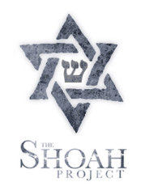
DIRECTIONS
The paper should be 1.5-2 pages in length (double spaced).
QUESTIONS
Choose ONE of the videos below to complete this assignment. Based on watching the survivors' testimonies, answer the following:
1. In your own words, summarize the main ideas/stories/memories of the survivors.
2. How does the testimony connect to the bigger historical picture or context? Show that you understand with details from other assigned readings.
3. What are specific strengths & weaknesses of using this kind of testimony to learn about the Holocaust?
USC Shoah Foundation Testimonies
Memories of Kristallnacht (22 minutes)
Jehovah's Witness Survivor (34 minutes)
Holocaust Survivor Nechama Shneorson (30 minutes)
Sobibor Uprising of 1943 (28 minutes)
Warsaw Ghetto Uprising of 1943 (29 minutes)
Auschwitz II-Birkenau Sonderkommando Uprising of 1944 (24 minutes)
Auschwitz II-Birkenau Survivors (33 minutes)

USC Shoah Foundation: Segments for the Classroom
The link above will give access to the same video clips, plus PDFs with additional information about each of the survivors being interviewed.

