Amen (2002): Viewing Guide
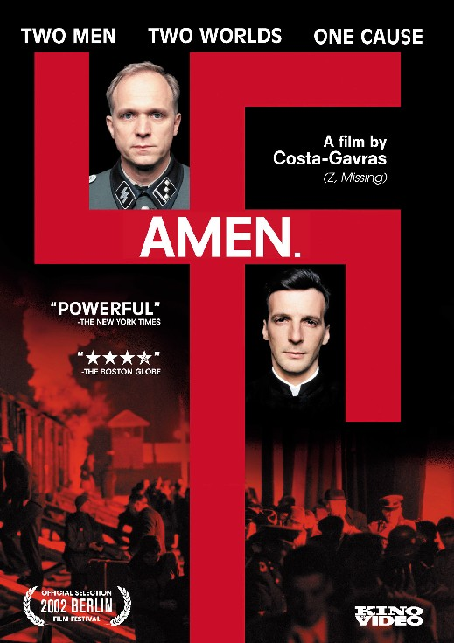
The Setting:
Where? Nazi Germany & occupied Poland
When? 1936 to ca. 1942
Who? Kurt Gerstein (1905-1945)

Big Picture:
How do the scenes from the film connect to class readings, lecture, & discussion? What parts of the film clips appear to be historically accurate, be specific with details from the movie?

To Know [Selected Scenes]
Ch. 1 [start of film]
- 1936: League of Nations, Geneva, Switzerland, Stefan Lux’s suicide?
- 1940: T-4 “Euthanasie” Program
- physician’s review board & gassing?
- Dr. Gerstein’s lecture on hydrocyanic acid & SS officer’s entrance?
  - “What if the water is known to be drinkable?”
  - “What is drinkable for a Slav may not be for a human being.”
- Funeral for Berthe & significance of two urns?
- Bishop von Galen’s complaint for murder of “unproductive citizens”
Ch. 2 [18:10 min]
- 1941:daughter’s arithmetic problem?
- Bishop von Galen’s sermon (August)?
  - “some day, you will be, we all will be, unproductive”
- Five hundred canisters of prussic acid (Zyklon B)?
  - Gerstein’s concerns?
  - “Only 500? There’s a lot of vermin between Berlin and Moscow”
Ch. 3 [27:32 min.]
- 1942: a demonstration at a “special camp” (“400 units to be treated”)
- Gerstein’s response & meeting of Swedish official on the train?
Fellow Christians! In the pastoral letter of the German bishops of June 26, 1941, which was read out in all the Catholic churches in Germany on July 6, 1941, it states among other things: It is true that there are definite commandments in Catholic moral doctrine which are no longer applicable if their fulfillment involves too many difficulties…
German men and women, section 211 of the Reich Penal Code is still valid. It states: 'He who deliberately kills another person will be punished by death for murder if the killing is premeditated.'
Those patients who are destined to be killed are transported away from home to a distant asylum presumably in order to protect those who deliberately kill those poor people, members of our families, from this legal punishment. Some illness is then given as the cause of death. Since the corpse has been burnt straight away, the relatives and also the criminal police are unable to establish whether the illness really occurred and what the cause of death was.
However, I have been assured that the Reich Interior Ministry and the office of the Reich Doctors' Leader, Dr. Conti, make no bones about the fact that in reality a large number of mentally ill people in Germany have been deliberately killed and more will be killed in the future…
I have received no news concerning intervention by the Prosecutor's Office or by the police...Thus we must assume that the poor helpless patients will soon be killed.
For what reason?
Not because they have committed a crime worthy of death. Not because they attacked their nurses or orderlies so that the latter had no other choice but to use legitimate force to defend their lives against their attackers. Those are cases where, in addition to the killing of an armed enemy in a just war, the use of force to the point of killing is allowed and is often required.
No, it is not for such reasons that these unfortunate patients must die but rather because, in the opinion of some department, on the testimony of some commission, they have become 'worthless life' because according to this testimony they are 'unproductive national comrades.' The argument goes: they can no longer produce commodities, they are like an old machine that no longer works, they are like an old horse which has become incurably lame, they are like a cow which no longer gives milk.
What does one do with such an old machine? It is thrown on the scrap heap. What does one do with a lame horse, with such an unproductive cow?
No, I do not want to continue the comparison to the end--however fearful the justification for it and the symbolic force of it are. We are not dealing with machines, horses and cows whose only function is to serve mankind, to produce goods for man. One may smash them, one may slaughter them as soon as they no longer fulfill this function.
No, we are dealing with human beings, our fellow human beings, our brothers and sisters. With poor people, sick people, if you like unproductive people.
But have they for that reason forfeited the right to life?
Have you, have I the right to live only so long as we are productive, so long as we are recognized by others as productive?
If you establish and apply the principle that you can kill 'unproductive' fellow human beings then woe betide us all when we become old and frail! If one is allowed to kill the unproductive people then woe betide the invalids who have used up, sacrificed and lost their health and strength in the productive process. If one is allowed forcibly to remove one's unproductive fellow human beings then woe betide loyal soldiers who return to the homeland seriously disabled, as cripples, as invalids. If it is once accepted that people have the right to kill 'unproductive' fellow humans--and even if initially it only affects the poor defenseless mentally ill--then as a matter of principle murder is permitted for all unproductive people, in other words for the incurably sick, the people who have become invalids through labor and war, for us all when we become old, frail and therefore unproductive.
Then, it is only necessary for some secret edict to order that the method developed for the mentally ill should be extended to other 'unproductive' people, that it should be applied to those suffering from incurable lung disease, to the elderly who are frail or invalids, to the severely disabled soldiers. Then none of our lives will be safe anymore. Some commission can put us on the list of the 'unproductive,' who in their opinion have become worthless life. And no police force will protect us and no court will investigate our murder and give the murderer the punishment he deserves.
Who will be able to trust his doctor anymore?
He may report his patient as 'unproductive' and receive instructions to kill him. It is impossible to imagine the degree of moral depravity, of general mistrust that would then spread even through families if this dreadful doctrine is tolerated, accepted and followed.
Woe to mankind, woe to our German nation if God's Holy Commandment 'Thou shalt not kill,' which God proclaimed on Mount Sinai amidst thunder and lightning, which God our Creator inscribed in the conscience of mankind from the very beginning, is not only broken, but if this transgression is actually tolerated and permitted to go unpunished.
Cardinal Clemens von Galen - August 3, 1941

