Armenian Genocide [Videos]: Big Picture Questions & Terms to Know

As you watch the video, take notes carefully and note the meaning and significance of the terms in the list below.

Big Picture:
- What is the significance of the Ottoman Empire’s rule in understanding the background to the Armenian genocide?
- How were the Christian Armenian minority treated in the Muslim Ottoman Empire during the 19th century?
- What role did war(s) play in paving the way for the Armenian genocide?
- How was the genocide of Armenians carried out in Turkey during WWI? What roles were played by the CUP and specific individuals in the government?
- What is the position of the Turkish government today toward the Armenian genocide?
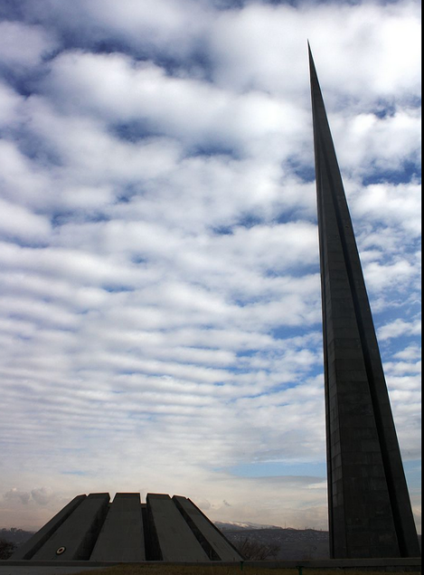
- “The Bloody Sultan”
- Abdul Hamid II
- Balkan Wars
- Committee for Union & Progress
- Enver Pasha
- Germany
- Hamidiye regiments
- millet system
- Muslims & Christians
- nationalism
- New York Times
- Ottoman Empire
- Russia
- Sarikamis
genocide memorial, Yerevan, Armenia
- WWI
- Young Turks

Misspelled answers on the video quizzes will receive zero credit. Read your answers carefully. All quizzes (reading & video) are open-note & open-handout. Print out this guide before watching the video!

