Russia’s War: The Darkness Descends (1924-1938)
[50 minutes]
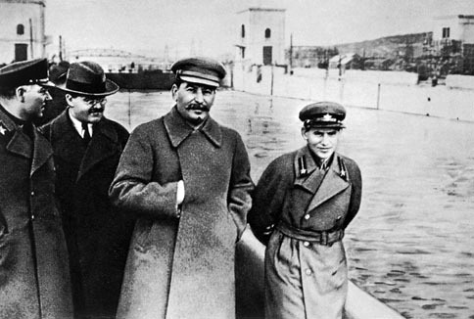
As you watch the video, take notes carefully, note the meaning/significance of the terms listed below.

Big Picture:
- What was the Soviet Union like in 1924 when Lenin died of a stroke? Lenin’s secret testament, his view of Stalin?
- What was Stalin’s personality & how was he publically received by the mid 1920s?
- Why is 1928 a watershed year in Soviet history? Start of the first Five-Year Plan/forced collectivization?
- How did the peasants react to government policies? What happened to many in specific regions (Kazakhstan, Ukraine, etc.)
- How did Stalin instill fear and wage war against his own people? Show trials, purges, famine, deportations, slave labor camps.
- How did the prison camps systems operate? Who specifically was targeted by Stalin and why?

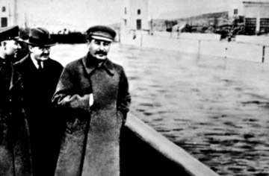
TERMS TO KNOW
Cathedral of Christ the Savior
“Congress of Victors”
GULAG
kulaks
Lubyanka
Maxim Gorky
Mikhail Tukhachevsky
Nikolai Yezhov (“Yezhovschina”)
Sergei Kirov
Sergei Shchegolkov
Shakhty trial
Solovki
STON
White Sea Canal
zeks

