Science & the Swastika: Episode I
Hitler’s Biological Soldiers
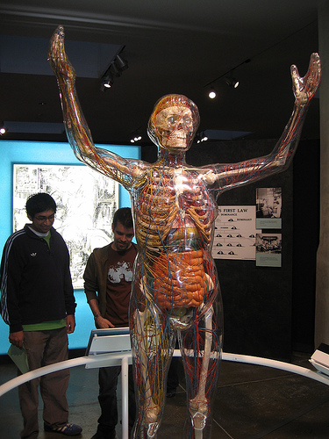
“Big Picture” Questions:
- What role did doctors & eugenics play in Germany prior to the Nazis coming to power?
- Why were the Nazis special in the way they used doctors? What role did doctors play in Nazi Germany? Specific examples
- Were German doctors & others “just following orders”? Elaborate.

IMPORTANT TERMS/CONCEPTS
Model glass woman Nazi’s favorite science: human biology
German Hygiene Museum (Dresden) biological research funding
Eugenics movement Racial Hygiene in Germany (Alfred Ploetz)
Nazis in power treatment of Jewish students, doctors, & scientists
- Anti-Semitic legislation & laws
- physicians joining the Nazi party (Erich Hässler)
- Nordic supremacy & eugenics (Alfred Ploetz)
- racial hygiene & sterilization (Ernst Rüdin)
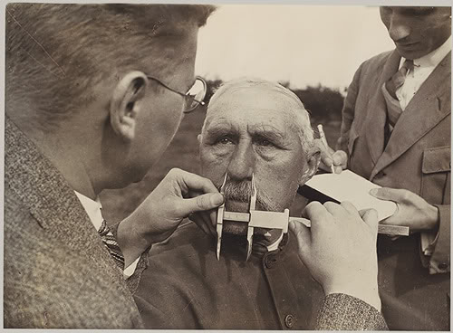
Führer school (Rudolf Hess)
- biological soldiers
- purpose/ideology
- ‘just following orders’?
Indoctrinating school children
- family trees
- Rolf Thurm
Health Courts & Sterilization
- surgeries & #s of victims

Targeting the Mentally Disabled & Others
- the path from sterilization to murder (Karl Brandt)
- murdering “lives unworthy of life”
T-4 Euthanasia Program

