Namibian Genocide [Video]: Big Picture Questions & Terms to Know

As you watch the video, take notes carefully and note the meaning & significance of the terms in the list below.

Big Picture:
- What was the broader context in which the genocide in German South West Africa took place? Imperialism, racism, eugenics, etc.
- What different forces & factors drove the Germans to kill the Herero & Nama between 1904 and 1908? What was the relationship between the German colonists, the natives, and the colonial government?
- How did events evolve from rebellion to military action to concentration camps over time? What role or responsibility did the government in Germany play in this?
- What did General von Trotha do to punish the Herero & what is the significance of the “annihilation order”?
- How did the concentration camps operate, what role did slave labor play, and how can these events be connected to Nazism directly or indirectly?

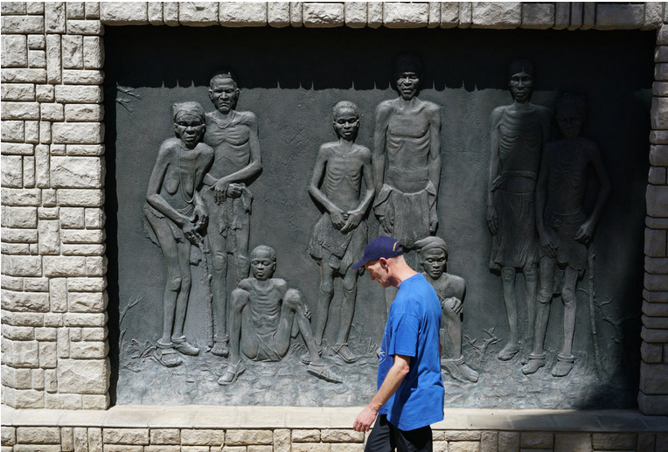
- Eugen Fischer
- Franz Ritter von Epp
Genocide memorial, Windhoek, Namibia
- Friedrich Rätzel
- Herero
- Lebensraum
- Lothar von Trotha
- Lüderitz
- Nama
- Omaheke
- Shark Island
- Swakopmund
- Theodor Leutwein
- Vernichtungskrieg
- Windhoek

Misspelled answers on the video quizzes will receive zero credit. Read your answers carefully. All quizzes (reading & video) are open-note & open-handout. It is recommended to print out this guide before watching the video.

