VOD: The Nuremberg Trials (2006)

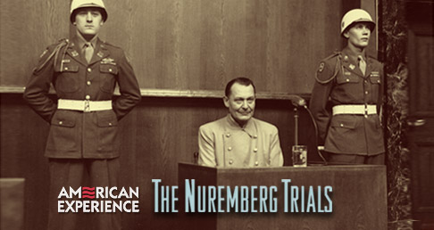
QUESTIONS:
- What were the major challenges at the Nuremberg Trials?
- Who was Robert Jackson and what role did he play?
- How did the leading Nazis defend themselves?
- What did Winston Churchill & Joseph Stalin want to do with Nazi leadership at the end of the war? How did the American politicians respond? [e.g., Morgenthau, Stimson, Roosevelt, Truman]
- What arguments were there for & against summary execution?
- How did war criminals try to hide or justify their crimes? What were they charged with?
- Explain the “you did it too” argument that was disallowed by the prosecution.
- What did Hermann Goering argue when taking the stand?
- Why were the trials located at Nuremberg?

