War of the Century (2005): Episode 2
Spiral of Terror

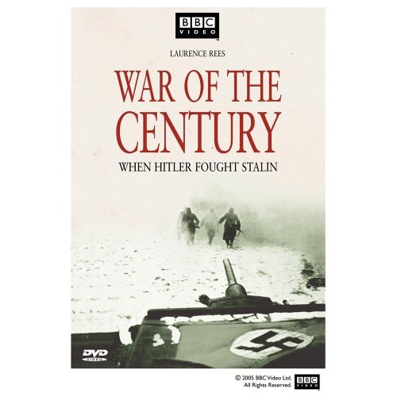
“Big Picture” Questions:
- Why did the war in the East between Germany and the USSR result in widespread destruction? What impact did this have on civilian populations (other than Jews)?
- What role did the weather have on the Eastern Front? Why did partisan warfare escalate the brutality of the war?
- Why did this war lead down the path to genocide of the Jews? How did the Nazis rule the lands they conquered? What role did the German army play in these policies?

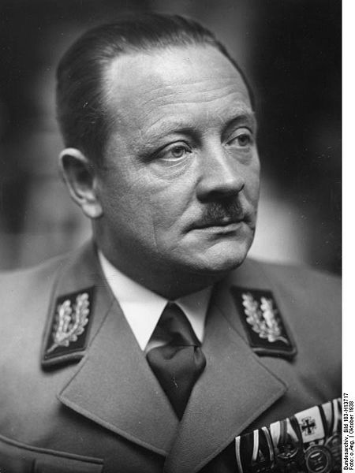
IMPORTANT TERMS/CONCEPTS
- Operation Typhoon
- “blocking detachments”
- Hitler’s response to stalled German offensive
- Battle of Moscow
- Wolf’s Lair Vinnitsa, Ukraine
- Hitler’s attitude towards conquered Soviet peoples (Germanizing Ukraine)
- Aleksey Bris (interpreter)
- Erich Koch versus Alfred Rosenberg
- German occupation of Kharkov (role of Wehrmacht)
- Partisan warfare (propaganda versus reality)
- Stalin’s “partisan order”
- German soldiers’ attitude toward their enemies
- Hitler’s response to partisan warfare
- Reinhard Gehlen’s proposal & Hitler’s response
- Anti-partisan operations (e.g., “Operation Otto”)

Why did so many innocent people die in this war?

