Wannsee Protocol (January 20, 1942)
Take careful notes as you read pages 2-10 and 14-15 of the document.

Only one copy of this document has survived (out of 30 originals), it was found in 1947 during war crimes trials in Berlin, Germany in a folder labeled “Final Solution to the Jewish question.”

- What does “the final solution to the Jewish question” mean in the context of this document? Explain.

- How does Reinhard Heydrich summarize what had been the main policy towards Jews up to October 1941? [3-5]
- What does “disadvantages of such forced emigration methods” refer to?
- How has this “forced emigration” been financed & what are the reported results of this policy?

- What does the phrase “emigration has now been replaced by evacuation to the East” mean in the broader context of the war? [5-10]
- What is the significance/meaning of the following:
- “The influence that Jews exert everywhere in the USSR is well known.” [7]
- “in the process a large number of them will undoubtedly drop out by way of natural attrition.” [7]
- “Those who ultimately should possibly get by will have to be given suitable treatment.” [8]
- “Europe will be combed through from West to East.” [8]

- What does Dr. Buhler say regarding the “final solution” in the General Government? Why is this significant? [14-15]

Conspiracy (2001): Viewing Guide

On January 20, 1942, with the tide of war turning in favor of the Allies, a small group of SS officers, government ministers, and Nazi officials met near Berlin to decide the fate of Europe's Jews. Based on the only surviving record of that meeting, Conspiracy is a powerful combination of historical reconstruction and speculation that attempts to offer new insights into a pivotal moment in history.
The cast does a marvelous job of fleshing out the documentary evidence to create convincing characters. Kenneth Branagh is especially chilling as SS Chief of Security Reinhard Heydrich, who uses a combination of charm and ruthless power-mongering to gain support for his plans. Colin Firth is fascinating as Wilhelm Stuckart, a lawyer who sees the brutal tactics of the SS as a threat to his own intellectualized anti-Semitism, and Stanley Tucci gives a wonderfully understated performance as Adolf Eichmann. [from Amazon.com]

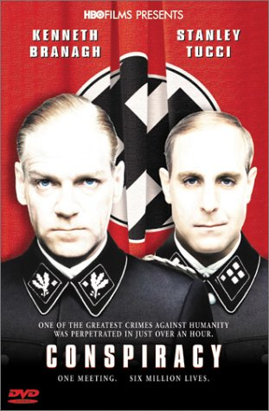
Ch. 1 Prologue [2:02 min.]
- Two hours that would change the world?
- Only one record survives?

Ch. 5 Matter at hand [5:45 min.]
- Emigration policy (even America)?
- Acquiring Poland & conquering USSR?
- Ghettoes are full?
- “This is our mandate”
- “Emigration is over”

Ch. 6 “This meeting is not taking place” [4:51 min.]
- Evacuation to the East?
- Counting Jews in Europe (how many)?
- Problems with defining Jews non-racially?

Ch. 14 A Triumphant German Vision [3:44 min.]
- Mobile gas vans permanent installations (where)?
- 2,500 per hour?
- “means of disposal”?
- “The machinery is waiting, feed it”?

