War & Remembrance (1988): Viewing Guide
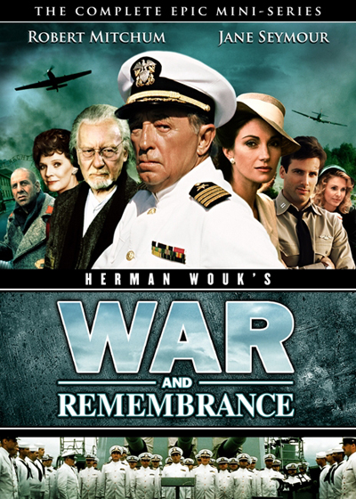
The Setting:
Where? German-occupied Poland & Soviet Union
When? ca. 1941-1944

Big Picture:
How do the scenes from the film connect to class readings, lecture, & discussion? What parts of the film clips appear to be historically accurate, be specific with details from the movie?

Selected Scenes:
Auschwitz [6 minutes]
December 18, 1941
Prisoners at the Camp [9:16 minutes]
December 25, 1941
Crematoria [18:21 minutes]
Auschwitz-Birkenau
Babi Yar [19:06 minutes]

Pay attention to details from the clips that connect to what you already know from class, readings, and documentaries.

