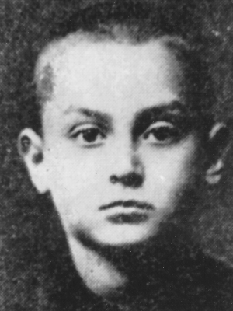
Source Reading & Analysis: Lithuania
Yitskhok Rudashevski (1927-1943)
The Diary of the Vilna Ghetto (1973)
Carefully read the excerpts from the diary, use the following to guide reading/notes. Think about how this source fits into the bigger picture of the history of Lithuania during WWII/Holocaust.
Yitskhok Rudashevski’s parents came to Vilna (Vilnius), Lithuania in 1923. Born December 10, 1927, he was an only child. His father worked as a typesetter for the Yiddish daily newspaper, Vilner Tog and his mother was a seamstress. Yitskhok was a serious student, always studying & reading, with a particular liking for literature and history. He also loved the Red Army, believing in the ultimate Soviet victory over the Nazi invaders.
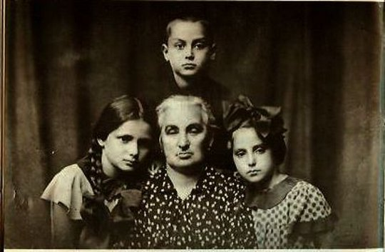
Written in a small notebook of 204 pages, the diary begins with the German invasion of June 1941. The actual diary starts in September 1942, with earlier entries summarizing past events from memory. In his last dated entry from April 7, 1943, he states: “We may have been fated for the worst.” On September 23, 1943, Yitskhok, his parents, and five others moved into a hide-out or maline in an attic space during the final liquidation of the Vilna ghetto. In early October, the Germans discovered this hide-out; his family and other survivors were taken to the headquarters of the Gestapo, and then to the infamous Ponar forest. Sometime in October 1943, Yitskhok and his family were murdered.
While being led to Ponar’s “killing field”, Sore (Sarah) Voloshin, a 14-year old cousin of Yitskhok’s (see her on the right in the photograph with their grandmother), escaped and joined the partisans in the forests. She served as a resistance “runner” delivering important papers, weapons, or whatever was needed. After six months with the partisans, Vilna was liberated in July 1944. The 15-year old girl returned to Vilna, found her family’s maline in the ghetto, and recovered her cousin’s diary. Sore Voloshin moved to Israel after the war and devoted her life to Yad Vashem, Israel’s Holocaust remembrance museum and research center. Yitskhok Rudashevski’s diary was published in Hebrew translation (1968) and English translation (1973) in Israel.
Terms & Questions to consider as you read:
EXCERPT ONE: September to December, 1941 [pp. 34-48]
What is the significance of the following, according to Yitskhok [read carefully]?
- Jewish policemen, Lithuanians, Germans
- working certificates (white, yellow, pink)
- maline
- Ponar Forest, Lukishki Prison
What do the ghetto’s inhabitants argue over & what happens as workers return to the ghetto after work?
What happened in the second ghetto, as described by Yitskhok?
What is Yitskhok’s description of the ghetto after it had been attacked & what happened to those taken from the ghetto?
What is the meaning or significance of the following phrases in the diary?
- “Today it is Yom Kippur”
- “Ponar is the same as a nightmare”
- “we are again packing bundles”
- “free labor for the exploiters”
- “I feel we are like sheep”

EXCERPT TWO: March to October, 1942 [pp. 49-67]
How does Yitskhok describe Rosh Hashanah, and why is it significant?
- poster on the ghetto gate
- “poverty has been scrubbed away”
- Ghetto News
- “we owe our existence solely to our work”
What is Yitskhok’s attitude toward school & what information is he getting about the war in the East?
- Soviet offensives
- Battle of Stalingrad
- secret radio
What is the role of the brigadiers amongst the ghetto workers?
- “a kind of caste, a class”
- Levas
- “everything in the ghetto depends on the gate”
- “brother was forced to beat brother…”
What is Yitskhok’s reaction to the High Holy day of Yom Kippur (Sept. 20, 1942)?
- “the ghetto is drenched in tears”
- Ninth of November (book)
- Yitskhok’s illness & the death of his favorite teacher
How does Yitskhok describe the behavior of the Lithuanians towards the Jews in the ghetto?
What is significant about the memorial service for the teacher Gershteyn?

