Birth of the Nazi Party [NSDAP]: Read each primary source excerpt carefully. Match it with the correct author, date, & description. Write on a separate sheet of paper. If you read carefully, these are NOT difficult.

- The Jewish question is not just an internal German matter that is more important to one person and less important to the other. It is at present the most important issue for the Western world.
- Two of our company units….were so surprised by the deluge that the men in the trench barely had time to grab their guns and equipment and to rescue themselves on the rampart. They clung there and cowered, a mire before them and a raging stream behind them, many of them exposed without protection to the open view of the enemy.
- I like and value Hitler, but his striving for total power concerns me. It’s going to come to a bad end if he doesn’t change his ways and allow others to share power. We have to keep in mind that violence and cronyism scare away the best comrades and cripple the best forces, and in doing so empowers the less desirable elements.
- By the winter of 1915-1916, this inner struggle had for me been decided. At last my will was undisputed master. If in the first days I went over the top with rejoicing and laughter, I was now calm and determined. The young volunteer had become an old soldier. And this transformation had occurred in the whole army.
- We Americans must realize that the altruistic ideals which have controlled our social development during the past century, and the maudlin sentimentalism that has made America “an asylum for the oppressed,” are sweeping the nation toward a racial abyss.
- By anti-Semite one means all those who recognize the destructive Jewish influence on the life of our people, who fight against it and who protect themselves from the economic strangulation by the Jews!.. From the moment that I recognized the true enemy of all workers, there was no stopping me. With the great love that I felt for my fatherland I set myself the task to use every means at my disposal to help to open the eyes of those poor misled souls to the true enemy.
- Crumbling walls of earth, crushed sandbags, scattered debris, stretches of barbed wire twisted and broken: Filthy remnants litter the ground, shreds of uniforms, bloody rags, socks, canteens, fragments of French newspapers, torn pages from English magazines, ration cans, empty cartridges, unspent ammunition… When you arrive at the villages, they are pathetic and ruined, houses gutted by bombs, farmed burned, walls riddled with bullet holes. A hopeless landscape!
- Eckart: “Luther expressed his opinion of it plainly enough. He urges us to burn the synagogues and Jewish schools and to heap earth on the remains so that no man would ever again see one stone or cinder of them.” Hitler: “Burning their synagogues, I am afraid, would have been of damn little avail. The fact of the matter is: even if there had never been a synagogue, never a Jewish school, never an Old Testament, and never a Talmud, the Jewish spirit would still have been there and had its effect.”
- There is today one State in which at least weak beginnings toward a better conception are noticeable. Of course, it is not our model German Republic, but the American Union, in which an effort is made to consult reason at least partially. By refusing immigration on principle to elements in poor health, by simply excluding certain races from nationalization, it professes in slow beginnings a view which is peculiar to the folkish state concept.
- Despite their desire to be placed on equal terms with Germans, the Jews continually emphasize their foreignness in the most obvious manner through the style of their synagogues…. Each and every irksome Jew is a serious affront to the authenticity and veracity of our German identity… Jews will remain Jews.

Match the correct primary source quotations on the front of the handout with the accompanying descriptions and writers below.
- Describes the harrowing conditions during a rainstorm in a history of the German company that Hitler served in during the Great War. [Fridolin Solleder, Vier Jahre Westfront: Geschichte des Regiments List, RIR 16 (Munich, 1932)]
- American lawyer and eugenicist asserts that immigrants are not good for the racial future of the United States. [Madison Grant, The Passing of the Great Race; or, the Racial Basis of European History (New York, 1916)]
- A German soldier graphically describes the conditions of warfare on the Western Front [Max Osborn, Drei Strassen des Krieges (Berlin, 1916)]
- Adolf Hitler praises restrictions on immigration in the United States as positive steps that, by implication, also need to be enacted in the Weimar Republic [Mein Kampf (vol. I, 1925)]
- One of the founding fathers of German anti-Semitism, also a biblical scholar & scholar of oriental languages, complains about the foreign nature of Jewish architecture and how the presence of Jews is an insult to true German identity [Paul de Lagarde, Deutsche Schriften (Munich, 1934, originally published 1878)]
- A fictional dialogue written by one of Hitler’s closest friends refers to the Protestant reformer’s pamphlet against the Jews published in 1542. [Dietrich Eckart, Der Boschewismus von Moses bis Lenin: Ein Zweigespräch zwischen Adolf Hitler und mir (Munich, 1924)]
- Founder of the German Workers’ Party or Deutsche Arbeiterpartei (DAP) and Hitler’s early mentor explains why Jews are the ultimate enemy and why other Germans must be brought to realize this fundamental truth. [Anton Drexler, Mein politisches Erwachen (Munich, 1919)]
- An early Nazi associate fears Hitler’s rigid approach to politics requires that he make compromises and be willing to share power [Gottfried Grandel writing to Dietrich Eckart (August 1921)]
- A German philosophy professor proclaims that the issue of the Judenfrage or “Jewish question” is important for everyone in the Western world. [Otto Dickel, Auferstehung des Abendlandes (Augsburg, 1921)]
- Adolf Hitler describes the transformative nature of his service during WWI on his personality and on the entire German army [Mein Kampf (vol. I, 1925)]
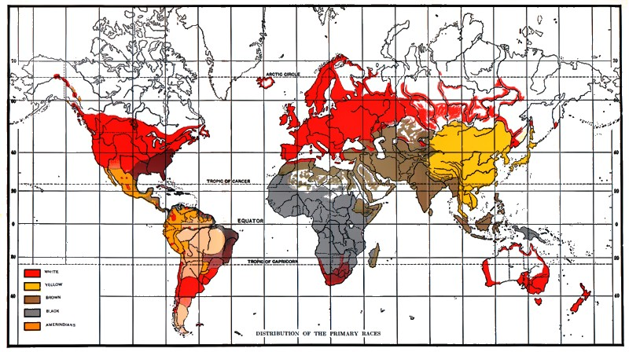
Race map from Lothrop Stoddard, The Rising Tide of Color Against White World-Supremacy (New York, 1920)

