Primary Sources: Fighting to the End, Death Marches, & Liberation: Read each excerpt carefully. Match it with the correct author, date, & description. Write on a separate sheet of paper [10 points].

- One morning there was suddenly an unusual noise, and the SS roused the dying women, who were sleeping, worn out from their labors, with unprecedented sadism. Within minutes we were standing ready in lines of five, each of us was given a loaf of bread, which the starving women ate immediately… we wrapped our feet in newspapers before shoving them into our heavy wooden clogs so that we would be warmer on the road, which was covered in a thick, slippery layer of snow. None of us knew what lay ahead.
- We were in the hospital. Our things were in the bunker and we see on the street in front of the lager there go crowds of SS men, soldiers are marching, automobiles, tanks at high speed, and there walk Polish people and Reichs-Germans and Volks-Germans with wagons, and they transport their clothes and move on. We see that something was in the offing. That liberty is coming for us.
- At first we didn’t see what happened to comrades who lay exhausted at the roadside… On the third day of the march we saw the first signs of what had happened where earlier marches had used these streets: we could see the corpses of those left behind, killed with a shot to the neck, lying in graves right next to people’s homes on the street and covered only with a few handfuls of earth or else uncovered.
- We have similar reports of atrocities from the eastern territories. They are truly horrifying. They cannot be repeated in detail… In certain towns and villages all women between the age of 10 and 70 were raped innumerable times. This seems to have been done on orders from above…
- The defenders of Stalingrad have now reached Treblinka; from the Volga to the Vistula turned out to be no distance at all. And now the very earth of Treblinka refuses to be an accomplice to the crimes the monsters committed. It is casting up everything that Hitler’s people tried to bury within it.
- It is doubtful whether history has ever witnessed a mass movement of people to compare with the hasty and disorganized trek of millions now taking place in Eastern Germany. As invariably happens in refugee movements, the people affected are primarily women, children, old people and invalids, although even the Germans admit that a large number of able-bodied men, who should be remaining in their factories or fighting with the Volkssturm, having joined the trek.
- Visiting these soup kitchens and the poor Jewish neighborhoods in Iasi can traumatize ever a person who has already seen penury and hardship and was prepared for horrible sights. Anyone who saw these living dead, the exhausted old men and women, and people aged 40-something with dimmed eyes, the pale children, with swollen bellies and covered with boils, who walk around almost naked even in the autumn chill, the ‘houses’ in which these unfortunates live in unimaginable overcrowding—would never be able to forget what he saw.
- And then the march began, and in order to compare it somehow, anyone who has seen the film about the 1812 Russian-French war, and the scenes of the retreat of the French from Moscow, the snow-covered soldiers, the soldiers with crystals of ices on their lips, on their moustaches, soldiers without head coverings and with a layer of snow, and soldiers retreating with torn boots and toes protruding from the torn leather, soldiers who collapsed out of weakness, starvation—it was nothing compared to the hell of the retreat, of the death march.
- The Chopin Warehouse was like a vast, five-storey department store, part of the grandiose Maidanek Murder Factory. Here the possessions of hundreds of thousands of murdered people were sorted and classified and packed for export to Germany. In one big room there were thousands of trunks and suitcases, some still with carefully written-out labels… here were thousands of pairs of shoes, all of much better quality than those seen in the big dump near the camp. Then there was a long corridor with thousands of women’s dresses, and another with thousands of overcoats.
- In a brick barracks we found several female prisoners, two or more to a bunk. Was it really the third day after liberation? Had time stopped for these women—had nothing changed for them?... They had difficulty moving; it seemed as though every movement was carefully thought out and assessed. Their expressionless, mostly cold eyes aroused shame in us. Had they used up all their joy and enthusiasm on the first day, when all the prisoners rushed into the arms of the Soviet soldiers?

Match the correct primary source quotations above with the descriptions & writers below.
- Red Army journalist Vasily Grossman gives one of the earliest accounts of Treblinka based on interviews of some of this death camp’s very few survivors (“The Hell of Treblinka,” fall 1944).
- Polish doctor Tadeusz Chowaniec arrived at Auschwitz only three days after it had been liberated by the Red Army. In this excerpt the doctor describes the desperate hopelessness he felt from the few women survivors he saw there. (winter 1945)
- Auschwitz survivor Georg Kaldore describes the chaotic conditions and the sense that the war almost over and the few survivors would soon be liberated (interview by psychologist, David P. Boder, August 31, 1946). Boder was the first person to record interviews of Holocaust survivors.
- British journalist Alexander Werth, who was travelling with the Red Army, describes the mountains of personal belongings discovered at the Majdanek extermination center in August 1944. The BBC refused to use Werth’s report, deeming it ‘unbelievable’ as Soviet propaganda. It was only printed after the war (Russia at War, 1941-1945, 1964).
- Auschwitz survivor Yitzhak Peri compares conditions of the death march to that of the Napoleonic armies from Russia in the early 19th century (Yitzhak Peri, Yad Vashem Archives, April 25, 1994).
- This excerpt from a U. S. Army Intelligence report describes the variety of refugees toward the end of the war with entire populations on the move (“Evacuation, Refugees and Displaced Persons in Germany,” February 10, 1945).
- Nazi Propaganda Minister, Josef Goebbels reports stories of the Red Army and their mass rape of women of all ages in the final months of the war (Goebbels’ diary, March 1, 1945).
- Excerpt from a survivor memoir by Katerina (Bloch) Feuer explains the unexpected exodus from Auschwitz for herself and other starving/dying women. She stresses the sense of having no idea what was going to happen next (“Diary Nearly Fifty Years Later” ca. 1995)
- Jewish refugees headed for Romania after the war believing it would be easier to each Palestine or other countries from there. This account describes the horrible post-war conditions for refugees in Iasi (summer 1947).
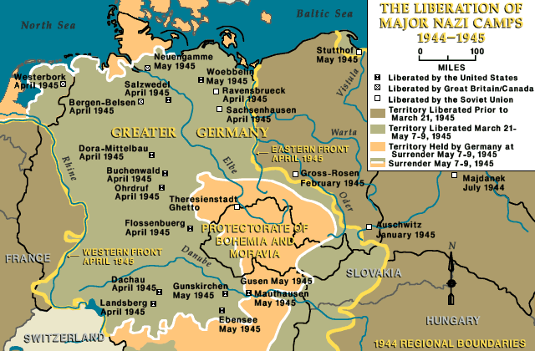
- Interned as Communist, Andre Grevenrath wrote about his experiences (in the 1960s) at Sachsenhausen concentration camp and of the death marches. In this excerpt, he describes a growing awareness of being surrounded by death as bodies piled up during the course of their forced march.

