“Columbus - Hero or Villain?”
from History Today, May 1992 (42): 4-9
By Felipe Fernández-Armesto
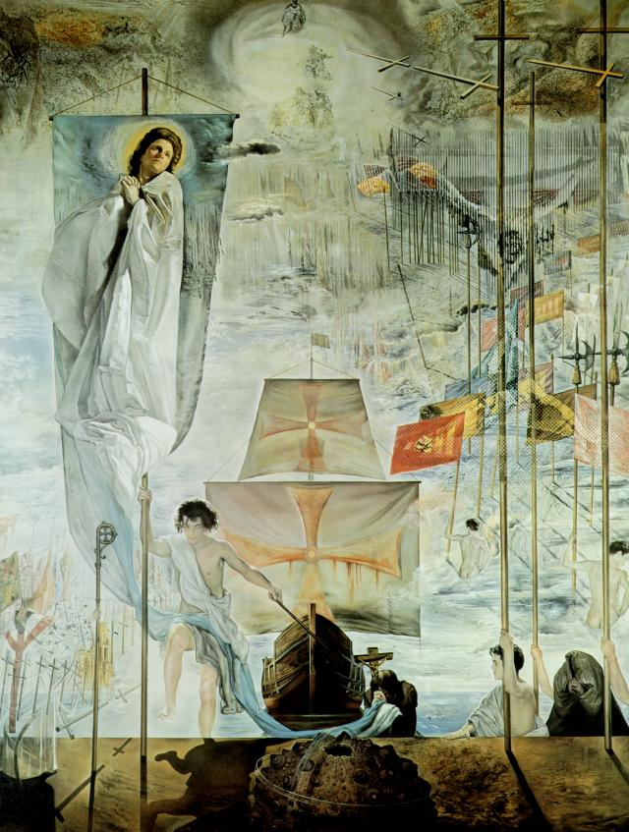
This year, his statue in Barcelona exchanged symbolic rings with the Statue of Liberty in New York; meanwhile, the descendants of slaves and peons will burn his effigy. In a dream-painting [from 1958-59] by Salvador Dali, Columbus takes a great step for mankind, toga-clad and cross-bearing—while a sail in the middle distance drips with blood. The Columbus of tradition shares a single canvas with the Columbus of fashion, the culture-hero of the western world with the bogey who exploited his fellow-man and despoiled his environment. Both versions are false and, if historians had their way, the quincentennial celebrations ought to stimulate enough educational work and research to destroy them . . .
It is commonly said that the traditional Columbus myth—which awards him personal credit for anything good that ever came out of America since 1492--originated in the War of Independence, when the founding fathers, in search of an American hero, pitched on the Genoese weaver as the improbable progenitor of all-American virtues. Joel Barlow’s poem, The Vision of Columbus, appeared in 1787. Columbus remained a model for nineteenth-century Americans, engaged in a project for taming their own wilderness. Washington Irving’s perniciously influential History of the Life and Voyages of Christopher Columbus of 1828--which spread a lot of nonsense including the ever-popular folly that Columbus was derided for claiming that the world was round—appealed unashamedly to Americans’ self-image as promoters of civilisation.
Yet aspects of the myth are much older—traceable to Columbus’ own times and, to a large extent, to his own efforts . . . The image he projected was that of a providential agent, the divinely-elected ‘messenger of a new heaven’, chosen to bear the light of the gospel to unevangelised recesses of the earth—the parts which other explorers could not reach. His plan for an Atlantic crossing ‘God revealed to me by His manifest hand’. Playing on his Christian name, he called himself ‘Christo ferens’ and compiled a book of what he said were biblical prophecies of his own discoveries. Enough contemporaries were convinced by his gigantic self-esteem for him to become literally a legend in his own lifetime . . . To a humanist from Italy who taught the would-be Renaissance men of Castile, he was ‘the sort of whom the ancients made gods’.
From his last years, his reputation dipped: writers were obliged to belittle him in the service of monarchs who were locked in legal conflict with Columbus’ family over the level of reward he had earned. Yet his own self-perception was passed on to posterity by influential early books. Bartolome de Las Casas—Columbus’ editor and historian—professed a major role for himself in the apostolate of the New World and heartily endorsed Columbus’ self-evaluation as an agent of God’s purpose . . .
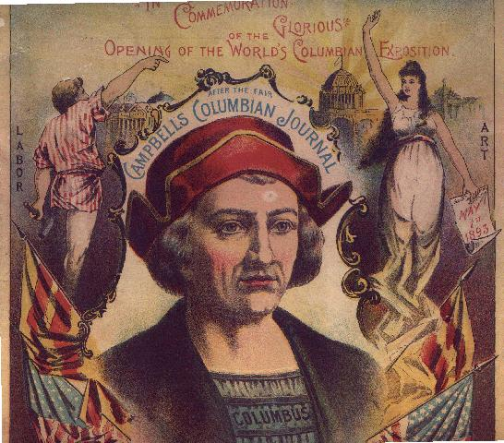
. . . Demonstrably false was the second element in Columbus’ self-made myth: his image of tenacity in adversity . . . This theme has echoed through the historical tradition. That ‘they all laughed at Christopher Columbus’ has been confirmed by modern doggerel. Vast books have been wasted in an attempt to explain his mythical perseverance by ascribing to him ‘secret’ foreknowledge of the existence of America. Yet almost all the evidence which underlies it comes straight out of Columbus’ own propaganda, according to which he was isolated, ignored, victimised and persecuted . . . then, after fulfilling his destiny . . .
These passages of autobiography cannot be confirmed by the facts. The documented length of his quest for patronage was less than five years. Throughout that time he built up a powerful lobby of moral supporters at the Castilian court and financial backers in the business community of Seville. His own protestations of loneliness are usually qualified by an admission that he was unsupported ‘save for’ one or two individuals. When added together, these form an impressive cohort, which includes at least two archbishops, one court astrologer, two royal confessors, one royal treasurer and the queen herself. In his second supposed period of persecution, he was an honoured figure, loaded with titles, received at court, consulted by the crown and—despite his woebegone protestations of poverty—amply moneyed.
The explanation of the image of Columbus-as-victim must be sought in his character, not in his career . . . When he appeared at court in chains, or in a friar’s habit, he was playing the role of victim for all it was worth. His written lamentations—which cover many folios of memoranda, supplications and personal letters—are thick with allusions to Jeremiah and Job. . .
The most successful promotional literature is believed by its own propagators. To judge from his consistency, Columbus believed in his own image of himself. It is not surprising that most readers of his works, from Las Casas onwards, have been equally convinced. Columbus seems to have been predisposed to self-persuasion by saturation in the right literary models: saints, prophets and heroes of romance . . .
Like Columbus-the-hero, Columbus-the-villain is also an old character in a long literary tradition. Most of the denunciations of him written in his day have not survived but we can judge their tenor from surviving scraps. The usual complaints against servants of the Castilian crown in the period are made: he acted arbitrarily in the administration of justice; he exceeded his powers in enforcing his authority; he usurped royal rights by denying appeal to condemned rebels; he alienated crown property without authorisation; he deprived privileged colonists of offices or perquisites; he favoured his own family or friends; he lined his pockets at public expense . . .
Other allegations attacked his competence rather than his good faith, generally with justice. It was true, for instance, that he had selected an unhealthy and inconvenient site for the settlement of Hispaniola; that he had disastrously misjudged the natives’ intentions in supposing them to be peaceful; and that his proceedings had so far alienated so many colonists that by the time of his removal in 1500 it was a missionary’s opinion that the colony would never be at peace if he were allowed back. All these complaints reflect the priorities of Spaniards and the interests of the colonists and of the crown. There were, however, some charges against Columbus which anticipated the objections of modern detractors, who scrutinise his record from the natives’ point of view, or who look at it from the perspective of fashionably ecological priorities.
First, there was the issue of Columbus’ activities as a slaver. Coming from a Genoese background, Columbus never understood Spanish scruples about slavery, which had been characterised as an unnatural estate in the most influential medieval Spanish law-code, and which the monarchs distrusted as a form of intermediate lordship that reserved subjects from royal jurisdiction. Castilian practice was, perhaps, the most fastidious in Christendom. The propriety of slavery was acknowledged in the cases of captives of just war and offenders against natural law; but such cases were reviewed with rigour and in the royal courts, at least, decision-making tended to be biased in favour of the alleged slaves. . .
Although the ferocious Caribs of the Lesser Antilles were generally deemed to be lawful victims of enslavement (since the cannibalism imputed to them seemed an obvious offence against natural law) Columbus’ trade was chiefly in Arawaks, who, by his own account, were rendered exempt by their amenability to evangelisation. By denying that the Arawaks were idolatrous, Columbus exonerated them of the one possible charge which might, in the terms of the time, be considered an ‘unnatural’ offence. Even when the monarchs reproved him and freed the Arawaks he sold, Columbus was astonishingly slow on the uptake. In a colony where the yield of other profitable products was disappointing, he traded slaves to allay the colony’s grievous problems of supply. ‘And although at present they die on shipment,’ he continued, ‘this will not always be the case, for the Negroes and Canary Islanders reacted in the same way at first’. In one respect, contemporary criticisms of the traffic differed from those made today. The friars and bureaucrats who denounced Columbus for it did so not because it was immoral, but because it was unlawful.
Slavery was only one among many ills which Columbus was said to have inflicted on the natives. The current myth incriminates him with ‘genocide’. In the opinion of one . . . Native American spokesman, ‘he makes Hitler look like a juvenile delinquent’. This sort of hype is doubly unhelpful: demonstrably false, it makes the horrors of the holocaust seem precedented and gives comfort to Nazi apologists by making ‘genocide’ an unshocking commonplace. Though he was often callous and usually incompetent in formulating indigenist policy, the destruction of the natives was as far removed from Columbus’ thoughts as from his interests. The Indians, he acknowledged, were ‘the wealth of this land’. Their conservation was an inescapable part of any rational policy for their exploitation. Without them the colony would have no labour resources. At a deeper level of Columbus’ personal concerns, they were the great glory of his discovery: their evangelisation justified it and demonstrated its place in God’s plans for the world, even if the material yield was disappointing to his patrons and backers. And Columbus had enough sense to realise that a large and contented native population was, as the monarchs said, their ‘chief desire’ for his colony. ‘The principal thing which you must do,’ he wrote to his first deputy,
is to take much care of the Indians, that no ill nor harm may be done them, nor anything taken from them against their will, but rather that they be honoured and feel secure and so should have no cause to rebel.
Though no contemporary was so foolish as to accuse Columbus of wilfully exterminating Indians, it was widely realised that his injunctions were often honoured in the breach and that his own administrative regulations sometimes caused the natives harm. The missionaries almost unanimously regarded him as an obstacle to their work, though the only specific crime against the natives to survive among their memoranda—that ‘he took their women and all their property’—is otherwise undocumented. The imposition of forced labour and of unrealistic levels of tribute were disastrous policies, which diverted manpower from food-growing and intensified the ‘culture-shock’ under which indigenous society reeled and tottered, though Columbus claimed they were expedients to which he was driven by economic necessity. . . Columbus’ treatment of the Indians inflicted catastrophe on them rather by mistakes than by crimes. In general, he was reluctant to chastise them—refusing, for instance, to take punitive measures over the massacre of the first garrison of Hispaniola; and he tried to take seriously the monarchs’ rather impractical command to ‘win them by love’.
It would be absurd to look for environmental sensitivity of a late twentieth-century kind in Columbus’ earliest critics. Yet the accusation of over-exploitation of the New World environment, which is at the heart of the current, ecologically-conscious anti-Columbus mood, was also made before the fifteenth century was quite over. According to the first missionaries, members of Columbus’ family were ‘robbing and destroying the land’ in their greed for gold . . .
. . . The modifications [to the environment] made by Columbus and his successors were intended, from their point of view, to improve, not to destroy. They introduced sources of protein—like livestock; comforts of home—like wheat really disastrous is hard to judge dispassionately. The loss of population in the early colonial period was probably due to other causes. In the long run, colonial Hispaniola proved able to maintain a large population and a spectacular material culture.
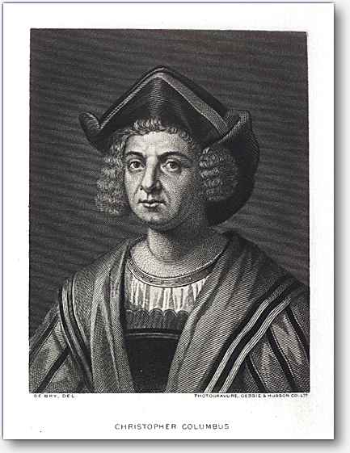
Since it was first broached in Columbus’ day, the debate about the morality of the colonisation of the New World has had three intense periods: in the sixteenth century, when the issues of the justice of the Spanish presence and the iniquity of maltreatment of the natives were raised by religious critics and foreign opportunists; in the late eighteenth century, when Rousseau and Dr Johnson agreed in preferring the uncorrupted wilderness which was thought to have preceded colonisation; and in our own day. Until recently, Columbus managed largely to avoid implication in the sins of his successors. Las Casas revered him, and pitied, rather than censured, the imperfections of his attitude to the natives. Eighteenth-century sentimentalists regretted the colonial experience as a whole, generally without blaming Columbus for it. This was fair enough. Columbus’ own model of colonial society seems to have derived from Genoese precedents: the trading factory, merchant quarter and family firm. The idea of a ‘total’ colony, with a population and environment revolutionised by the impact and image of the metropolis, seems to have been imposed on him by his Castilian masters. In making him personally responsible for everything which followed . . . his modern critics have followed a convention inaugurated by admirers, who credited Columbus with much that was nothing to do with him—including, most absurdly of all—the culture of the present United States. Columbus never touched what was to become US territory except in Puerto Rico and the Virgin Islands. The values which define the ‘American ideal’—personal liberty, individualism, freedom of conscience, equality of opportunity and representative democracy—would have meant nothing to him.
Columbus deserves the credit or blame only for what he actually did: which was to discover a route that permanently linked the shores of the Atlantic and to contribute—more signally, perhaps, than any other individual—to the long process by which once sundered peoples of the world were brought together in a single network of communications, which exposed them to the perils and benefits of mutual contagion and exchange. Whether or not one regards this as meritorious achievement, there was a genuine touch of heroism in it—both in the scale of its effects and in the boldness which inspired it. There had been many attempts to cross the Atlantic in central latitudes, but all—as far as we know—failed because the explorers clung to the zone of westerly winds in an attempt to secure a passage home. Columbus was the first to succeed precisely because he had the courage to sail with the wind at his back.
. . . A great part of the historian’s art is now held to consist in what the examiners call ‘empathy’—the ability to see the past with the eyes, and to re-construct the feelings, of those who took part in it. If value judgments are made at all, they ought at least to be controlled by certain essential disciplines. First, they must be consistent with the facts: it is unhelpful to accuse of ‘genocide’, for instance, a colonial administrator who was anxious for the preservation of the native labour force. Secondly, they should be made in the context of the value-system of the society scrutinised, at the time concerned. It would be impertinent to expect Columbus to regard slavery as immoral, or to uphold the equality of all peoples . . . Thirdly, moral judgments should be expressed in language tempered by respect for the proper meanings of words. Loose talk of ‘genocide’ twists a spiral to verbal hype. Useful distinctions are obliterated; our awareness of the real cases, when they occur, is dulled.
Finally, when we presume to judge someone from a long time ago, we should take into account the practical constraints under which they had to operate, and the limited mental horizons by which they were enclosed. Columbus was in some ways a man of extraordinary vision with a defiant attitude to the art of the possible. Yet he could not anticipate the consequences of his discovery or of the colonial enterprise confided to him. Five hundred years further on, with all our advantages of hindsight, we can only boast a handful of ‘successful’ colonial experiments—in the United States, Siberia, Australia and New Zealand—in all of which the indigenous populations have been exterminated or swamped. The Spanish empire founded by Columbus was strictly unprecedented and, in crucial respects, has never been parallelled. The problems of regulating such vast dominions, with so many inhabitants, so far away, and with so few resources, were unforeseeable and proved unmanageable. Never had so many people been conquered by culture-shock or their immune-systems invaded by irresistible disease. Never before had such a challenging environment been so suddenly transformed in an alien image. In these circumstances, it would be unreasonable to expect Columbus’ creation to work well. Like Dr Johnson’s dog, it deserves some applause for having performed at all.
So which was Columbus: hero or villain? The answer is that he was neither but has become both. The real Columbus was a mixture of virtues and vices like the rest of us, not conspicuously good or just, but generally well-intentioned, who grappled creditably with intractable problems. Heroism and villainy are not, however, objective qualities. They exist only in the eye of the beholder.
In images of Columbus, they are now firmly impressed on the retinas of the upholders of rival legends and will never be expunged. Myths are versions of the past which people believe in for irrational motives—usually because they feel good or find their prejudices confirmed. To liberal or ecologically-conscious intellectuals, for instance, who treasure their feelings of superiority over their predecessors, moral indignation with Columbus is too precious to discard. Kinship with a culture-hero is too profound a part of many Americans’ sense of identity to be easily excised.
Thus Columbus-the-hero and Columbus-the-villain live on, mutually sustained by the passion which continuing controversy imparts to their supporters. No argument can dispel them, however convincing, no evidence, however compelling. They have eclipsed the real Columbus and, judged by their effects, have outstripped him in importance. For one of the sad lessons historians learn is that history is influenced less by the facts as they happen than by the falsehoods men believe.
- Summarize the author’s most important points regarding the way Columbus is remembered today [5-6 sentences maximum]. What is the author’s thesis?
- In your own words, evaluate & analyze the following statements: “If anything, the views of Columbus as a hero or a villain demonstrate that history is all personal opinion. Therefore, any history is just as true as any other history.”

