Europe: Age of Nationalism

**HIS-124-CRF02 (0255055), 3 credits, 45 contact hours**

**Spring 2016, MWF 10:10-11:05 am, BH303**

**Dr. Robinson Yost**

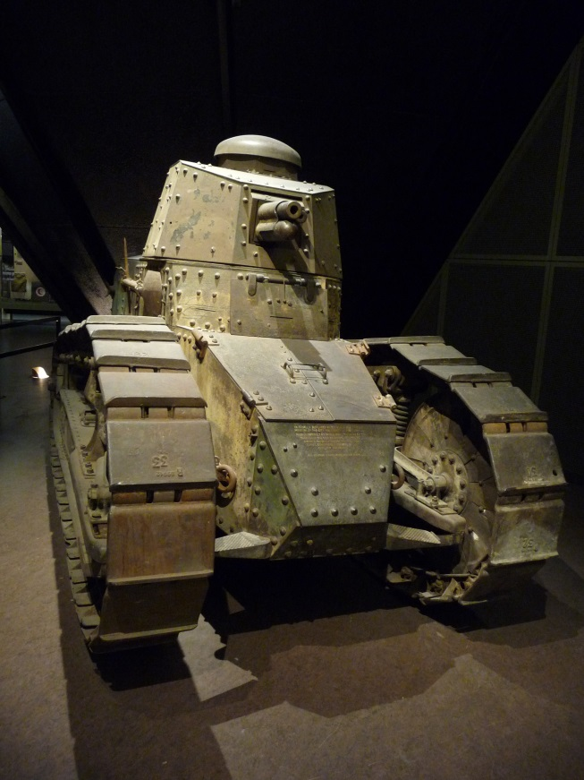

Renault FT17 French tank (1918), Kansas City, Missouri [[National World War I Museum](http://theworldwar.org/)]

**Official Course Description:**

Examines themes of modern European civilization. Emphasis is on the development of nationalism, the rise of Communism and Fascism, and the changes in the present society.

**Pre-requisites:**

There are no official pre-requisites for this course. However, it is **highly recommended** that you have experience doing structured writing assignments to perform well in the class. What you lack in writing skills you may have to work on via private tutoring (2071 Cedar Hall) or in the [Writing Center](http://www.kirkwood.edu/site/index.php?p=17584) (3067 Cedar Hall). You can always ask me questions as well. Be sure to get help early if needed.

**Introduction:**

What is history? Why should we study it? Who cares? It is nothing but dead people anyway, right? Or is it much more?

This course, while grappling with these broader questions, will trace the influence of nationalism in European history from the mid-19th c. into recent times. We will examine pivotal historical events such as the unification of Germany, New Imperialism, World Wars, Cold War, & collapse of the Soviet Union. Above all, we will emphasize the importance of history as a series of debates about **what happened** and **why it happened**.

First and foremost, history requires interpreting many different sources (primary & secondary) to reconstruct an explanation of the past. The study of history **requires READING** and lots of it. **Regular READING CANNOT be avoided in a history course**. In the quest to reconstruct the past, historians also examine non-written materials such as paintings, engravings, tools, weapons, scientific instruments, architecture, or cartoons.

Because historians are human beings the study of history always involves different levels of **interpretation**. It is never simply: "**Just Facts**." Nonetheless, responsible historians seek to reach plausible or probable conclusions based upon the best available **evidence**. Because history is guided by **evidence** (or sources), it is not: "**Just Opinion**." Studying history means **connecting facts** (not memorizing names, dates, etc.) and **interpreting** evidence in a bigger picture or **historical context**.

**General purposes of this course [Learning Objectives]**

* **Demonstrate** **broad knowledge** of key historical events, people, ideas, and other factors that have shaped diverse civilizations in Europe: Age of Nationalism.
* **Interpret** various primary sources within the historical context of the period.
* **Analyze** and evaluate secondary sources written about the period and identify approaches to history interpretation through critical reading
* **Construct historical arguments** based on sources relevant to Europe: Age of Nationalism.
* Show understanding of the **lasting impact** of Europe: Age of Nationalism on later periods including the present.

**Contact Information:**

● Office: [Cedar Hall](http://www.kirkwood.cc.ia.us/locations/crmain/index.html), Social Sciences, Office 1029

● Phone: 398-5899 ext. 5210

● E-mail: yosthistory@yahoo.com

● Website: [http://www.kirkwood.edu/faculty/ryost](http://www.kirkwood.cc.ia.us/faculty/ryost)

● Office Hours: MWF 11:10-12:10 pm or by appt. NOTE: I will **not** be regularly checking e-mail on weekends or evenings. Also, information about grades cannot be given out over the phone or e-mail.

**Grades & Exams (Subject to Change):**

● First examination 100 points Feb. 17th

● Second examination 100 points March 23th

● Third examination [FINAL] 150 points May 6th, 10:10 am-12 pm

● Reading/video quizzes 200-250 points several weekly

● In-class writings/other 200-250 points daily or weekly

**THREE EXAMS** = 30-35% (approx. total grade); **EVERYTHING ELSE** = 65-70% (approx. total grade)

#### In-class exams & reading quizzes are OPEN NOTES, you may NOT use your textbooks or photocopies of the textbooks. Please take notes in your own words and remember that copying everything into a notebook is not [good note-taking](http://faculty.kirkwood.edu/ryost/hist201/Notetaking.doc). Exams will be returned within TWO WEEKS of when the exam was taken. Contact me if you do not get your exam back. It is the student’s responsibility to keep all assignments and track their own grades. Please visit me in my office with any questions about exams, quizzes, notes, grades, or ways to improve performance (I will not “re-grade” assignments or exams). You can always ask questions in writing as well any time during the semester.

**Required Course Materials [books available on Kirkwood bookstore]:**

● Hunt, Lynn., et. al., [The Making of the West: Peoples and Cultures](http://bcs.bedfordstmartins.com/hunt4e/#t_747800____)(Fourth Edition, Volume II), 2012

● Lualdi, Katherine J., *Sources of* *The Making of the West* (Fourth Edition, Volume II), 2012 [S]

● Handouts, internet readings, & videos (it is a requirement of this course to get assignments from the internet)

● TALON: regular access to TALON is a **REQUIREMENT** of this course for watching videos online, obtaining numerous readings, & keeping up with course assignments. If your home computer does not work (and the Help Desk cannot help you fix the problem), then you will need to use computers on campus to complete assignments. TALON will NOT be used for grades. **PLEASE READ THIS CAREFULLY!**

● **Exam books** (3-4 are required for exams for entire semester; these are **purchased by student** at the bookstore)

**Exam book Policy**: if a student fails to bring a exam book for an exam, he or she may either

**a) buy one for an inflated price from the instructor** or

**b) write on notebook paper & take 10 points off the score**

● An extra **copy of the textbook** is available on 2-hour reserve at the Kirkwood library main campus.

● There is also an [**accompanying website**](http://bcs.bedfordstmartins.com/hunt4e/#t_747800____) for the textbook with chapter overviews, practice exercises, etc.

NOTE: These study guides are for supplementary use. They are for study purposes only; exercises will not be graded.

**Grading Scale:**

A = 93-100% B = 83-86% C = 73-76% D = 63-66%

A- = 90-92% B- = 80-82% C- = 70-72% D- = 60-62%

B+ = 87-89% C+ = 77-79% D+ = 67-69% F = 59% or below

**NOTE: No curving in this course, bonus points will give plenty of opportunities to earn points.**

**Drop Date:** The last day to drop a course is April 22nd. The [**Academic Calendar**](http://www.kirkwood.edu/pdf/uploaded/874/15_16_academic_calendar.pdf) with all important dates is available online.

**Attendance/Make-up Exam/Late Assignment Policy: [see also** [**Student Handbook**](http://www.kirkwood.edu/handbook)**]**

Each student is expected to attend every scheduled class meeting. In the event that classes are missed due to illness, injury, or other legitimate reasons, it is the **responsibility of the student** to obtain class notes from a classmate (**NOT** the instructor); schedule makeup exams with instructor directly. **LATE ASSIGNMENTS (out of class only)** will receive **HALF CREDIT**, unless there are **valid and verifiable reasons for being late**. Contact the instructor immediately if you are unsure about what constitutes a valid excuse. **IN-CLASS ASSIGNMENTS**, including quizzes, cannot be made up owing to large amounts of bonus points available. Simply showing up every day and handing in everything does not guarantee high grades; **QUALITY counts not just quantity**. Unless arrangements have been made with the instructor **in advance**, homework submitted via e-mail will be given a zero and deleted.

Make-up exams must be scheduled and taken within **ONE WEEK** of the original exam date. To schedule a make-up a student must have a **legitimate** and **verifiable reason** (e.g., doctor's note) for missing the exam. Hence, "I was tired" or "I didn't feel well" are **NOT** valid reasons for taking a make-up exam. Scheduling makeup exams with the instructor is the **responsibility of the individual student**. Makeup exams will be taken in the [Testing Center](http://www.kirkwood.edu/testcenter) (**Cedar Hall 2055**).

[**Academic Accommodations**](http://www.kirkwood.edu/accommodations)**:** Students with specific academic and/or classroom needs may request individualized accommodations. Students wishing to request accommodations should complete an ‘Accommodation Request Form’ which is available at the Learning Services office, **2063 Cedar Hall**, or online at www.kirkwood.edu/accommodations. Students will be asked to provide documentation supporting their request. An accommodation plan must be completed each semester and given to instructors before academic accommodations will be provided.

[**Career Counseling**](http://www.kirkwood.edu/counseling) **& Services**: Free, confidential counseling services are available for Kirkwood Community College students seeking career direction, academic support and individual counseling. While college years are a time of personal growth, this time can be accompanied by accelerated change and significant challenges that often bring considerable stress. Counselors promote student emotional and intellectual well – being. Call 319-398-5540.

**[](http://www.utoronto.ca/writing/p)**[**Kirkwood Plagiarism Policy**](http://faculty.kirkwood.edu/site/index.php?p=33171)**:** Kirkwood Community College is a community of shared values, foremost of which is a strong commitment to academic integrity, honorable conduct, and respect for others.  Through the honest completion of academic work, students sustain the integrity of the college and promote a culture of civility, fairness, trust, and respect among its members.  Those who violate these standards must be held responsible.

Kirkwood students are responsible for authenticating all work in a course.  This includes but is not limited to quizzes, exams, presentations, papers, journals, and projects. For this reason, it is recommended that students engage in a verifiable working process on assignments and conduct themselves during class in a manner that does not lead to the suspicion of academic dishonesty.  Examples of Academic Dishonesty include but are not limited to: Plagiarism and Fabrication, Misrepresentation, Cheating and Facilitation, and Impeding Fair and Equal Access to the Education and Research Process.  It is the student’s responsibility to be aware of the behaviors that constitute academic dishonesty.  See here for a detailed description of this [policy](http://www.kirkwood.edu/catalog/2014-2015/cheating-and-plagiarism.htm) and the sanctions associated with it.

[**Productive Classroom Learning Environment**](http://www.kirkwood.edu/catalog/2014-2015/productive-classroom-learning-environment.htm)**:** We believe that the best learning takes place in an environment where faculty and students exhibit trust and mutual respect. In a productive learning environment, faculty and students work cooperatively, recognize and respect differences, model the values of character and citizenship, and become lifelong learners. All students, faculty, staff, service providers and visitors who are involved with any aspect of the college’s mission are members of Kirkwood’s learning community.

**Course-Specific Student Conduct Policy**: In this course, it is unacceptable to do homework during class or bring children into the classroom. See the Kirkwood Student Handbook if you are unsure about other inappropriate behaviors. The following address distracting, disrespectful, or otherwise inappropriate behaviors disrupting a productive learning environment among mature adults

* Disruptive actions include, but are not limited to, sleeping, repeated tardiness, passing notes, talking, reading textbooks during class, doing homework in class, open demonstrations of disrespect to the class, headphone/ear bud usage; repeated classroom departures (during a single class or over the course of the semester).
* When behavior is disruptive, the student may be asked to stop or leave for that class; any and all worked missed during that session CANNOT be made up. We do have the right to ask individual students to leave the classroom.
* When disruptive or disrespectful behavior continues, **10 points** will be deducted from his/her total points earned (this applies in each instance of noncompliance). For example, reading the textbook or phone use of any kind in class. Students using **cell phones** for any reason (even just checking messages or the time) will see **10 points** deducted from his/her total points earned (this will apply EVERY time). This penalty may, or may not, be announced by the instructor at the time of the infraction. Please be polite; put them away & turn them off.

.

**In-Class Writings:** You will be expected to read any assignments and take notes **BEFORE** class so that you will be able to take part intelligently in class discussions. Both lectures & discussions will assume that you have **already read the material**. There will be numerous **in-class writing assignments** [**SEE BELOW**] that make up a **significant part** of your grade and **CANNOT BE MADE UP** if you miss class (or are late) **regardless of the reason**. Over the course of the semester you will do numerous short in-class timed writings, usually based on reading assignments. **These writings will usually be evaluated in the following manner**:

* √ (check mark): shows preparation & solid understanding of material [**FULL CREDIT= 5 points**]
* √- (check minus): shows lack of preparation & lack of understanding [**HALF CREDIT= 2.5 points**]
* 0 (zero): shows little or no sign of preparation & no understanding [**NO CREDIT = 0 points**]

**Midterm Grades**: A midterm grade will be calculated and posted on EagleNet.  The midterm grade is a grade-in-progress, and will not affect your official GPA, nor will it impact financial aid. The midterm grade has three purposes: first, to communicate your academic performance; second, to provide opportunities for you to discuss your progress with your instructor; and third, to allow Kirkwood to design college-wide intervention programs that will improve student success.

**Resources for Students:** Kirkwood offers many easily accessed services to assist students, but it is up to the individual to take advantage of these resources. There’s lots of help available for those willing to take initiative (see below).

* [Facilities: Emergency/Crisis Information](http://www.kirkwood.edu/site/index.php?p=7987) Campus Security 389-1774
* [One Stop Office](http://www.kirkwood.edu/onestop) (Financial Aid, Registration, etc.)— 319-398-7600 or 1-877-386-9101
* [Advising & Transfer Center](http://www.kirkwood.edu/advising) – 108 Iowa Hall, 398-5540
* [Counseling Center](http://www.kirkwood.edu/counseling) – 108 Iowa Hall, 398-5540
* [International Programs](https://www.kirkwood.edu/international) – 1-800-332-2055
* [Learning Services](http://www.kirkwood.edu/site/index.php?t=2&d=3&p=134&s=1&c=0) – 2063 Cedar Hall, 398-5425
* [Dean of Students](http://www.kirkwood.edu/catalog/current/dean-of-students-office.htm)—108 Iowa Hall, 393-5540
* [Adult Learners](http://www.kirkwood.edu/adultnextsteps) – 398-1265
* [Testing Center](https://www.kirkwood.edu/testcenter) - 2055 Cedar Hall, 1-800-332-2055
* [Writing Center](http://www.kirkwood.edu/writingcenter) – 3067 Cedar Hall
* Computer Labs—[131 Nielsen Hall](http://www.kirkwood.edu/site/index.php?p=11282) & [122 Linn Hall](http://www.kirkwood.edu/site/index.php?p=13294)

**Drop Date**: To get the last day to drop a class, or the last day for a 50% or 100% refund, go to any of EagleNet’s search for sections screens.  You don’t even have to login if you just click EagleNet for Students and then Search for Sections.  Click [here](https://eaglenet.kirkwood.edu/production/WebAdvisor?TOKENIDX=9443580219&type=M&constituency=WBST&pid=CORE-WBST). Students dropping a class during the first two weeks of a term may receive a full or partial tuition refund for 16 week terms, for shorter courses check with Enrollment Services for total withdrawal information. .

Details of the refund schedule can be found under [Academic & Enrollment Policies](http://www.kirkwood.edu/catalog/2014-2015/academic-and-enrollment-policies.htm).

[**History/Cultures**](http://www.kirkwood.edu/catalog/current/history---cultures.htm)**:** This course meets the criteria for the History/Cultures distribution group in the Liberal Arts Program. The following outcomes apply to all courses in this distribution group.

* Students will compare and contrast one’s own cultural perspective with that of another culture
* Students to be able to discuss key/unique features of a particular cultural & historical perspective
* Apply critical thinking to broad historical, cultural, and/or geographical contexts
* Employ methodologies used by historians & cultural practitioners to study the disciplines of history and culture

## [Student Policies](http://www.kirkwood.edu/site/index.php?p=32303) (Academic & Enrollment Policies): It each student’s responsibility to be aware of the behaviors that constitute academic dishonesty.  A detailed description of this policy and the sanctions associated with it can be found online. As stated in the Student handbook: In compliance with Public Law 105-244, Kirkwood Community College makes a wide variety of general institutional information available to students.

[**FERPA Regulations**](http://www.kirkwood.edu/ferpa)**:** Due to federal privacy regulations, students CANNOT RECEIVE GRADING or ATTENDANCE information via e-mail or the phone. Otherwise, all such information has to be handled by speaking directly with the instructor. (If a student wishes to waive FERPA privileges, it will be his/her responsibility to present the instructor with a copy of signed/official paperwork ahead of time.)

If you have filled out FERPA forms that allow your grade information to be discussed without direct contact, please provide a copy to your instructor. For verification purposes, students must physically be present when they complete the paperwork. (If you are interested in filling out FERPA forms, visit or speak with someone in Enrollment Services **OR** Learning Services.

[**College-Sponsored Activities**](http://www.kirkwood.edu/catalog/current/class-attendance-and-class-attendance-policy-related-to-college-sponsored-activities.htm)**: Students** involved in activities where they are required to represent the college, i.e. college-sponsored activities, must give written notice to the faculty member at least one week in advance of the absence unless last minute schedule changes make this notice impossible. If regular season athletic schedules have been developed, student participants must present written notice of anticipated absences within the first week of the semester. Failure to provide timely written notice may result in the loss of this opportunity.

**Faculty** shall accord students the opportunity to independently make up course work or work of equal value, for the day(s) the event was scheduled and to take a scheduled exam at an alternate time. The faculty member shall determine alternate exam times and due dates for missed coursework. These assigned dates may be prior to the dates of the absence.

**Organizers** (coaches, faculty and staff) of college sponsored activities shall 1) assist students in planning class schedules to minimize the number of absences; 2) inform students of their responsibilities as described above; and 3) provide written communications to faculty announcing and verifying the need for student class absence. Written notices should be provided at the beginning of the semester if the schedule is known, or as soon as possible after the need for a student absence is determined.

* College sponsored activities (excluding practices) include such events as athletic competitions, student academic competitions and conferences, musical and drama performances, and class field trips. Questions on whether an activity is a college-sponsored event for purposes of this policy should be directed to the Vice-President of Instruction. If anticipated absences for a semester appear to be extraordinarily numerous or difficult to accommodate, a faculty member may appeal the need for the full accommodation to the VP of Instruction.

**Tentative Schedule**

The following schedule is **NOT set in stone**. Therefore, if you miss classes **you need to find out what was missed from a classmate**. Do not expect the instructor to contact you. Do not assume that we are exactly following the schedule; it is intended as a general guideline to course topics and reading assignments. Remember this is a **face-to-face class**, so I expect to see your face in class.

**Introduction: What is history? What do historians do?**

**I. Aftermath of the “Dual” Revolution: Nationalism & Imperialism Weeks 1-5**

Ch. 21 **The Industrial Revolution**, 1830-1850

Abuses & Reforms Overseas [701-702]

Ideologies & Political Movements [703-709]

Ch. 22 **Politics & Culture of the Nation-State**, 1850-1870

End of the Concert of Europe [722-729]

War & Nation Building [729-739]

Nation Building through Social Order [739-748]

The Culture of Social Order [748-754]

Ch. 23 **Empire, Industry, and Everyday Life**, 1870-1890

The New Imperialism [761-768]

The Industry of Empire [768-775]

Imperial Society & Culture [775-783]

Birth of Mass Politics [783-791]

## EXAM ONE

**II. The Great War: Origins, Slaughter, & Aftermath Weeks 5-10**

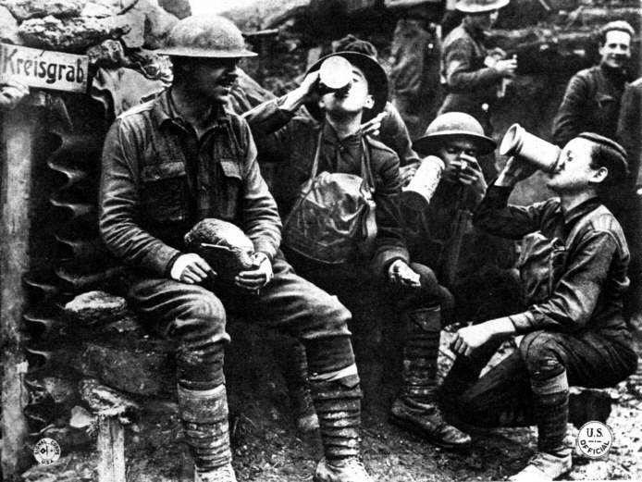Ch. 24 **Modernity & the Road to War**, c. 1890-1914

Public Debate over Private Life [798-805]

Modernity & the Revolt in Ideas [806-810]

Growing Tensions in Mass Politics [810-817]

European Imperialism Challenged [817-825]

Roads to War [825-830]

Ch. 25 **World War I and Its Aftermath**, 1914-1929

The Great War, 1914-1918 [836-845]

Protest, Revolution, & War’s End, 1917-1918 [845-851]

Search for Peace in an Era of Revolution [851-857]

A Decade of Recovery: Europe in the 1920s [857-862]

Mass Culture & the Rise of Modern Dictators [862-868]

**EXAM TWO**

**III. WWII: Origins, Slaughter, & Aftermath Weeks 10-15**

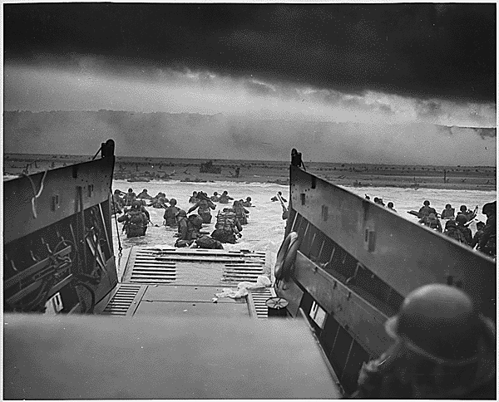Ch. 26 **The Great Depression & World War Two**, 1929-1945

Great Depression [874-878]

Totalitarian Triumph [878-885]

Democracies on the Defensive [885-889]

Road to Global War [890-896]

World War II, 1939-1945 [896-908]

Ch. 27 **The Cold War & the Remaking of Europe**, 1945-1960s

World Politics Transformed [914-922]

Political & Economic Recovery of Europe [922-930]

Decolonization in a Cold War Climate [930-936]

Daily Life & Culture in the Shadow of Nuclear War [936-944]

Ch. 28 **Postindustrial Society & the End of the Cold War Order**, 1960s-1989

Ch. 29 **Collapse of the Soviet Union & Its Aftermath** [986-994]

**EXAM THREE** **May 6th, 10:10 am -12 pm**

**"Top Dozen Most Common Irresponsible Student Attitudes & Behaviors"**

1. Just because you **didn’t pay attention**, **listen, or follow directions** (given verbally & in writing), how is that your teacher’s fault? Information given in class & the syllabus is important, whether you paid attention to it or not. “I didn’t realize” isn’t a valid excuse.
2. **Rude & demanding behavior** is not only rude & demanding (whether in class or via e-mail), but it will not to get you what you want. Respect is a two-way street, you don’t get to *demand* respect while being ***disrespectful***.
3. Don't tell your instructor as class begins that you “**Couldn't get it to work” or “Couldn’t find it**.” It’s too late, you waited too long. It doesn’t matter how many “allies” you bring over to your side either, they are *irresponsible* like you. You should have asked for help *before* class.
4. Apparently you are “**really busy**.” But so is everyone else. Good students are **just as busy** as you are, but don’t use that as an excuse. Success is about the choices you make, but so is failure.
5. Because you (or someone else) paid for school, does **NOT make you a customer**. You are a student & that comes with **responsibilities beyond paying**. Being a student is like a job, failing means you’re about to be fired unless you get your act together.
6. We get it, you *really like* **looking at your phone** every thirty seconds! Maybe you really believe that you “need” to do this, but you don’t. This won’t help you learn, and it doesn’t make you any smarter either. It’s just rude & disrespectful to everyone else.
7. **Showing up late** a couple times is not a big deal. However, when you are frequently five or more minutes late, then it’s time to reevaluate why you signed up for this class. Figure out your schedule early in the semester, and show up on time.
8. Okay, you were **absent that one time** because you got sick, but that doesn't cover the other five times you weren't in class (instructors know when you are not in class, we keep records and notice when people are missing).
9. I understand **you think it’s “unfair”** that you’re not getting what you want. But is it “fair” to everyone else if you get special breaks or extra credit? How is making exceptions for one student “fair” to everyone else?
10. Saying things like "**I have As in all my other classes**" doesn't impress, especially if you've done nothing to earn your grade in this class. In any case, what goes on in other courses is NOT relevant to this class. Corollary: “**This isn’t my major**” is a *non sequitur*.
11. Showing up after midterms to claim you're “**ready to work really hard**" fails to demonstrate genuine seriousness, especially when also you ask "Is there any extra credit?"
12. Of course **all classes** **should be fun, easy, & entertaining** because “this isn’t your major.” But meaningful learning requires hard work, frustration, even failure. If everything were fun, easy, & entertaining, then no one would learn anything.

**Just consider the above a common-sense list of what not to do as a mature, responsible college student. The list was compiled with the input of multiple teachers with decades of teaching experience at Kirkwood. Don’t be on the list!**

**What is History & How to Study It**

**What a student gets out of his education depends largely upon what he puts into it.**

**The student is not an empty vessel to be pumped full of learning . . .**

*How to Study* (1917) by George Fillmore Swain

# I. [Suggestions for Studying](http://faculty.kirkwood.edu/ryost/hist201/highschoolcollegetransition.doc)

As you study for this class, answer the following:

**1) Did I read the assignment more than once?**

**2) Did I look up words if I didn't know their meaning?**

**3) Did I study with someone else in the class?**

**4) Did I seek out additional sources in the library?**

**5) Did I take good notes and keep up with the reading assignments?**

If you find yourself answering "**Yes**" to the above, but are still having difficulties answer these:

**1) Did I ask the instructor or others for help? Why not?**

**2) Did I get assistance from** [**Kirkwood Learning Services**](http://www.kirkwood.cc.ia.us/learningservices/)**, including tutoring?**

If you find yourself answering "**No**" to all of these questions, remember this:

**You only get out of your education what you are willing to put into it.**

**II. "Just the facts, m'am." Joe Friday, *Dragnet***

History is about answering basic questions about the past**:**

1) **What** happened and **when** did it happen?

2) **Why** and **how** did it happen and **who** did it?

3) What are the **causes**? What are the **consequences**? Why is this **important**?

Although these questions may *seem* like simple factual matters, think about the following:

1) Can history be **just the facts**? How are facts generated?

2) What facts are being used? What sources do they come from?

a) Is a history book **just the facts** or is it necessarily an **interpretation of facts**?

b) What are **primary sources** and why do historians need them?

3) What are the **connections** between historical events? What does it mean to say something caused another thing to happen? Is this easy to figure out?

4) Why can't good history simply be **lists of facts** (names, dates, people, etc.)?

5) Why can't good history simply be **vague generalizations** about the past?

**III. "Who Cares? This stuff won't get me a job, why learn it?"**

If your attitude is reflected above, think about the following:

**1) Historical forces continue to shape the present.**

**2) Individuals have had an enormous impact on the past & present.**

**3) People do not behave in isolation from their times.**

**4) Events rarely have simple causes or consequences.**

**5) Our beliefs and actions today are influenced by the beliefs and actions of those in the past.**

**6) Ideas, when put into practice, have consequences.**

**Some Basics for Studying History**

It is what the pupil can do, not what the teacher can do, that counts. . . No coach ever built up a winning team by carrying the ball himself. The pupil must by active. He must carry the ball. He must ask and answer questions. He must make as well as solve problems. He must be in the game himself, if he is to learn to play the game. He must be independently productive.

He must learn to do things for himself. . . (1908)

1) **Chronology**: Some things happened before others. This concept must be grasped in order to understand history because historians deal with cause & effect relationships. Thus, dates are important.

2) **Geography**: Some things happened in certain places. Knowing where events took place is also vital to the study of history. Thus, places are important (and knowing where these places are in relation to other places).

3) **People**: Some things were caused by specific humans. Understanding the role of specific individuals in history is vital. Thus, people are important (and so is grasping the interactions between different people).

4) **Language**: Meanings of words are dependent on how and when they were used. Not everyone speaks and writes in English. And the use of English itself alters over time and in differing contexts.

5) **Interpretation**: History is BOTH **descriptive** ("What happened?") and **explanatory** ("Why did it happen?"). Historians invariably interpret collected evidence or "the facts." There are no "unbiased" histories, but there are better and worse interpretations.

6) **Evidence**: Not all historical arguments are equally plausible, valid, or true. History depends upon how well the available evidence is utilized to a support particular position. In order to be worth anything, opinions must have something to back them up.

7) **Incompleteness**: Where there is no record, there is no history. Nonetheless, there are many, many different kinds of evidence available. There is no such thing as having "all the facts." History, by its very nature, is incomplete.

8) **Complexity**: Historical causes are rarely, if ever, simple. Cause and effect are very difficult to prove, but historians must deal with these to the best of their ability. This will lead to disagreements, but that is the nature of history.

9) **Ambiguity**: History is not a crystallized body of knowledge on display in a museum or in a college textbook. It is an ongoing, complex, changing, even confusing debate over what happened, why it happened, and its significance. Do not expect clear-cut, black-and-white answers from studying history.

10) **Context**: The study of history leads to an appreciation for the ways things are and how they got that way. Things were not always as they are now. People did not always think or live in the ways they do now. An attempt to understand the many different strange, sometimes offensive ideas of the past may give better grounds for defending or modifying our own beliefs. History is about trying to understand the bigger picture or context in which particular events or beliefs arose, even when we disagree with them.

**Student Contract (Spring 2016)**

# Please READ VERY CAREFULLY. Sign & date at the bottom.

I understand the importance of **CLASS ATTENDANCE** to my grade. I recognize that in-class writing assignments (as described in the syllabus) and reading quizzes **CANNOT** be completed outside of class regardless of excuse (legitimate or illegitimate). I know the **ONLY EXCEPTIONS** to this are: college-sponsored activities, jury duty, & military service. I know the reason for this is the opportunities for **LOTS OF BONUS POINTS** throughout the semester [if I think this is unfair, I should meet immediately with the instructor to opt out of the bonus points in favor of make ups].

I understand the necessity of keeping up with **READING ASSIGNMENTS** (as mentioned in the syllabus) for my success in this course. I know that cramming the night before an exam is not a good idea; neither is reading assigned homework *during class time*. I recognize that regular reading & note-taking are expected.

I understand that when I am **ABSENT** (as discussed in the syllabus), I need to go to TALON announcements and get notes from a student not the instructor. I know that I should exchange e-mail addresses or phone numbers with several reliable classmates to get assignments if I have to miss class. It is my responsibility to keep up with missed work.

I understand what **PLAGIARISM** is (as discussed in the syllabus) and I know that plagiarized work will receive a zero. I realize that copying sentences from another source (including the textbook) is a form of plagiarism. I should write everything in my own words in this class.

I understand that there are point penalties for **DISRUPTIVE** behavior as described in the syllabus and that I am expected to complete all assignments as found on **TALON**. If I have questions, I will ask them as soon as possible.

I understand the **GRADING SCALE** and **MAKEUP EXAM** policies (as discussed in the syllabus). I will ask questions about anything I do not understand.

I know when the **LAST DAY TO DROP** the course is (as discussed in the syllabus) and I know dropping is my responsibility not the instructor’s.

I realize that there exists accompanying **STUDY GUIDES** for most of the readings. Even if I choose not to use these, I recognize their existence.

I understand when I **NEED HELP OR HAVE QUESTIONS**, I should seek it out immediately from the instructor or other available resources (as discussed in the syllabus). I realize that the instructor does not have the power to read my mind, move objects without touching them, or communicate with the dead.

Signing this contract means that I have **READ** the syllabus and the contract itself. I realize that the instructor is the first person I should approach with any problems, questions, or concerns.

**Your Name (Please Print): __________________________ Date: ______________________**

**Your Signature: ___________________________________**

**Course: __________________________________________**

**NOTE:** Each student is responsible for being familiar with the information appearing in the syllabus and contract. Failure to read these will not be considered an excuse for noncompliance. Do not sign something without reading it!

**Take-Home Survey (to be handed in next class period)**

1. **Briefly describe your experience with studying history in high school. Was it a positive or negative learning experience? Explain.**
2. **How much reading did you do in your high school history classes? Estimate by number of pages per week.**
3. **How much time spent on the following: TV, computers, video games, Facebook, Twitter, cell phone? Estimate by hours per day total.**
4. **What type of exams or tests did you have in your high school history course? How did you study or prepare for them? Explain.**
5. **How much writing did you do in your high school history classes? Did you have a research paper? Did you have essays? What sort of assignments? Explain.**
6. **History is about more than just names, dates, & places (or facts), but everyone needs to know some facts. Without basic content knowledge, you cannot claim to know any deeper historical knowledge. With this in mind, please answer the following:**
   1. **When was World War I? Give years.**
   2. **What is the significance of the dates: June 6, 1944? Dec. 7, 1941? Aug. 5, 1945?**
   3. **On what continents are the following: Cambodia, Rwanda, Bosnia, Sudan, Iraq?**
   4. **How many non-Jewish people died under the Nazi regime?**
   5. **Why is the Cold War significant? Explain.**