Webster’s New Modern English Dictionary (1925)
Selected words from A List of the Latest Words:
Including those especially relating to the World War . . .

This list is designed to present a selection from the more important new words and meanings owing their origin to the Great War . . .
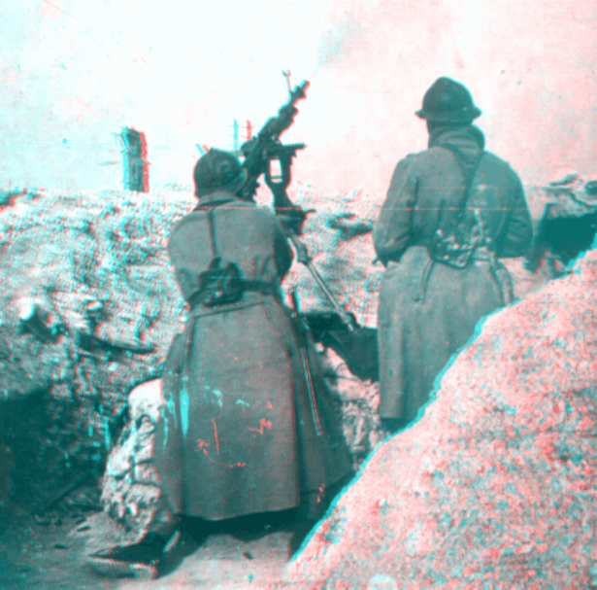
anti-aircraft gun, n. a gun designed to destroy enemy aircraft.

A. W. O. L., n. in the American Army, an abbreviation signifying Absent Without Official Leave.

baby tank, n. equivalent of whippet tank, applied to the French Renault whippet tank of 7 tons.

Big Bertha, n. a popular name given to the long range gun which bombarded Paris in 1918, and to similar guns.

Blighty, n. British army slang for a wound; also signifying England; home.

bully beef, n. canned or preserved beef. [French bouilli, boiled]

caterpillar tread, n. a type of traction consisting of an endless band passing about the front and rear wheels of heavy vehicles; used in farm tractors and in army tanks.

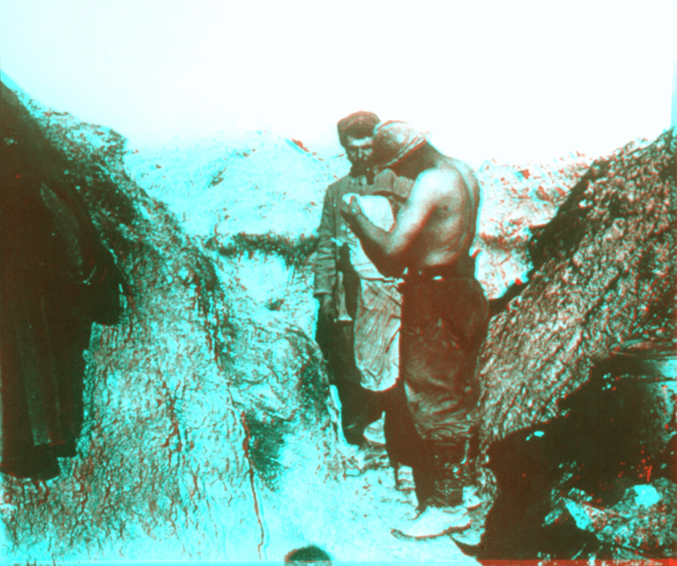
conscientious objector, n. a person who refuses to do military duty because of religious or personal scruples.

contact mine, n. a form of mine which is exploded by being struck, as a submarine mine.

cootie, n. army slang for a louse.

delousing camp, n. a camp where soldiers undergo disinfection on leaving the trenches.

doughboy, n. in American army slang, an infantryman.

dud, n. a shell that has failed to explode.

Duma, n. the Russian Parliament or Council of State, an advisory body under the empire, established in 1905, abolished in 1917.
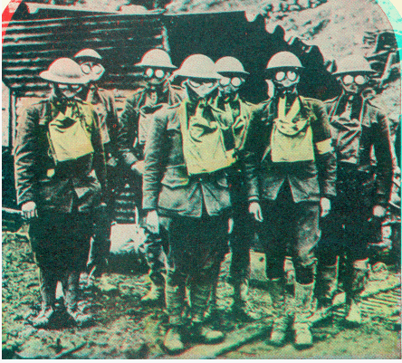
dumdum bullet, n. an expanding bullet intended to make a lacerated wound; frequently formed from ordinary bullets by filing or biting the tip. The use of such bullets is prohibited by the regulations of the Hague Peace Conference.

Fritz, Fritzie, n. a name given to the German soldier by the American forces in Europe.

gas mask, n. a device used in the World War to protect against the effects of asphyxiating gas.

hedgehog, n. an egg-shaped, crisscross tangle of barbed wire for filling in gaps in a wire entanglement.

Heinie, n. a British nickname for the German soldier.

hydrophone, n. a sound detector of American invention, with an effective range of six miles, by which the presence of a submarine and its position may be accurately determined.

Krupp, n. a family of German gun makers. The great Krupp works at Essen turned out the famous long range guns which enabled Germany to prolong the World War.

Kultur, n. the German term for “civilization,” “culture”; the specifically German conception of the relation of the individual and the state to society; in popular acceptation, ruthlessness, savagery.
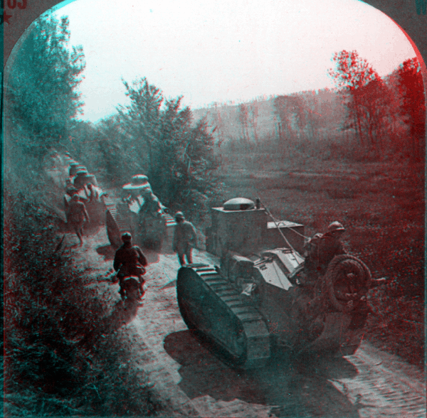
machine gun, n. a small caliber cannon loaded and fired continuously by a mechanical device instead of by hand.

mustard gas, n. a poisonous irritant gas used in the World War, so called from its odor.

No Man’s Land, n. the ground lying between opposing trenches or lines of battle.

over the top, adv. army slang for over the breastworks, out of the trenches, to make an attack; in popular use, beyond a set goal.

pacifist, n. an opponent of militarism, or of war even on just grounds.

poilu, n. the popular nickname of the French soldier, meaning “hairy,” “bearded.” [French]

Red, n. an anarchist, a revolutionist; a member of the extreme wing of the socialistic party.

shell shock, n. a severe nervous affection frequently resulting from exposure to the concussion caused by exploding shells.

Sinn Fein, n. a revolutionary society which aims at the independence of the Irish race.

smoke screen, n. an enveloping screen of dense smoke used to conceal the movements of troops or ships.

Soviet, n. a council of soldiers and workers. [Russian]

Spartacist, n. a member of the communistic party in Germany, so called from Spartacus, the organ of the party, published at Essen.

tear gas, n. an irritant gas used in warfare to produce copious flow of tears, thus blinding the enemy.

time fuse, n. a fuse constructed to cause automatically the explosion of a shell or mine at the end of a determined period.

T N T, the symbol for trinitrate or toluol, an explosive largely used in the World War.

Tommy, n. the popular term for a private in the British army.

trench feet, n. a painful form of swelling produced by prolonged service in the trenches.

trench fever, n. a form of fever arising from unsanitary conditions in the trenches.

wasps of the sea, n. a term applied to destroyers and torpedo boats.

zero hour, n. the moment appointed for leaving the trenches for an attack.

1) The selected words above demonstrate how historical events can bring new vocabulary and phrases into a language. Read the definitions to see how many of the entries are familiar. Answer the following:

- What words or phrases above are still used today? Have any of their meanings changed? Explain.
- How would you place the words & phrases into several categories? Justify your classification system. [There is no single correct answer here.]
- How might dictionaries be a useful historical source? Explain and give a specific example of using a dictionary for historical research.

