The Great War & Gothic Cathedrals


From Mons to Ypres With General French (1916)
by Frederic Coleman

After luncheon I ran to Rheims with the General to see the ravaged cathedral. The stately Gothic pile was reported to be a heap of ruins. It was hardly that, but nevertheless had been cruelly knocked about. Streets near by were choked lanes between rows of desolate monuments to the German love of wanton destruction. [p. 206]

The Diagnosis of the German Obsession (1918)
by William Armstrong Fairburn

Some time ago Kaiser Wilhelm II boasted that his army had already destroyed seventy-three Gothic cathedrals and churches. . . . Rheims Cathedral has been repeatedly and deliberately shelled by the Germans on the false excuse that there was an observation post on the tower. Other cathedrals, churches and magnificent edifices have been wantonly destroyed, including the University Library at Louvain . . . None of these splendid structures were used for military purposes, but their destruction is universally approved in Germany. [pp. 17-18]

The Story of the Great War (vol. II, 1916)

Then on September 18, 1914, the shelling of the city began and a bombardment of the most terrific character. . . . Rheims Cathedral . . . was said to have been demolished by the German guns. The act created a sensation throughout the world, for Rheims Cathedral was like a gem from Paradise, regarded by most art lovers as one of the most beautiful buildings in the world. Every civilized country was shaken with grief when the news of the disaster to Rheims Cathedral was published. [p. 148]
With the Allies (1918) by Richard Harding Davis

In several ways the city of Rheims is celebrated. Some know her only through her cathedral, where were crowned all but six of the kings of France, and where the stained-glass windows, with those in the cathedrals of Chartres and Burgos, Spain, are the most beautiful in all the world. . . .

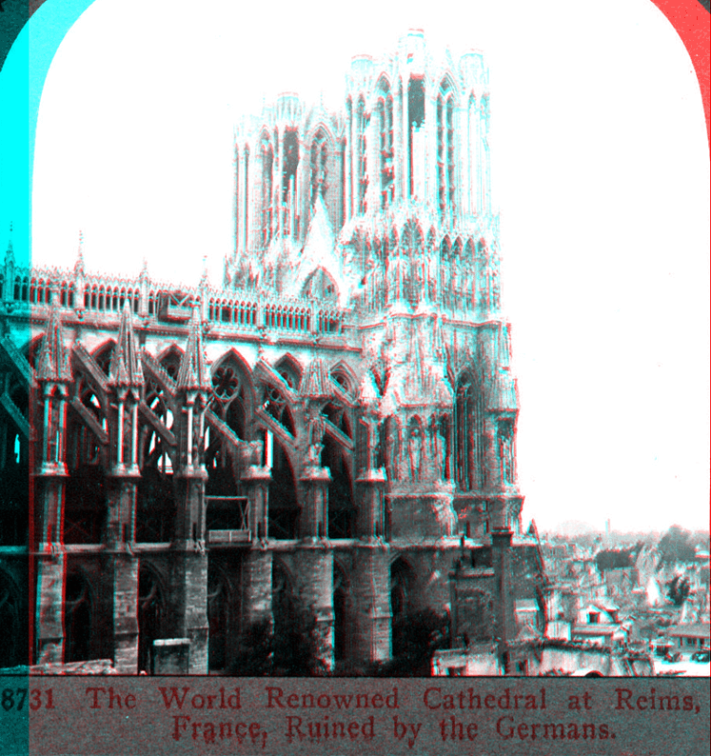
The proportion of those [German shells] that struck the cathedral or houses within a hundred yards of it to those falling on other buildings was about six to one. So what damage the cathedral suffered was from blows delivered not by accident but with intent. As the priests put it, firing on the church was "exprès." [on purpose] . . .

[The cathedral] has been called "perhaps the most beautiful structure produced in the Middle Ages." On the west façade, rising tier upon tier, are five hundred and sixty statues and carvings. The statues are of angels, martyrs, patriarchs, apostles, the vices and virtues, the Virgin and Child. In the centre of these is the famous rose window; on either side giant towers. [pp. 117-119]

As the young curé guided me through the wrecked cathedral his indignation and his fear of being unjust waged a final battle. "Every summer," he said, "thousands of your fellow countrymen visit the cathedral. They come again and again. They love these beautiful windows. They will not permit them to be destroyed. Will you tell them what you saw?"

It is no pleasure to tell what I saw. Shells had torn out some of the windows, the entire sash, glass, and stone frame--all was gone; only a jagged hole was left. On the floor lay broken carvings, pieces of stone from flying buttresses outside that had been hurled through the embrasures, tangled masses of leaden window-sashes, like twisted coils of barbed wire, and great brass candelabra. . . . And everywhere was broken glass. [pp. 123-124]
The Spirit of France (1916) by Owen Johnson
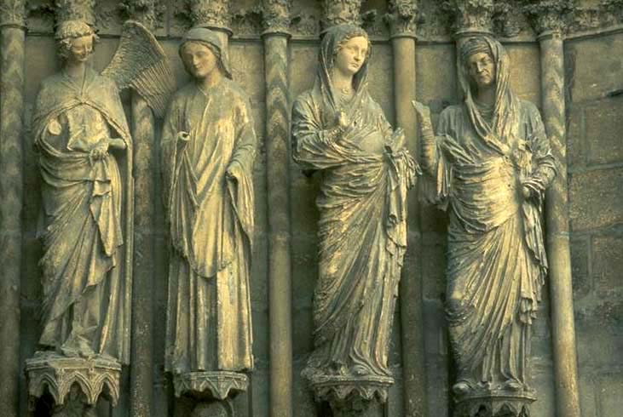

Figures on exterior Rheims cathedral (ca. 1211-25)

At first sight the cathedral [at Rheims] came to us as a surprise. Architecturally it seemed unharmed. Only when we entered the square, under the looming shadow of the great façade, buttressed with logs and sand bags to the height of forty feet, did we realize the devastation of the bombardment and conflagration, the effect of some suspended body that at a distance still shows a human outline and which only on approaching you perceive is a corpse horribly incinerated, a skull under a hat, hideous and yawning.

For the first time, gazing at the white calcined walls and the broken statues, we comprehended the mutilation that has been wrought across that fairy screen; a once transcendingly beautiful face, robbed of its beauty by a cowardly dash of vitriol. Inside the impression deepened. No photographs can adequately visualize what has been wrought.

The great roof, reduced to ashes, had broken through the vault in spots; an interior stripped bare; two-thirds of the great stained-glass windows, the pride of centuries, reduced to dust. A vast profanation had been wrought; something that these ancient, mellow windows held from a ruder world fled forever, a whole history gone—the spirit of the Middle Ages, the heart of France, the France of Jeanne d'Arc, with the pomp of Kings and ancient legends! Rheims, as a living echo of the past, is gone. What remains is only a monument. . . .

Black as has been the stain upon the pages of history of this desecration performed, Heaven grant that the final chapter may not be the willful and futile blotting out of the ornamented past, as the conqueror has done at Arras and is doing at Soissons! . . .

No one who has visited Rheims can have the slightest illusion as to the original deliberate intent of the Germans to reach and destroy the cathedral. The ruined quarters run as ruthlessly and mathematically in the line of the German batteries to the cathedral and stop at that apex as though they had been razed by a giant scythe. [pp. 45-48]

