Take-Home Section:

Final Exam (optional) [100 pts.]

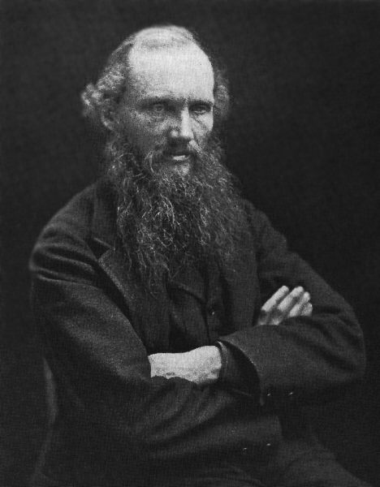
Antoine-Laurent Lavoisier (1743-1794) chemistry & physics
Joseph Priestley (1733-1804) experimental chemistry
Benjamin Thompson, Count Rumford (1753-1814) relation work & heat
John Dalton (1766-1844) founder of modern atomic theory
Thomas Young (1773-1829) wave theory of light
Augustin Jean Fresnel (1788-1827) wave theory of light
Sir Humphry Davy (1778-1829) physics & chemistry
Michael Faraday (1791-1867) electricity & magnetism
James Prescott Joule (1818-1889) mechanical theory of heat
William Thomson, Lord Kelvin (1824-1907) 19th century physics
James Clerk Maxwell (1831-1879) electromagnetic theory of light
Ludwig Boltzmann (1844-1906) kinetic theory & thermodynamics
Rudolf Clausius (1822-1888) Second Law of thermodynamics

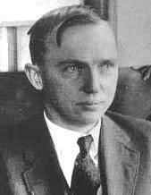
William Herschel (1738-1822) discovery of Uranus
John Herschel (1792-1871) astronomy & physics
William Huggins (1824-1910) stellar spectroscopy
J. Norman Lockyer (1836-1920) astrophysics
Percival Lowell (1855-1916) existence & position of Pluto
Karl Schwarzchild (1873-1916) predicted existence of black holes
Henry Norris Russell (1877-1957) stellar evolution
Harlow Shapley (1885-1972) structure of Milky Way
Edwin Powell Hubble (1889-1953) expansion of the universe
Cecilia Payne (1900-1979) founder of astrophysics
Fred Hoyle (1915-2001) steady-state theory of the universe

Wilhelm Roentgen (1845-1923) discoverer of X-rays
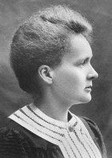
Albert Michelson (1852-1931) the Michelson-Morley experiment
Hendrik Anton Lorentz (1853-1928) theory of the electron
J. J. Thomson (1856-1940) discoverer of electron
Heinrich Rudolf Hertz (1857-1894) discovery of radio waves
Max Planck (1858-1947) originator of quantum theory
Marie Curie (1867-1934) discoverer of radium & polonium
Sir Arthur Stanley Eddington (1882-1944) eclipse expedition of 1919
Niels Bohr (1885-1962) quantum theory of atomic structure
Erwin Schrödinger (1887-1961) wave mechanics
Werner Heisenberg (1901-1976) uncertainty principle
Wolfgang Pauli (1900-1958) exclusion principle

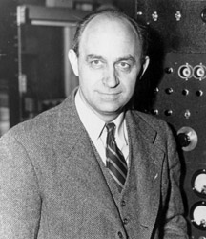
Ernest Rutherford (1871-1937) founder of nuclear physics
Lise Meitner (1878-1968) nuclear fusion
Otto Hahn (1879-1968) radiochemistry
Sir James Chadwick (1891-1974) discoverer of neutron
Leo Szilard (1898-1964) nuclear fission
Enrico Fermi (1901-1954) first atomic reactor
J. Robert Oppenheimer (1904-1967) the Manhattan project
Otto Robert Frisch (1904-1979) nuclear fission of uranium
Richard Feynman (1918-1988) particle physics
Edward Teller (1908-2003) hydrogen bomb
“Nature” versus “Nurture”:

Genetics, Eugenics, Behaviorism

- Variation, Mutation, Mendelian Genetics
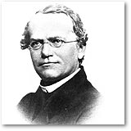
Gregor Mendel (1822-1884) “father” of genetics
August Weismann (1834-1914) germ plasm theory
Hugo de Vries (1848-1935) mutation theory

Luther Burbank (1849-1926) agricultural genetics
William Bateson (1861-1926) rediscovery of Mendel
Thomas Hunt Morgan (1866-1945) fruit fly genetics
Reginald Punnett (1875-1967) poultry genetics
William E. Castle (1867-1962) rodent genetics
Ronald A. Fisher (1890-1962) population genetics
Sewall Wright (1889-1988) population genetics
J. B. S. Haldane (1892-1964) population genetics
Theodosius Dobzhansky (1900-1975) evolutionary synthesis

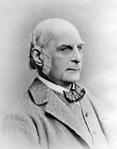
- Eugenics, Psychology, Intelligence Testing
Francis Galton (1822-1911) “father” of eugenics
Karl Pearson (1857-1936) biometry & eugenics
Henry H. Goddard (1866-1957) "idiots" and "morons"
Charles Davenport (1866-1944) Cold Spring Harbor
Alfred Binet (1859-1911) intelligence testing
Lewis Terman (1877-1956) I. Q. testing
Carl C. Brigham (1890-1943) creator of SATs

Cesare Lombroso (1835-1909) criminology
Richard Dugdale (1841-1883) study of criminal families
Havelock Ellis (1868-1935) scientific study of sex

Cyril Burt (1883-1971) experimental psychology, mental tests

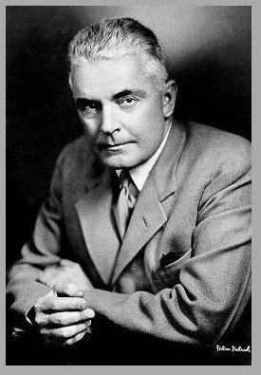
- Behaviorism, Anthropology, Miscellaneous

John B. Watson (1878-1958) "father" of behaviorism
Ivan Petrovich Pavlov (1849-1936) "classical conditioning"
B. F. Skinner (1904-1990) "operant conditioning"
Franz Boas (1858-1942) concept of “culture”
Alfred L. Kroeber (1876-1960) Native American anthropology
Margaret Mead (1901-1978) South Pacific anthropology
Trofim Lysenko (1898-1976) genetics in the USSR
Nikolai Vavilov (1887-c. 1943) victim of Lysenkoism
Edward Bagnall Poulton (1856-1943) insect camouflage
Paul Kammerer (1880-1928) the midwife toad
Take-Home Portion:
Final Writing Assignment [100 points]

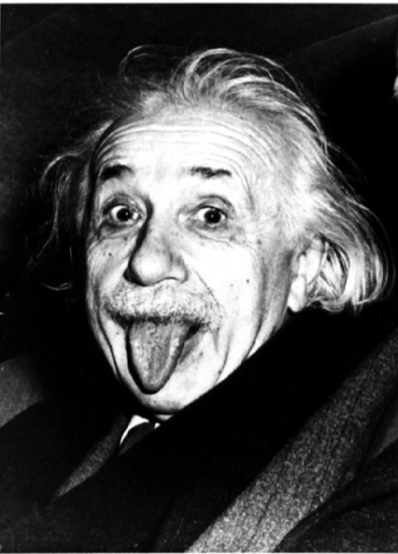
- Choose ONE of the scientists on the lists provided & find out who they are (where are they from, what is their training and background) and what they did (important research or theoretical work or important concepts).
- You can use printed sources or the internet search engines, but try to find reliable substantial sources from universities, colleges, museums, or research institutions (if you cannot, then pick a different scientist)
- In your own words in 5-7 pages (typed, double-spaced) write a brief “scientific” biography of the person & his/her accomplishments. Consider historical context, do not write presentist history. Place the research or theories of the scientist you choose in the BROADER historical context, do not merely regurgitate facts about his or her life (this WILL NOT fulfill the assignment). Consider both internalist & externalist approaches in your paper.
Be sure to cite the sources of your information (including URLs for web sources). Try to find at least THREE sources (either printed or online). At least one source must be printed (NOT from the Internet). Printed sources used should be photocopied and handed in with the final paper. Do NOT cite Wikipedia as one of your official sources

- Several useful online sources are:
http://www.eugenicsarchive.org/eugenics/
http://cogweb.ucla.edu/EP/DNA_history.html
http://www.aip.org/history/

NOTE: You may NOT do your report on Albert Einstein, but you may use the David Bodanis book (E= mc²) as one source for other physicists on the list. Also, if you have problems finding adequate information on your scientist then please see me. Avoid waiting until finals week to begin this assignment.

