Chronology:
Scopes “Monkey” Trial
Dayton, Tennessee (July 10-17, 1925)

January, 1925: Tennessee House of Representatives passes the Butler Bill making it unlawful for state-supported schools “to teach any theory that denies the story of the Divine Creation of man as taught in the Bible, and to teach instead that man has descended from any lower order of animals.”

February-March, 1925: Tennessee Senate approves the bill; Governor Austin Peay signs the bill into law (i.e., the Butler Act) on March 23.

May, 1925: John Thomas Scopes, a young high school science teacher & coach in Dayton, TN, agrees to test the constitutionality of the law. The American Civil Liberties Union (ACLU) in New York City has been soliciting for volunteers for a test case.

July, 1925: The trial begins. On the seventh day, Clarence Darrow examines William Jennings Bryan on witness stand about biblical matters. After nine minutes of deliberation, Scopes is found guilty by the jury and fined $100 by the judge. Defense attorneys want the conviction to test constitutionality of the law.

January, 1927: Tennessee Supreme Court upholds the constitutionality of Butler Act, but overturns Scopes’ conviction on a technicality— thus preventing further appeals by the defense attorneys.

Big Picture Questions:
- What is fundamentalism and why did arise in America?
- Why did opposition to evolution of all kinds grow in the late 1910s?
- Do all “creationists” believe the same thing? Do all “creationists” reject the very notion of evolution?
- How well does the movie Inherit the Wind (1960) reflect the Scopes Trial (1925)?

Inherit the Wind The Scopes Trial
Hillsboro, Tennessee Dayton, Tennessee
Matthew Harrison Brady William Jennings Bryan
Henry Drummond Clarence Darrow
E. K. Hornbeck H. L. Mencken
Bertram Cates John Scopes

Hollywood & History:
The Scopes Trial (1925) versus
Inherit the Wind (1955, 1960)

Inherit the Wind dramatically illustrates why so many Americans continue to believe in the mythical war between science and religion. But in doing so, it sacrifices the far more complex historical reality.

Ronald Numbers, “Inherit the Wind” (1993)

- Neither play nor movie is really about the Scopes trial.
“Inherit the Wind does not pretend to be journalism. It might have been yesterday. It could be tomorrow . . . Only a handful of phrases have been taken from the actual transcript of the famous Scopes trial.”
Introduction to the play, Jerome Lawrence & Robert E. Lee

“Like The Crucible, Inherit the Wind was a response to and a product of McCarthyism. In each play, the authors looked to American history for a parallel.”
Tony Randall, original Broadway cast member

- Differing relationships between Scopes & Dayton (history) and Cates & Hillsboro (play, movie).
Scopes was never jailed. He was never threatened by mob violence.

“The little town of Dayton behaved on the whole quite well. The atmosphere was so far from being sinister that it suggested a circus day. The authors of Inherit the Wind made it chiefly sinister, a witchhunt of the sort war are now all too familiar with.”
Joseph Wood Krutch, trial correspondent

- Bryan (history) was not a mindless, bumbling reactionary as portrayed by Matthew Harrison Brady (play, movie).
Brady assaults all of science in the play & attacks evolution only on narrow biblical grounds. Bryan opposed a penalty provision for violating the law, Brady rants about the fine being too low.

“[For] the first time, I walked out of a play in disgust. I ended up actually sympathizing with Bryan, even though I was and continue to be opposed to his ideas in the case, simply because the playwrights had drawn the character in such comic strip terms.
Gerald Gunther, constitutional scholar

- Darrow (history) is portrayed in an idealized light by Drummond (play, movie) the clear voice of reason, compassion, & tolerance.

Science & Religion?:
The Scopes “Monkey Trial”

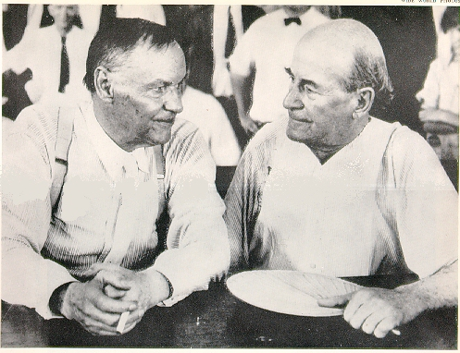
The Myth:
- In Dayton, Tennessee, 1925, high school biology teacher, John Scopes is caught “red-handed” teaching evolution in the classroom. His actions are against a recently passed state law, the Butler Act.
- During the “Monkey Trial”, the defense attorney, Clarence Darrow makes the prosecuting attorney, William Jennings Bryan, look like a bumbling fool by placing him on the witness stand. Bryan’s views on religion and evolution are inconsistent and ignorant.
- The nation, and entire world, laughs at the ignorance of Tennessee and at the fundamentalists like Bryan who oppose evolution.
- Even though Scopes is found guilty (and fined $100), the evolutionists eventually triumph. After the “Monkey Trial”, never again would right-wing, conservative Christianity rise to challenge science in the same way.
- Evolutionists triumphed. Fundamentalists lost.

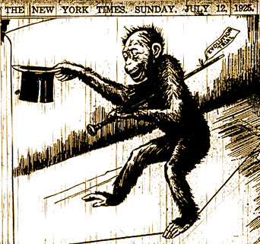
Complicating the Myth:
- Members of small town Dayton set up the trial, many thought the publicity would be good for local businesses. They were correct.
- Scopes was NOT caught teaching evolution, he was NOT even a biology teacher. He let himself be prosecuted deliberately for the ACLU who wished to test the constitutionality of the Butler Act. There are doubts as to whether Scopes ever actually taught evolution at all.
- Bryan was NOT made to look like a complete fool, he did NOT believe in a literal six-day creation (as did many fundamentalists).
- There was NOT a clear victory of the evolutionists over the fundamentalists. Scopes’ conviction and fine were overturned in an appeal. Textbook publishers omitted controversial material on evolution or modified it to be less offensive. The Butler Act remained on the books in Tennessee until the 1960s.
- There was NOT a clear unambiguous victory of evolutionists (“science”) over fundamentalism (“religion”).

Excerpts from Darwinism comes to America (1998) by Ronald L. Numbers

If we strip away the many myths attached to the Scopes trial, what can we say about it as a historical event? Or, perhaps, what should we no longer say? Clearly the trial did not bring the antievolution movement to an end or even slow it down . . . Because Bryan’s espousal of the day-age interpretation of Genesis 1 represented Fundamentalist orthodoxy at the time, he did not betray his cause while on the witness stand. He did not cave in under pressure from Darrow; he merely stated his long-held views. The trial did subject Bryan and Fundamentalism to considerable public ridicule, and it did contribute in some circles to a negative, antiscientific image of the South. It no doubt encouraged publishers to downplay evolution in their texts. But most of all it served as a protean source for legend-making: about Bryan and Darrow, about Fundamentalism and modernism, about science and religion. [91]

Excerpts from The Evolution Wars (2001) by Michael Ruse

Looking back over the years, what should we say? For myself, I cannot say [that]
. . . gutting evolution from the textbooks . . . was right and proper . . . But equally, I cannot say that I am surprised or that I am entirely unsympathetic to the fundamentalists. Evolution after Darwin had set itself up to be something more than science. It was popular science, the science of the marketplace and the museum, and it was a religion . . .

I do not say the evolution as religion was always a bad thing . . . But let us not pretend that is was not what it was and that right and decency was all on one side. As is usually the case in these things, both sides had their saints and their sinners, their people of reason and their people of emotion. Most may have pulled back from the extremes, but the polarization was more than simply one of black and white . . . science and religion. As always when you are dealing with history, when you dig beneath the surface, things become a lot more complex and interesting then appears at first sight. [113-114]

Sources:

Allen, Frederick Lewis. Only Yesterday: An Informal History of the Nineteen-Twenties (1931).

Appleman, Philip (ed.). Darwin: A Norton Critical Edition (3rd edition, 2001).

Bowler, Peter J. Charles Darwin: The Man and His Influence (1990).

Bowler, Peter J. Evolution: The History of an Idea (new edition, 1989).

Brooke, John and Geoffrey Cantor. Reconstructing Nature: The Engagement of Science and Religion (1998).

Brooke, John Hedley. Science and Religion: Some Historical Perspectives (1991).

Conkin, Paul. When All the Gods Trembled: Darwinism, Scopes, and American Intellectuals (1998).

Ferngren, Gary B. (ed.). The History of Science and Religion in the Western Tradition (2000).

Larson, Edward J. Summer for the Gods: The Scopes Trial and America’s Continuing Debate Over Science and Religion (1997).

Larson, Edward J. Trial and Error: The American Controversy over Creation and Evolution (1985).

Lesiak, Christine. “Monkey Trial: An All-Out Duel Between Science and Religion” American Experience (PBS Home Video, 2002).

Moran, Jeffrey P. The Scopes Trial: A Brief History with Documents (2002).

Numbers, Ronald L. The Creationists: The Evolution of Scientific Creationism (1992).

Numbers, Ronald L. Darwinism Comes to America (1998).

Osborn, Henry Fairfield. The Earth Speaks to Bryan (1925).

Ward, Henshaw. Evolution for John Doe (1925).

The World’s Most Famous Court Trial: Tennessee Evolution Case (3rd edition, 1925).

